|  |  |
| --- | --- |
|  | **MINISTRY OF EDUCATION AND** **TRAINING** |

**FPT UNIVERSITY**

Capstone Project Document

**Design and Implement**

**The model of Handheld POS**

**(point of sale) system for retailers**

|  |  |
| --- | --- |
| **Group 2** | |
| **Group members** | Nguyễn Thanh Hải – HaiNTSE90195  Đặng Minh Hiếu – HieuDMSE60969  Lê Long Hồ - HoLLSE61291  Huỳnh Hữu Nghị - NghiHHSE61055 |
| **Supervisor** | Bùi Đại Trí – TriBD |
| **Ext. Supervisor** | N/A |
| **Capstone Project code** | HPOS |

-Ho Chi Minh City,***1st Sep 2016***-

Table of Contents

A. Report No. 1 Introduction 7

1. Project Information 7

2. Introduction 7

3. Current Situation 7

4. Problem Definition 8

5. Proposed Solution 9

5.1. Feature functions 9

5.2. Advantage and Disadvantage 9

6. Functional Requirements 10

7. Role and Responsibility 10

B. Report No. 2 Software And Hardware Project Management Plant 11

1. Problem Definition 11

1.1. Name of this Capstone Project 11

1.2. Problem Abstract 11

1.3. Project Overview 11

2. Project organization 14

2.1. Software And Hardware Process Model 14

2.2. Roles and responsibilities 16

2.3. Tools and Techniques 16

3. Project Management Plan 18

3.1. Software and hardware development life cycle 18

3.2. Increment Detail 19

3.3. Task sheet 22

3.4. All Meeting Minutes 22

4. Coding Convention 22

C. Report No. 3 Software And Hardware Requirement Specification 23

1. User Requirement Specification 23

1.1. Shop Assistant Requirement 23

1.2. Manager Requirement 23

2. System Requirement Specification 23

2.1. External Interface Requirement 23

2.2. System Overview Use Case 32

2.3. List of Use Case 33

3. Software And Hardware System Attribute 60

3.1. Reliability 60

3.2. Availability 60

3.3. Security 60

3.4. Maintainability 60

3.5. Performance 60

3.6. Usability 60

D. Report No. 4 Software Design Description 61

1. Design Overview 61

2. System Architecture Design 62

2.1. Software Architecture Description 64

2.2. Hardware Architecture Description 65

2.3. Software – Hardware Connection Architecture Description 76

3. Component Diagram 77

3.1. Physical Component Diagram 77

4. Detailed Description 79

4.1. Class Diagram 79

4.2. Class Diagram Explanation 79

4.3. Interaction Diagram 83

5. Interface 95

5.1. Component Interface 95

5.2. User Interface Design 96

6. Database Design 103

6.1. Entity Relationship Diagram (ERD) 103

6.2. Data Dictionary 104

7. Flowchart 108

7.1. Add index of sensors to database 108

7.2. Control Water Pump through Algorithm 109

7.3. Control Light through Algorithm 110

E. System Implementation & Test 111

1. Introduction 111

1.1. Overview 111

1.2. Test Approach 111

2. Database Relationship Diagram 111

2.1. Physiscal Diagram 111

2.2. Data Dictionary 112

3. Performance Measures 116

4. Test plan 116

4.1. Features to be tested 116

4.2. Features not to be tested: 119

4.3. Test environment 119

5. System Testing Test Case 120

5.1. Component Testing 120

5.2. Integration Test 136

F. Report No.6 Software User’s Manual 142

1. Installation Guide 142

1.1. Setting up environment 142

1.2. Deployment at server side 142

2. User’s Guide 145

2.1. Login 145

2.2. Show zone 146

2.3. Add zone 147

2.4. Library info 148

2.5. Add new plant 149

2.6. Show plant info 150

2.7. Update Zone 151

2.8. Show sensor info 152

2.9. History sensor 153

2.10. Show actuator 153

**Definitions, Acronyms, and Abbreviations**

|  |  |
| --- | --- |
| **Name** | **Definition** |
| HPOS | Handheld POS (point of sale) system for retailers |
| MCU | Micro-controller Unit |
| I/O | Input / Output |
| GPIO | General purpose input output |
| PC | Personal computer |
| IPC | Industrial PC |
| USB | Universal Serial Bus |
| UART | Universal Asynchronous Receiver/Transmitter |

# **Report No. 1 Introduction**

## Project Information

* Project name: **Design and Implement The model of Handheld POS (point of sale).**
* Project Code: **HPOS**
* Product Type: **Device**
* Start Date: **01/09/2016**
* End Date: **August 2016**

## Introduction

Whether you are in a grocery store, at a craft fair, or at the mall, no one wants to deal with slow point of sale (POS) systems. During busy or hectic times, slow, lagging computers may actually deter sales and frustrate both employees and customers. For the benefit of not only your workforce, but also the customer service experience you provide, portable, handheld POS systems may be the solution to slower, less effective systems.

Business owners also benefit with these types of systems, as they lend themselves to multitasking and help to complete necessary tasks that are essential for the business to function optimally. With an effective handheld POS system, you can analyze sales data, manage inventory, and authorize sales on the fly.

This document describes our working process in 4 months includes our perspective in the system, component designs and detailed core workflows. We developed a good solution that provides a user convenient application for retailer.

## Current Situation

Handheld POS system is necessary for any business store so today there are many system being introduced to solve this problem such as:

+ **Handheld POS terminal EPOS-6780**: An handheld POS device with elegant and slim design, works well for a store, but they aren’t many function to manager product.

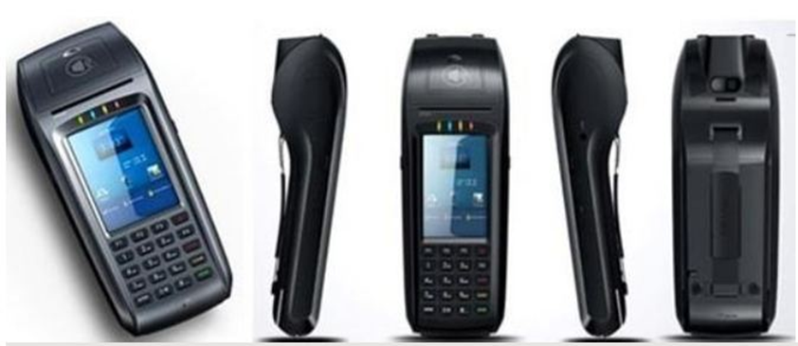

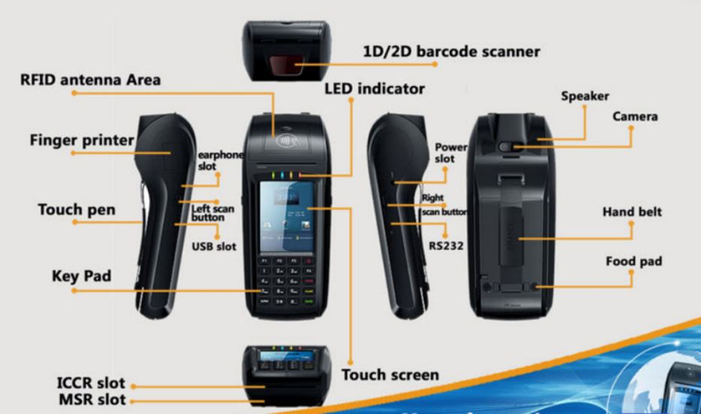

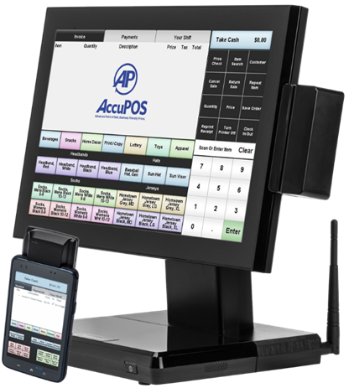+ **Accupos - Android Handheld POS:** start developing POS systems from 2006. A complete system includes: An Android PDA with Magnetic Card Reader or an Android PDA with Barcode Scanner and an Android Wireless Desktop POS Terminal.

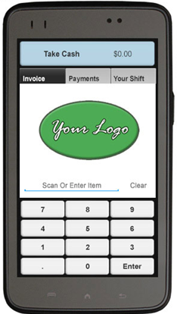

## Problem Definition

According searching and reading documents of current situations, we give some disadvantage of those above systems if applied.

+ **Handheld POS terminal EPOS-6780**: working well at a grocery store or at craft fair, they can’t can analyze sales data, manage inventory, or authorize sales on the fly.

+ **Accupos - Android Handheld POS**: is a good solution, but they have high initial expenses.

## Proposed Solution

In Vietnam, they are prefer working with a large system like Accupos at a mall or chain stores, terminal POS for a grocery store or a craft fair. Our proposed solution is to design a product combined the convenient of terminal POS with the power of an POS system.

### Feature functions

* Full integration with accounting software.
* Friendly for the user, and friendlier for the customer.
* Rocket fuel for your company’s efficiency.

### Advantage and Disadvantage

***Advantages:***

+ A compact with full integration.

+ Expansion function can scan more than 1 bar code at a time.

+ Friendly GUI for customer with two languages.

+ The system has low initial cost.

***Disadvantage:***

+ Depended on hardware and external lighting conditions.

+ Sometimes this system does not work right.

## Functional Requirements

Function requirements of the system are listed as below:

+ Input: imported products to database.

+ Output: exporting product.

+ Sale manager: Scan barcode, printing invoices.

## Role and Responsibility

Table A‑1: Role and Responsibility

|  |  |  |  |  |
| --- | --- | --- | --- | --- |
| **No** | **Full Name** | **Role** | **Position** | **Contact** |
| 1 | Bùi Đại Trí | Product owner | Supervisor | [Daitribk@gmail.com](mailto:Daitribk@gmail.com) |
| 2 | Nguyễn Thanh Hải | Developer | Leader | [HaiNTSE90195@fpt.edu.vn](mailto:HaiNTSE90195@fpt.edu.vn) |
| 3 | Đặng Minh Hiếu | Developer | Member | [HieuDMSE60969@fpt.edu.vn](mailto:HieuDMSE60969@fpt.edu.vn) |
| 4 | Lê Long Hồ | Developer | Member | [HoLLSE61291@fpt.edu.vn](mailto:HoLLSE61291@fpt.edu.vn) |

# **Report No. 2 Software And Hardware Project Management Plant**

## Problem Definition

### Name of this Capstone Project

Official name: Handheld POS (point of sale) system for retailers.

Vietnamese name: Thiết bị bán hàng cầm tay cho siêu thị nhỏ.

Abbreviation: “HPOS”.

### Problem Abstract

As current in Viet Nam customer often use Handheld POS terminal for a grocery store or at a craft fair, … Using a Handheld POS terminal cannot manager the input, output so they don’t know about the inventory.

We provide a solution can do all that thing just in one device with low initial costs. With our device, you can scan barcode, import, export product, save your data to database and using it to analyze sale data, manage inventory, and authorize sales on the fly. In addition, you can expand your store into chain stores.

### Project Overview

#### Current Situation

Below are the problems encountered in this project:

* + Knowledge of accountancy: lack of information about accountancy and their rule.
  + The variety of model: there are many type of POS in market, competing with our product.

#### The Proposed System

According to the technology researches, we found that Raspberry pi 3, **ZBar** and **Opencv** are very capable of resolve the current situations.

We create a database with MySQL to store and update the good information such as price, name... and transaction data.

Build the program to manage the store and good status. Image processing using **Opencv** libraries and Use **ZBar** libraries to decode barcodes.

Build power supply circuits for the system. Send the receipt to printer via the Wi-Fi or Bluetooth.

Build main program to control all sub-function.

Our system includes two main subsystems: advice to read barcode and transfer information to web-server, a website for manager goods and user.

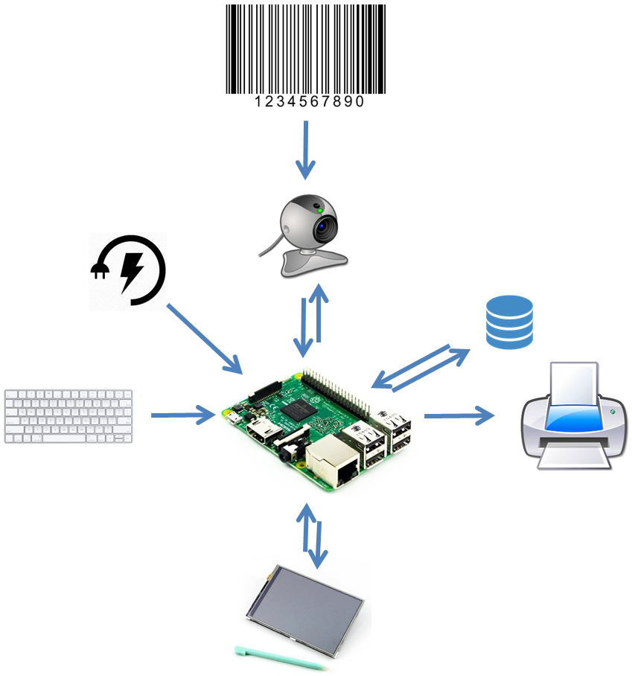

Figure B‑1: Components of HPOS System

This system includes:

+ Raspberry Pi 3 with an embedded program running in QT framework can: (1) scan barcode using Opencv and ZBar library, (2) manage the store and goods status, (3) send the receipt to printer via Wi-Fi (or Bluetooth).

+ A database with MySQL to store and update the goods information.

#### Future plans

Current system only can deploy to a small store. We will provide a web-server to save more data such as goods status, customer information and a program to analyses this data to develop this system can be deploying in a large chains store.

#### Development Environment

##### **Hardware requirements**

Table B‑1: Hardware Requirements

|  |  |  |
| --- | --- | --- |
| **Devices** | **Minimum Requirements** | **Recommended** |
| SBC | Raspberry Pi 3 | Beagle Board black rev. B |
| Screen | Waveshare 3.5 Inch LCD (A) with resistive touch. | Waveshare 7 Inch LCD with capacitive touch. |
| Keyboard | Mini keyboard | Mini keyboard |

##### **Software Requirements**

- Project management:

Table B-2: Software Requirements of Project Management

|  |  |  |
| --- | --- | --- |
| **Software** | **Name / Version** | **Description** |
| Real-time messaging | Slack Cautionary Tale 2.0.6  Group in Facebook | Slack brings all communication together in one place |
| Task Plan | Microsoft Excel  Trello.com | It's tempting to start a project plan in Excel because it helps you quickly list all your projects, arrange them how you want them, and even create something that resembles a Gantt Chart view  Trello’s boards, lists, and cards enable you to organize and prioritize your projects in a fun, flexible and rewarding way. |
| Source Control | GitKraken 1.7.1 | A free Git & Mercurial client for Windows or Mac |

- Embedded Development

Table B‑3: Software Requirements of Embedded Development

|  |  |  |
| --- | --- | --- |
| **Software** | **Name / Version** | **Description** |
| OS | Windows 7 or above  Linux Ubuntu  Raspbian |  |
| IDE | QT Creator 4.1.0  QT Designer 5.3.2 | - QT Creator is the cross-platform IDE that makes application and UI development a breeze.  - QT Designer is QT's tool for designing and building graphical user interfaces (GUIs) from QT components |
| Database | My SQL | MySQL is an open source relational database management system. |
| Modeling tool | Star UML | StarUML is one of the most popular UML tools in the world. |
| Document tool | Microsoft Word  Microsoft Excel  Microsoft Power Point |  |

## Project organization

### Software And Hardware Process Model

#### Overall Description

Agile development is methods allow the development team to focus on the software itself rather than on its design and documentation. Agile methods universally rely on an incremental approach to software specification, development, and delivery. They are best suited to application development where the system requirements usually change rapidly during the development process during the development process.

Scrum is one the models of Agile method. It is an iterative and incremental agile software development framework for managing product development. It defines "a flexible, holistic product development strategy where a development team works as a unit to reach a common goal", challenges assumptions of the "traditional, sequential approach" to product development, and enables teams to self-organize by encouraging physical co-location or close online collaboration of all team members, as well as daily face-to-face communication among all team members and disciplines involved.

References:

<http://www.agiledata.org/essays/evolutionaryDevelopment.html>

<https://en.wikipedia.org/wiki/Scrum_(software_development)>

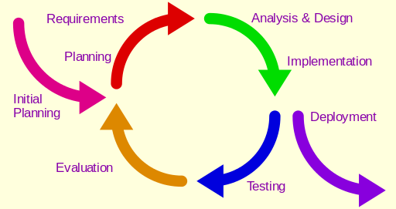

Figure B‑4: Scrum Model

#### Reasons for choosing

We use Scrum model, which is an iterative and incremental agile software development framework for managing product development, to develop this project. We apply customized this model because follow reasons:

+ The team must study Opencv, Zbar, C++, GUI designer...

+ The team has to study how to decode barcode.

+ The team just has some knowledge about electronic and board design. We must solve power supply for modules.

For those reasons, the requirements of the project cannot be stable, clear, and fix. It even can be rapidly changed. However, the team must be implement at the same time in this project is 4 months due to FPT University Capstone Project timeline, so the team needs model, which is:

*+ Easy to change:* We choose this model to change requirements.

*+ Easy to update:* According with research and implementation, we can update easily document, scope, coding with supervisor’ agreement.

*+ Resources share:* There are many phases in this project and we just have four members. This model permits us share resources easily, one person can work more than task.

*+ Soon bugs:* We work on this model to do more test case iterative, so we can detect bugs soon and fix it.

### Roles and responsibilities

Table B‑5: Roles and Responsibilities

|  |  |  |  |
| --- | --- | --- | --- |
| **No** | **Full name** | **Role in Group** | **Responsibilities** |
| 1 | Bùi Đại Trí | Supervisor  Project manager | Defining business.  Supporting in technique issues.  Controlling the development process. |
| 2 | Nguyễn Thanh Hải | Team leader  BA  Developer  Tester | Managing process.  Clarifying requirements.  Preparing documents and reports.  Creating task plan.  Reviewing documents and reports.  Committing all individual works.  Design and implement hardware.  Researching components, document for implementing.  Design and implement mobile application.  Supporting each other.  Test hardware system. |
| 3 | Đặng Minh Hiếu | BA  Developer  Tester | Review documents and reports.  Committing all individual works.  Researching components, document for implementing.  Implement chart. Test hardware component. |
| 4 | Lê Long Hồ | BA  Developer  Tester | Review documents and reports.  Committing all individual works.  Researching components, document for implementing.  Implement chart. Test hardware component. |
| 5 | Huỳnh Hữu Nghị | BA  Developer  Tester | Review documents and reports.  Committing all individual works.  Researching components, document for implementing.  Implement chart. Test hardware component. |

### Tools and Techniques

Table B‑6: Tools and Techniques

|  |  |  |
| --- | --- | --- |
| **No** | **Tools/Techniques** | **Name/Version** |
| 1 | For Embedded Software | QT Creator 4.1.0 QT STK 5.3.2 QT Designer 5.3.2 |
| 2 | For Hardware Design | OrCAD – PCB Editor16.6 |
| 3 | For Application | QT Creator 4.1.0 |
| 4 | For Managing Database | MySQL Workbench 6.3.6 CE |
| 5 | For Managing documents, reports, models | Microsoft Office 2013  Microsoft Visio 2013  StarUML 2.7.0  Software Idea Modeler |

## Project Management Plan

### Software and hardware development life cycle

Table B‑7: Software development life cycle

|  |  |  |  |  |  |
| --- | --- | --- | --- | --- | --- |
| **Phase** | **Description** | **Deliverables** | **Resource needed** | **Dependencies**  **and Constrains** | **Risk** |
| Increment 0:  Analysis & Research | - Collect requirement.  - Research the same system.  - Research tools and technique.  - Research hardware.  - Identify and clarify requirement.  - Define test phase.  - Create introduction report. | - Introduction report  - Research report | - 7 man-days | - N/A | - Missing requirement  - Unclear scope of project  - Lack of member share of understand |
| Increment 1:  Research  Planning  Design | - Create Software and Hardware project management plan report.  - Create Software and Hardware Requirement Specification report.  - Research OpenCV.  - Research ZBar.  - Implement function relate with camera and barcode.  - Define requirement.  - Define performance measures.  - Research hardware.  - Design database.  - Design user interface.  - Design test case. | - Software and Hardware project management plan.  - Software and Hardware Requirement Specification.  - Application with detect barcode function.  - Test report.  - Performance measures report. | - 14 man-days | - Depend on introduction report, research reports, hardware device | - Lack of Experience.  - Late for shipping hardware  - Measure is not exactly  - Test case cannot cover all cases |
| Increment 2  Implementation | - Create Software and Hardware Design Description report.  - Implement transfer data to MCU.  - Implement control with algorism and sent to application.  - Testing hardware transfer.  - Design user interface.  - Design model of demo. | - Software and Hardware Design Description report.  - Application.  - Test report.  - Performance measures report. | - 21 mans-day | - Depend on introduction report, research reports, hardware. | - Lack of Experience.  - Measure is not exactly  - Hardware work not good.  - Test case cannot cover all cases. |
| Increment 3  Implementation (communication in system)  Testing | - Create System Implementation & Test report.  - Implement schematic of board.  - Implement hardware connects together.  - Implement, show view to LCD.  - Implement model for demo.  - Test show view to LCD.  - Test scan barcode.  - Test power supply. | - Create System Implementation & Test report  - Board for hardware  - Application for control and show information.  - Test report.  - Performance measures report. | - 21 mans-day | - Depend on introduction report, research reports, hardware. | - Lack of Experience.  - Measure is not exactly.  - Hardware is not exactly.  - Test case cannot cover all cases. |
| Increment 4  Deployment | - Create installation guide.  - Create User guide.  - Integration test.  - Implement modeling device. | - Installation guide  - User guide  - Integration test report  - Modeling device. | - 7 mans-day | - All functions and reports are completed. | - Lack of experience.  - Hard to grow plant.  - Depend on weather. |

### Increment Detail

#### Increment 0: Analysis and Research

Table B‑8: Increment 0: Analysis and Research

|  |  |  |
| --- | --- | --- |
| **Task** | **Description** | **Author** |
| - Collect requirement | Meeting with supervisor and get all information about requirement of systems | Haint, Hieudm, Holl, Nghihh |
| - Research the same system | Find some current systems all over the world and popular ways in local  Find out strength and weakness for each current system. | Holl, Nghihh |
| - Research tools and technique | Predict tools and technique for the system based on requirement and current system. | Haint |
| - Clarify requirement | Define main functions which are approved by supervisor | Haint, Hieudm, Holl, Nghihh |
| - Research hardware | Research popular module in local market (how to work, IO, accuracy, pros and cons….) | Holl, Nghihh |
| - Define test phase | Define test phase for each part in system. | Haint |
| - Create introduction report |  | Holl, Nghihh |

#### Increment 1: Research - Planning - Design

Table B‑9: Increment 1: Research - Planning - Design

|  |  |  |
| --- | --- | --- |
| **Task** | **Description** | **Author** |
| - Create Software project management plan report | Define phase of project and what is need to do for each part in system | Haint |
| - Create Software Requirement Specification report | Identify detail requirements of system. | Haint, Hieudm, Holl, Nghihh |
| - Research Gantt chart. | Giving plan management for project.  Define model for management and development of project | Haint |
| - Research hardware | Compare sensors based on functions and report in Increment 0.  Choose hardware which approved by supervisor for system | Haint, Hieudm, Holl, Nghihh |
| - Research application | Define tools and techniques to create application for user | Haint |
| - Design database | Store all information of system for tracking and processing. | Holl |
| - Design test case | Create test case for each situation in system | Holl, Nghihh |

#### Increment 2: Implementation

Table B‑10: Increment 2: Implementation

|  |  |  |
| --- | --- | --- |
| **Task** | **Description** | **Author** |
| - Create Software Design Description report |  | Haint, Hieudm, Holl, Nghihh |
| - Testing hardware | Do test case based on design in Increment 1 | Holl, Nghihh |
| - Design user interface | Design application’s interface | Hieudm |
| - Design model of demo | Design and printing model of demo | Nghihh |

#### Increment 3: Merge Implementation - Testing

Table B‑11: Increment 3: Merge Implementation - Testing

|  |  |  |
| --- | --- | --- |
| **Task** | **Description** | **Author** |
| - Create System Implementation & Test report |  | Haint, Hieudm, Holl, Nghihh |
| - Redefine requirement | Rechecking requirement based on results of Increment 2. Find out risks and problem of system.  Fix requirements with supervisor’ agreement. | Holl, Nghihh |
| - Redesign test case | Redesign test case, which suitable with changes. | Holl, Nghihh |
| - Implement schematic of board | Design schematic of board in sub and main controller. | Hieudm |
| - Implement hardware connects together | Combine all in one system in real environment for experimentally and testing | Haint, Hieudm, Holl, Nghihh |
| - Implement demo model | Create a model to demo | Nghihh |

#### Increment 4: Deployment

Table B‑12: Increment 4: Deployment

|  |  |  |
| --- | --- | --- |
| **Task** | **Description** | **Author** |
| - Create installation guide | Create guide of installation. | Holl, Nghihh |
| - Create User guide | Create guide for user how to control the system | Holl, Nghihh |
| - Integration test | Retest all test case in combined system.  Fix bugs. | Haint, Hieudm, Holl, Nghihh |
| - Implement modeling. | Deploy system to demo HPOS | Haint, Hieudm, Holl, Nghihh |

### Task sheet

Place at folder “Task sheet”.

### All Meeting Minutes

Place at folder “Meeting Minutes”.

## Coding Convention

- C/C++ and Python: Using to develop program on hardware.

- Java: Using to develop Webserver.

- Android: Using to develop mobile application. The coding convention is based on Java.

Summary:

* Naming Conventions:

- Variable name should short yet meaningful. If the name is more than one word, it must be in mixed case, starting word with a lowercase.

- Constants name should be uppercase with all words separated by underscores.

- Methods name should be verbs, in mixed case with the first word lowercase, the first letter of each internal word capitalized.

- Class name should be nouns, in mixed case with the first letter of each internal word capitalized.

* Package and import statements:

- Package statements are the first non-comment line.

- Import statement is after package statement.

* Constants

- Numerical constants should not be coded directly.

* Variable Assignments:

- Avoid assigning several variable to the same value in a single statement.

* Comments:

- Using /* */ and """ """ for block comments.

- Using // and # for line comments.

* Return statements:

- A return statement with a value should not use parentheses.

Using C/C++ coding convention from

https://google.github.io/styleguide/cppguide.html

Using Python coding convention from

https://google.github.io/styleguide/pyguide.html

Using Java coding convention from

<http://www.oracle.com/technetwork/java/codeconvtoc-136057.html>

Using Android coding convention form

<http://source.andoird.com/source/code-style.html>

References: [Code Conventions for the Java TM Programming Language](http://www.oracle.com/technetwork/java/codeconvtoc-136057.html)

# **Report No. 3 Software And Hardware Requirement Specification**

## User Requirement Specification

User is required to wear the HPOS and a wireless printer connect to HPOS systems. They use HPOS by scanning the barcode of the items in a customer’s cart, providing information about the products to customers and printing a transaction receipt. After check out for customer, the transaction receipt is printed, they can move to a new customer, and begin a new transaction.

### Shop Assistant Requirement

Shop assistant can use some functions in the system. To use all functions, shop assistant must login. These are some functions shop assistant can use:  
- Login/Logout.  
- Search by scan barcode.

- Search by input barcode  
- Manage Orders Items.

- Payment by cash.  
- Print Receipt.

### Manager Requirement

Manager can use all functions in the system. To use all functions, manager must login. These are all functions manager can use:

- Login/Logout.  
- Search by scan barcode.

- Search by input barcode  
- Manage Orders Items.

- Payment by cash.  
- Print Receipt.

- Manage Employee.

- Manage Inventory.

## System Requirement Specification

### External Interface Requirement

#### User interface

* General requirement for graphics user interface is the GUI should be simple, clear, intuitive, and easy to use.
* The user application is designed base on QT design and display best on 320x480 pixels – screen size interface uses English language in Raspbian application.
* The interface is divided by role, which will allow users to switch easily between different parts of application.
* Meet all the main functions and easily to identify each of functions.
* Use obvious icon to avoiding misunderstanding.

#### Hardware interface

Each hardware component must meet the following requirements: easy to replace, low cost, easy to implement, stable and high durable.

##### **Raspberry Pi 3**

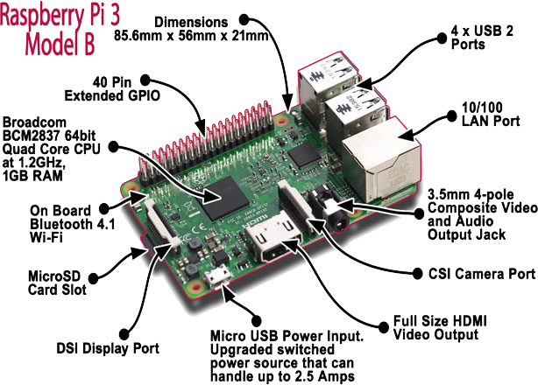

Figure C‑1: Raspberry Pi 3 Overview

Overview: The Raspberry Pi 3 Model B is the third-generation Raspberry Pi. This powerful credit-card sized single board computer can be used for many applications and supersedes the original Raspberry Pi Model B+ and Raspberry Pi 2 Model B. Whilst maintaining the popular board format the Raspberry Pi 3 Model B brings you a more powerful processer, 10x faster than the first-generation Raspberry Pi. Additionally, it adds wireless LAN & Bluetooth connectivity making it the ideal solution for powerful connected designs.

**Detail Specifications:** Here are functions that used in system.

Table C‑1: Raspberry Pi 3 Hardware Specification

|  |  |
| --- | --- |
| Specifications | |
| System on Chip  (SoC) | Broadcom BCM2837  1.2GHz Quad-Core ARM Cortex-A53 |
| CPU | 4x ARM Cortex-A53, 1.2GHz |
| GPU | Dual Core Video-Core IV® Multimedia Co-Processor. Provides Open GL ES 2.0, hardware-accelerated OpenVG, and 1080p30 H.264 high-profile decode.  Capable of 1Gpixel/s, 1.5Gtexel/s or 24GFLOPs  With texture filtering and DMA infrastructure. |
| RAM | 1GB LPDDR2 (900 MHz) |
| Networking | 10/100 Ethernet  Broadcom BCM 43438 chip provide 2.4 GHz 802.11b/g/n wireless LAN |
| Bluetooth | Bluetooth 4.1 Classic, Bluetooth Low Energy |
| Storage | micro SD |
| GPIO | 40 pin headers, populated |
| Ports | HDMI, 3.5mm analogue audio-video jack  4 x USB 2.0, Ethernet, Camera  Serial Interface (CSI), Display Serial Interface (DSI) |
| Power ratings | 800mA (4.0W) |
| Power source | 5V, 2.5A via Micro USB or GPIO header |
| Size | 85.60 * 56.5 mm (3.370 x 2.224 in) not including protruding connectors |
| Weight | 45g |
| Connectors | |
| **Video Output** | HDMI (rev 1.3 & 1.4)  Composite RCA (PAL and NTSC) |
| **Audio Output** | Audio Output 3.5mm jack, HDMI  USB 4 x USB 2.0 Connector. |
| **Camera Connector** | 15-pins MIPI Camera Serial Interface (CSI-2) |
| **Display Connector** | Display Serial Interface (DSI) 15 ways flat flex cable connector with two data lanes and a clock lane. |
| **Memory Card Slot** | Push/pull Micro SDIO |

##### **Camera**

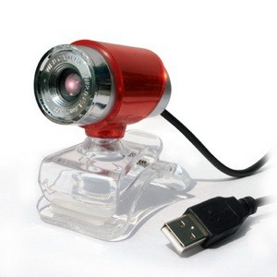

Figure C‑2: Camera

The camera specification:

• USB 5.0 Mega Pixel Webcam Camera High Quality.

• Shows the high definition and true color images in network conference and video chat.

• Up to 5 Mega Pixels window capture resolution supported.

##### **LCD Touch Screen 3.5 inch.**

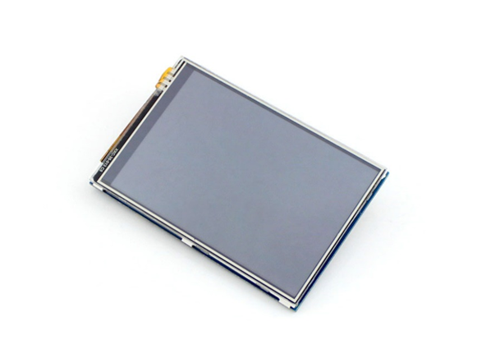

Figure C‑3: LCD Touch Screen 3.5 inch

The LCD specification:

* Power input: 3.3V DC
* Designed for Raspberry Pi, an ideal alternative solution for HDMI monitor
* Supports any revision of Raspberry Pi (directly-pluggable)
* Drivers provided (works with your own Raspbian/Ubuntu directly)
* 320×480 resolution, better display
* Convenient Men-Machine interface for Raspberry Pi, combined with the portable power, DIY anywhere anytime
* Supports Raspbian system, enables your system to:
* Take photos by touching (up to 17 camera modes)
* Support software keyboard (system interaction without keyboard/mouse)
* High quality immersion gold surface plating

##### **Power Supply**

##### **IC LM2577** Figure C - 4: IC LM2577

* + - Description  
      The LM2577 are monolithic integrated that provide all of the power and control functions for step-up (boost), flyback, and forward converter switching regulators. The device is available in three different output voltage versions: 12V, 15V, and adjustable. Requiring a minimum number of external components, these regulators are cost effective, and simple to use. Included on the chip is a 3.0A NPN switch and its associated protection circuitry, consisting of current and thermal limiting, and undervoltage lockout.
    - Features  
      - Requires Few External Components   
      - NPN Output Switches 3.0A, can Stand off 65V  
      - Wide Input Voltage Range: 3.5V to 40V   
      - Current-mode Operation for Improved Transient Response, Line Regulation, and Current Limit   
      - 52 kHz Internal Oscillator  
      - Soft-start Function Reduces In-rush Current During Start-up  
      - Output Switch Protected by Current Limit, Under-voltage Lockout, and Thermal Shutdown
    - Application  
      - Simple boost regulator.  
      - Multiple-out Regulator.
    - Package/Pins information  
      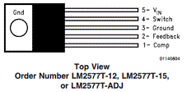  
        
      - **Comp (Pin1)** The comparator terminates the switch on time when the two voltages are equal, thereby controlling the peak switch current to maintain a constant output voltage.   
      - **Feedback (Pin2)** Feedback sense input pin. Connect to the midpoint of feedback divider to set VOUT for ADJ version or connect this pin directly to the output capacitor for a fixed output version.  
      - **Ground (Pin3)** Circuit ground pin.  
      - **Switch** **(Pin4)** This is a switching regulator used for producing an output voltage greater than the input supply voltage.  
      - **VIN (Pin5):** This pin is the positive input supply for the LM2577 step−up switching regulator.

##### **IC TP4056** Figure C – 5: IC TP4056

* + - Description  
      The TP4056 is a complete constant-current/constant-voltage linear charger for single cell lithium-ion batteries. Its SOP package and low external component count make the TP4056 ideally suited for portable applications. Furthermore, the TP4056 can work within USB and wall adapter.  
      No blocking diode is required due to the internal PMOSFET architecture and have prevent negative Charge Current Circuit. Thermal feedback regulates the charge current to limit the die temperature during high power operation or high ambient temperature. The charge voltage is fixed at 4.2V, and the charge current can be programmed externally with a single resistor. TP4056 other features include current monitor, under voltage lockout, automatic recharge and two status pin to indicate charge termination and the presence of an input voltage.
    - Features  
      - Programmable Charge Current Up to 1000mA.

- Constant-Current/Constant-Voltage.

- Charges Single Cell Li-Ion Batteries Directly from USB Port -Preset 4.2V Charge Voltage with 1.5% Accuracy.

- Automatic Recharge.

- Two Charge Status Output Pins.

* + - Application  
      - Cellular Telephones, PDAs, GPS.

- USB Bus-Powered Chargers, Chargers.

* + - Package/Pins information  
      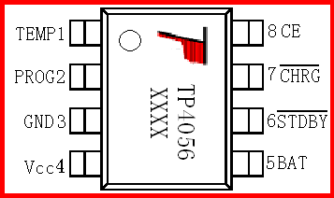  
      **TEMP (Pin 1)**: The battery’s temperature is too high or too low, charging is suspended. The temperature sense function can be disabled by grounding the TEMP pin.

**PROG (Pin 2):** Constant Charge Current Setting and Charge Current Monitor Pin charge current is set by connecting a resistor RISET from this pin to GND. The voltage on ISET pin can be used to measure the charge current as follows:

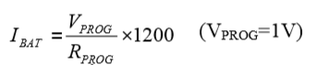

**GND (Pin3):** Ground Terminal

**Vcc (Pin 4):** Positive Input Supply Voltage VIN is the power supply to the internal circuit.

**BAT(Pin5):** Battery Connection Pin. Connect the positive terminal of the battery to BAT pin.

$\overline{STDBY}$**Pin6):** Open Drain Charge Status Output When the battery Charge Termination, the $\overline{STDBY}$ pin is pulled low by an internal switch, otherwise $\overline{STDBY}$ pin is in high impedance state.

$\overline{CHRG}$**(Pin7):** Open Drain Charge Status Output When the battery is being charged, the pin is pulled low by an internal switch, otherwise $\overline{CHRG}$ pin is in high impedance state.

$\overline{CE}$**(Pin8):** Chip Enable Input. A high input will put the device in the normal operating mode. Pulling the CE pin to low level will put the TP4056 into disable mode.

##### **IC LM324** Figure C - 6: IC LM324

* + - Description  
      The LM324 consists of four independent, high-gain, internally frequency-compensated operational amplifiers designed specifically to operate from a single power supply over a wide range of voltages.
    - Features  
      - Internally frequency-compensated for unity gain.  
      - Wide power supply range Single supply: 3VDC to 30VDC or dual supplies: ±1.5VDC to ±15VDC.  
      - Very low supply current drain: essentially independent of supply voltage (1mW/op amp at +5VDC).   
      - Differential input voltage range equal to the power supply voltage.
    - Application  
      - LM324 can be used as amplifiers, comparators, oscillators, rectifiers etc.
    - Package/Pins information  
      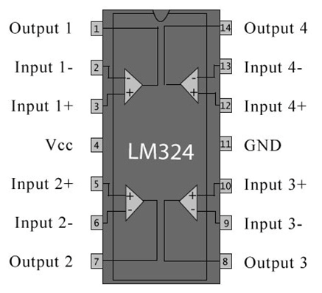

|  |  |  |
| --- | --- | --- |
| **Pin No** | **Function** | **Name** |
| 1 | Output of 1st comparator | Output 1 |
| 2 | Inverting input of 1st comparator | Input 1- |
| 3 | Non-inverting input of 1st comparator | Input 1+ |
| 4 | Supply voltage; 5V (up to 32V) | Vcc |
| 5 | Non-inverting input of 2nd comparator | Input 2+ |
| 6 | Inverting input of 2nd comparator | Input 2- |
| 7 | Output of 2nd comparator | Output 2 |
| 8 | Output of 3rd comparator | Output 3 |
| 9 | Inverting input of 3rd comparator | Input 3- |
| 10 | Non-inverting input of 3rd comparator | Input 3+ |
| 11 | Ground (0V) | Ground |
| 12 | Non-inverting input of 4th comparator | Input 4+ |
| 13 | Inverting input of 4th comparator | Input 4- |
| 14 | Output of 4th comparator | Output 4 |

##### **Buzzer** Voltage: 3.5-5.5V Current: <25mA Frequency: 2300 ± 500 Pitch: about 7.72MM Weight: 2 g

##### **Sdf**

#### Software Interface

- Application: QT C++ 5.3.2 (320x480)

- Database: MySQL

### System Overview Use Case

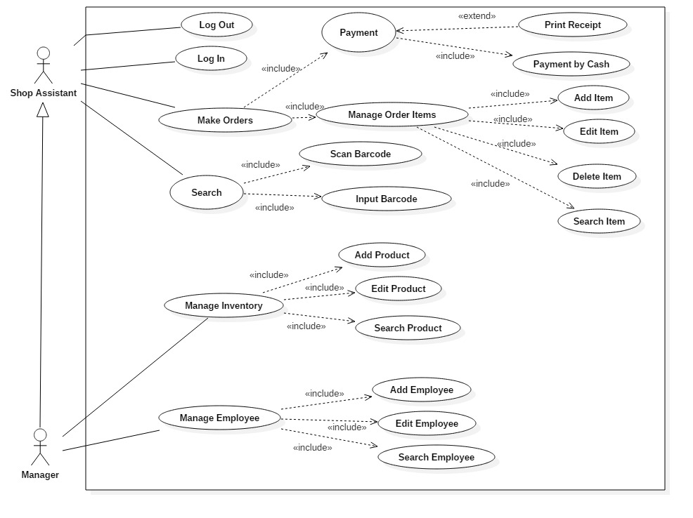

Figure C‑5: System Overview Use Case

### List of Use Case

#### <Shop Assistant> Login

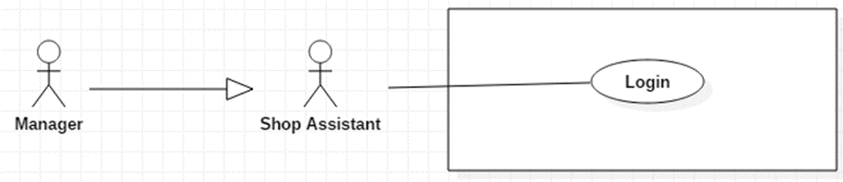

Figure C‑6: <Shop Assistant > Login

Table C-2: <Shop Assistant> Login

|  |  |  |  |
| --- | --- | --- | --- |
| **USE CASE – UC01** | | | |
| **Use Case No.** | **UC01** | **Use Case Version** | 1.0 |
| **Use Case Name** | Login | | |
| **Author** | Le Long Ho | | |
| **Date** | 27/9/2016 | **Priority** | Normal |
| **Actor:**  -Shop Assistant  **Summary:**  - This use case allows user to log in the system.  **Goal:**  - Users can log in the system.  **Triggers:**  - User sends the login command.  **Pre-conditions:**  - User must have provided account from system.  - Loading is successful.  **Post-conditions:**  - Success: User login the system. System goes to Menu screen.  - Fail: Show error message.  **Main Success Scenario:**   |  |  |  | | --- | --- | --- | | Step | Actor Action | System Response | | 1 | - User opened HPOS. | - Loading system display “Loading screen”. - System display a “Login” screen and require identity information from User: PinCode: free text input | | 2 | - User input pinCode. |  | | 3 | - Press “Login” button. | - Check validation of pinCode. - Check login data in database. - User will login system with their specific role. - LCD will display “Menu” screen. [Alternative 1] [Alternative 2] [Exception 1] |   **Alternative Scenario:**   |  |  |  | | --- | --- | --- | | No | Actor Action | System Response | | 1 | - User enter wrong identity pinCode. | - Display error message: “Wrong pinCode”. | | 2 | - User enter invalid pinCode. | - Display error message: “Invalid pinCode”. |   **Exceptions:**   |  |  |  | | --- | --- | --- | | No | Actor Action | System Response | | 1 |  | - System show message. “System is busy” when the system is maintained. |   **Relationships:**  - N/A.  **Business Rules:**  - After login to system, user will be redirected to specific view based on their role on system: manager or shop assistant.   * If role is “Manager”, the system will display to “Manager Menu” screen. * If role is “Shop Assistant”, the system will display to “Shop Assistant Menu” screen. | | | |

#### <Shop Assistant> Logout

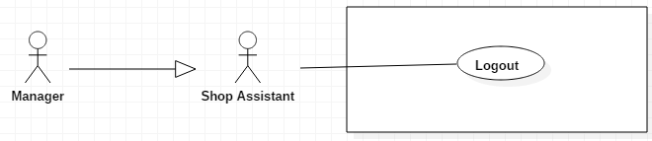

Figure C‑7: <Shop Assistant> Logout

Table C‑3: <Shop Assistant> Logout

|  |  |  |  |  |
| --- | --- | --- | --- | --- |
| **USE CASE – UC02** | | | | |
| **Use Case No.** | **UC02** | **Use Case Version** | 1.0 |
| **Use Case Name** | Logout | | |
| **Author** | Le Long Ho | | |
| **Date** | 27/9/2016 | **Priority** | High |
| **Actor:**  - Shop Assistant  **Summary:**  - This use case allows user to log out the system. **Goal:** - Users can log out the system. **Triggers:** - User sends the logout command. **Pre-conditions:** - Login is successful. **Post-conditions:** - Success: LCD will display “Login” screen. - Fail: Show error message. **Main Success Scenario:**   |  |  |  | | --- | --- | --- | | Step | Actor Action | System Response | | 1 | - Press “Logout” button on “Menu” screen. | [Exception 1]  - Redirect to “Login” screen. |   **Alternative Scenario:**  - N/A  **Exceptions:**   |  |  |  | | --- | --- | --- | | No | Actor Action | System Response | | 1 |  | - If logout failed, system show message: “System is busy”. |   **Relationships:**  - N/A.  **Business Rules:**  - N/A. | | | |

#### <Shop Assistant> Search Overview Use Case

Figure C‑8: <Shop Assistant> Search Overview Use Case

##### **<Shop Assistant> Search by Input Barcode**

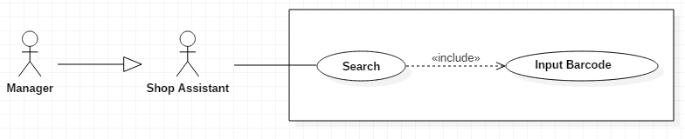

Figure C‑9:<Shop Assistant> Search by Input Barcode

Table C‑4: <Shop Assistant> Search by Input Barcode

|  |  |  |  |  |
| --- | --- | --- | --- | --- |
| **USE CASE – UC03** | | | | |
| **Use Case No.** | **UC03** | **Use Case Version** | 1.0 |
| **Use Case Name** | Input Barcode | | |
| **Author** | Le Long Ho | | |
| **Date** | 30/9/2016 | **Priority** | Normal |
| **Actor:**  - Shop Assistant  **Summary:**  - This use case allows User to search product by inputting barcode.  **Goal:**  - User can search by inputting barcode to view information or add order.  **Triggers: -** User goes to “Search” screen.  **Preconditions:**  **-** Login is successful.  **Post Conditions:**  - Success: System will display product information on “Result Search” screen.  - Fail: Show error message.  **Main Success Scenario:**   |  |  |  | | --- | --- | --- | | Step | Actor Action | System Response | | 1 | - Press “Keyboard” button on “Search” screen. | - LCD will display text field to input barcode number. | | 2 | - Enter number of barcode into text field.  [Alternative 1] [Alternative 2] [Alternative 3] [Alternative 4] | - Display product information on “Result Search” screen. [Exception1] [Exception2] |   **Alternative:**   |  |  |  | | --- | --- | --- | | No | Actor Action | System Response | | 1 | - User press “Add Cart” button. | - Add item to Cart.  - LCD will display “Search” screen. | | 2 | - User press “Menu” button. | - LCD will display “Menu” screen. | | 3 | - User press “View Cart” button. | - LCD will display “View Cart” screen. | | 4 | - User press “Back” button. | - LCD will display “Search” screen. |   **Exceptions:**   |  |  |  | | --- | --- | --- | | No | Actor Action | System Response | | 1 |  | - System show message. “Product is not found” when search barcode is no exist in database. | | 2 | - User enter invalid barcode | - System show message. “Invalid barcode”. |   **Relationships:**  - Have <<include>> relationship with “Search” use case.  **Business Rules:**  - Input barcode request will be sent to the system with inputted information.  - A notification will be sent to user after the process is completed.  - After searching user can add product to cart. - In case user cannot search by scan barcode, user will use on screen keypad or keyboard to input number of barcode. | | | |

##### **<Shop Assistant> Search by Scan Barcode**

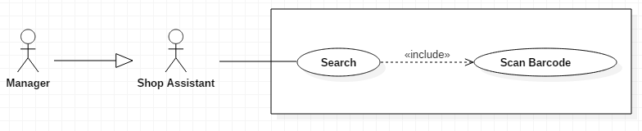

Figure C‑9: <Shop Assistant> Search by Scan Barcode

Table C‑5: <Shop Assistant> Search by Scan Barcode

|  |  |  |  |
| --- | --- | --- | --- |
| **USE CASE – UC04** | | | |
| **Use Case No.** | **UC04** | **Use Case Version** | 1.0 |
| **Use Case Name** | Scan Barcode | | |
| **Author** | Le Long Ho | | |
| **Date** | 1/10/2016 | **Priority** | Normal |
| **Actor:**  - Shop Assistant  **Summary:**  - This use case allows User to search information by barcode scanning.  **Goal:**  - User can use barcode scanning to search information.  **Triggers:**  - User goes to “Search” screen.  **Preconditions:**  - Login is successful.  - Camera connect to system.  **Post Conditions:**  - Success: System will display product information on “Result Search” screen.  - Fail: Show error message.  **Main Success Scenario:**   |  |  |  | | --- | --- | --- | | Step | Actor Action | System Response | | 1 | - User goes to Menu screen and press “Search” button. | - LCD will display “Search” screen. | | 2 | - Press “Scan” button. | - LCD will display “Scan” screen. | | 2 | - Scanning the barcode.    [Alternative 1] [Alternative 2] [Alternative 3] [Alternative 4] | - Search barcode in database.  - Get information of product. - Display product information on “Result Search” screen. [Exception 1] |   **Alternative:**   |  |  |  | | --- | --- | --- | | No | Actor Action | System Response | | 1 | - User press “Add Cart” button. | - Add item to Cart.  - LCD will display “Search” screen. | | 2 | - User press “Menu” button. | - LCD will display “Menu” screen. | | 3 | - User press “View Cart” button. | - LCD will display “View Cart” screen | | 4 | - User press “Back” button. | - LCD will display “Search” screen. |   **Exceptions:**   |  |  |  | | --- | --- | --- | | Step | Actor Action | System Response | | 1 | - If barcode scanning is failed. | - System show message. “Product is not found”. |   **Relationships:**  - Have <<include>> relationship with “Search” use case.  **Business Rules:**  - System update status of the “Search” screen from “Scanning” to “number barcode”. - A notification will be sent to user after the process is completed. - After searching, user can add product to cart. - In case user cannot “Search” by scan barcode, user will use on screen keypad or keyboard to input number of barcode to search. | | | |

#### <Shop Assistant> Manage Oder Items Overview Use Case

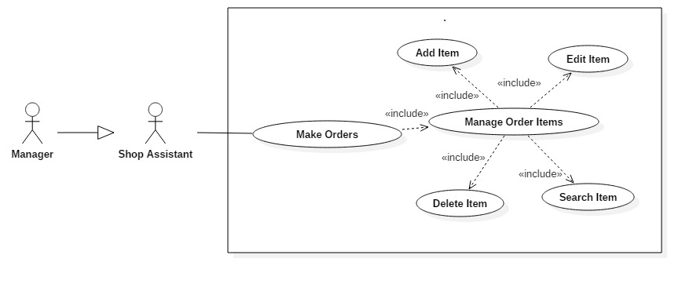

Figure C‑10: <Shop Assistant> Manage Oder Items Overview Use Case

##### **<Shop Assistant> Add Item**

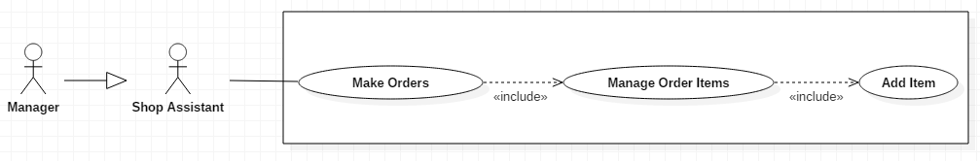

Figure C‑11: <Shop Assistant> Add Item

Table C‑6: <Shop Assistant> Add Item

|  |  |  |  |  |
| --- | --- | --- | --- | --- |
| **USE CASE – UC05** | | | | |
| **Use Case No.** | **UC05** | **Use Case Version** | 1.0 |
| **Use Case Name** | Add Item | | |
| **Author** | Le Long Ho | | |
| **Date** | 3/10/2016 | **Priority** | Normal |
| **Actor:**  - Shop Assistant  **Summary:**  - This use case allows User to add new item to cart.  **Goal:** - Add new item after view information.  **Triggers:** - User scan barcode. - User input number barcode.  **Preconditions:** - Have product on “Result Search” screen.  **Post Conditions:** - Success: Add new item to cart and user can view on “View Cart” screen.- Fail: Show error message.  **Main Success Scenario:**   |  |  |  | | --- | --- | --- | | Step | Actor Action | System Response | | 1 | - User press “Add Order” button on “Result Search” screen.  [Alternative 1] [Alternative 2] [Alternative 3] [Alternative 4] | - Added item to Cart.  - Calculate total and tax.  - LCD will display “Search” screen. [Exception 1] [Exception 2] |   **Alternative:**   |  |  |  | | --- | --- | --- | | No | Actor Action | System Response | | 1 | - User press “Add Cart” button. | - Add item to Cart.  - LCD will display “Search” screen. | | 2 | - User press “Menu” button. | - LCD will display “Menu” screen. | | 3 | - User press “View Cart” button. | - LCD will display “View Cart” screen | | 4 | - User press “Back” button. | - LCD will display “Search” screen. |   **Exceptions:**   |  |  |  | | --- | --- | --- | | Step | Actor Action | System Response | | 1 | - If add item failed. | - System show message to notify user that add item failed and renew request has been aborted. | | 2 | - Available quantity less than or equal to zero after edit item. | - Display error message: “Not enough product”. |   **Relationships:**  - Have << include>> relationship with “Manage Order Item” use case.  **Business Rules:**  - Total would be calculated. | | | |

##### **<Shop Assistant> Edit Item**

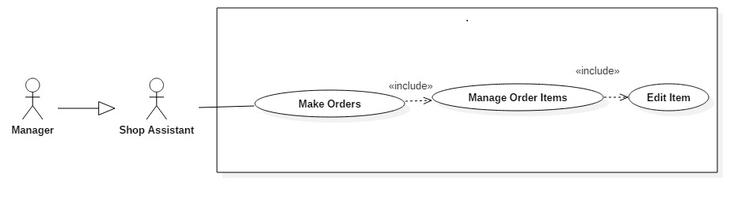

Figure C‑12: <Shop Assistant> Edit Item

Table C‑7: <Shop Assistant> Edit Item

|  |  |  |  |
| --- | --- | --- | --- |
| **USE CASE – UC06** | | | |
| **Use Case No.** | **UC06** | **Use Case Version** | 1.0 |
| **Use Case Name** | Edit Item | | |
| **Author** | Le Long Ho | | |
| **Date** | 3/10/2016 | **Priority** | Normal |
| **Actor:**  - Shop Assistant  **Summary:**  - This use case allows User to edit quantity of item in order list.  **Goal:** - User can edit quantity of item after add item in order list.  **Triggers:**  - Choose item in “View Cart” screen.  **Preconditions:**  - User have available item in order list.  **Post Conditions:**  - Success: Edit quantity of item in order list and user can view on “View Cart” screen.  - Fail: Show error message.  **Main Success Scenario:**   |  |  |  | | --- | --- | --- | | Step | Actor Action | System Response | | 1 | - User click one item in order list on “View Cart” screen. | - LCD will display “Input by Virtual Keyboard” screen. | | 2 | - Input new quantity.  - Press “Enter” button.      [Alternative 1] [Alternative 2] [Alternative 3] [Alternative 4] | - Checking inventory quantity.  - Calculate total of order.  - LCD will display “View Cart” screen. [Exception 1] |   **Alternative:**   |  |  |  | | --- | --- | --- | | No | Actor Action | System Response | | 1 | - User press “Add Cart” button. | - Add item to Cart.  - LCD will display “Search” screen. | | 2 | - User press “Menu” button. | - LCD will display “Menu” screen. | | 3 | - User press “View Cart” button. | - LCD will display “View Cart” screen. | | 4 | - User press “Back” button. | - LCD will display “Search” screen. |   **Exceptions:**   |  |  |  | | --- | --- | --- | | No | Actor Action | System Response | | 1 | - Available quantity less than or equal to zero after edit item. | - Display error message: “Not enough product to add”. |   **Relationships:**  - Have << include >> relationship with “Manage Order Item” use case.  **Business Rules:**  - Total would be calculated. | | | |

##### **<Shop Assistant> Delete Item**

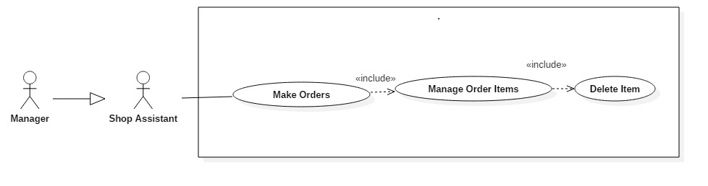

Figure C‑13: <Shop Assistant> Delete Item

Table C‑8: <Shop Assistant, Manager> Delete Item

|  |  |  |  |  |
| --- | --- | --- | --- | --- |
| **USE CASE – UC07** | | | | |
| **Use Case No.** | **UC07** | **Use Case Version** | 1.0 |
| **Use Case Name** | Delete Item | | |
| **Author** | Le Long Ho | | |
| **Date** | 3/10/2016 | **Priority** | Normal |
| **Actor:**  - Manager  - Shop Assistant  **Summary:**  - This use case allows User to delete item in order list.  **Goal:**  - User can delete item in order list.  **Triggers:**  - Choose item in “View Cart” screen.  - User press “Delete” button.  **Preconditions:**  - User have available cart.  **Post Conditions:**  - Success: Delete item in order list. User can view on “View Cart” screen after delete item.  - Fail: Show error message.  **Main Success Scenario:**   |  |  |  | | --- | --- | --- | | Step | Actor Action | System Response | | 1 | - User press “Delete Item” button on “View Cart” screen.  [Alternative 1] [Alternative 2] [Alternative 3] [Alternative 4] | - Delete item in order list.  - Calculate total of order.  - LCD will display “View Cart” screen. [Exception 1] |   **Alternative:**   |  |  |  | | --- | --- | --- | | No | Actor Action | System Response | | 1 | - User press “Add Cart” button. | - Add item to Cart.  - LCD will display “Search” screen. | | 2 | - User press “Menu” button. | - LCD will display “Menu” screen. | | 3 | - User press “View Cart” button. | - LCD will display “View Cart” screen. | | 4 | - User press “Back” button. | - LCD will display “Search” screen. |   **Exceptions:**   |  |  |  | | --- | --- | --- | | No | Actor Action | System Response | | 1 |  | - System show message to notify user that delete item failed. |   **Relationships:**  - Have <<include>> relationship with “Manage Order Item” use case.  **Business Rules:**  - Total and tax would be calculated. | | | |

##### **<Shop Assistant> Search Item**

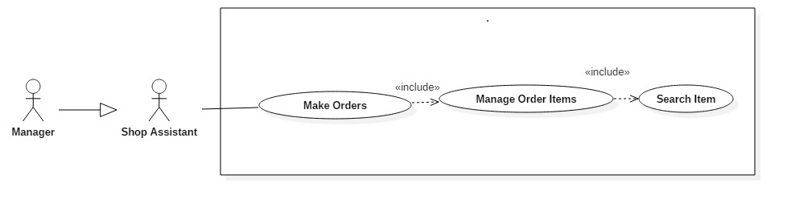

Figure C‑14: < Shop Assistant> Search Item

Table C‑9: < Shop Assistant> Search Item

|  |  |  |  |
| --- | --- | --- | --- |
| **USE CASE – UC08** | | | |
| **Use Case No.** | **UC08** | **Use Case Version** | 1.0 | |
| **Use Case Name** | Search Item | | | |
| **Author** | Le Long Ho | | | |
| **Date** | 3/10/2016 | **Priority** | Normal | |
| **Actor:**  - Shop Assistant  **Summary:**  - This use case allows User to search item in order list.  **Goal:**  - User can search item in order list.  **Triggers:**  - User press “Search” button in “View Cart” screen.  **Preconditions:**  - User have available product in order list.  **Post Conditions:**  - Success: User can view on “View Cart” screen after search item.  - Fail: Show error message.  **Main Success Scenario:**   |  |  |  | | --- | --- | --- | | Step | Actor Action | System Response | | 1 | - User press “Search Item” button on “View Cart” screen.    [Alternative 1] [Alternative 2] [Alternative 3] [Alternative 4] | - LCD will display “View Cart” screen. [Exception 1] |   **Alternative:**   |  |  |  | | --- | --- | --- | | No | Actor Action | System Response | | 1 | - User press “Add Cart” button. | - Add item to Cart.  - LCD will display “Search” screen. | | 2 | - User press “Menu” button. | - LCD will display “Menu” screen. | | 3 | - User press “View Cart” button. | - LCD will display “View Cart” screen. | | 4 | - User press “Back” button. | - LCD will display “Search” screen. |   **Exceptions:**   |  |  |  | | --- | --- | --- | | Step | Actor Action | System Response | | 1 |  | - System show message. “Product is not found” when search failed. |   **Relationships:**  - Have <<include>> relationship with “Manage Order Item” use case.  **Business Rules:**  - System update status of the “View Cart” screen from “Searching” to view item. | | | | |

#### <Shop Assistant> Payment Overview Use Case

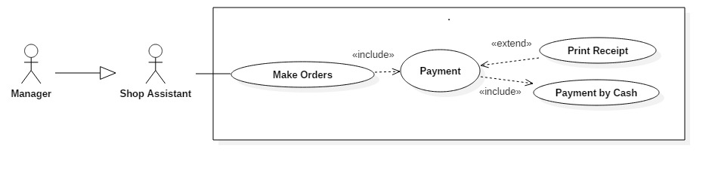

Figure C‑15: <Shop Assistant> Payment Overview Use Case

##### **<Shop Assistant>Payment by Cash**

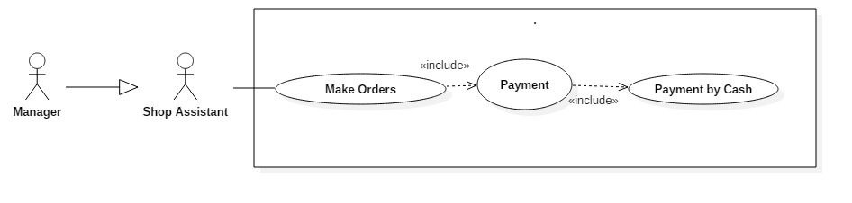

Figure C‑18: <Shop Assistant>Payment by Cash

Table C‑10: <Shop Assistant>Payment by Cash

|  |  |  |  |
| --- | --- | --- | --- |
| **USE CASE – UC09** | | | |
| **Use Case No.** | **UC09** | **Use Case Version** | 1.0 |
| **Use Case Name** | Payment by Cash | | |
| **Author** | Le Long Ho | | |
| **Date** | 3/10/2016 | **Priority** | Normal |
| **Actor:**  - Shop Assistant  **Summary:**  - This use case allows User to use “Payment by Cash” function.  **Goal:**  - User can input cash and return change to customer.  **Triggers:**  - User press “Payment” button.  **Preconditions:**  - User goes to “View Cart” screen.  **Post Conditions:**  - Success: System will display total and change on “Payment” screen.  - Fail: Display a popup message of error.  **Main Success Scenario:**   |  |  |  | | --- | --- | --- | | Step | Actor Action | System Response | | 1 | - Press “Payment” button on “View Cart” screen. | - Calculate total and tax.  - Push total to “Payment” screen. | | 2 | - User input number of cash in text field on “Payment” screen.    -Press “Submit” button.  [Alternative 1] [Alternative 2] [Alternative 3] | - Calculate change and return change.  - Push change to “Payment” screen.  - LCD will display “Payment” screen.  -LCD will display “Receipt” screen. |   **Alternative:**   |  |  |  | | --- | --- | --- | | Step | Actor Action | System Response | | 1 | User press “Print” button. | Print receipt by printer. | | 2 | User press “Menu” button. | LCD will display “Menu” screen. | | 3 | User press “Back” button. | LCD will display “View Cart” screen. |   **Exceptions:**  -N/A  **Relationships:**  - Have <<include>> relationship with “Payment” use case.  **Business Rules:**  - N/A. | | | |

##### **<Shop Assistant> Print Receipt**

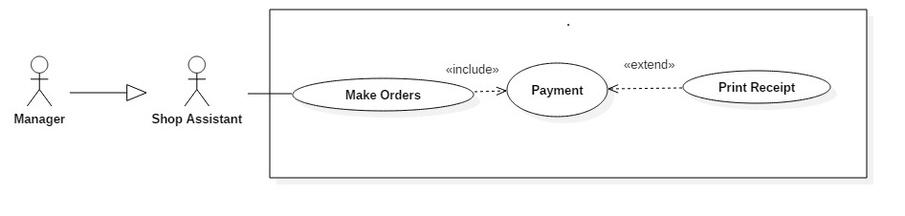

Figure C‑16: <Shop Assistant> Print Receipt

Table C‑11: <Shop Assistant> Print Receipt

|  |  |  |  |  |
| --- | --- | --- | --- | --- |
| **USE CASE – UC10** | | | | |
| **Use Case No.** | **UC10** | **Use Case Version** | 1.0 |
| **Use Case Name** | Print Receipt | | |
| **Author** | Le Long Ho | | |
| **Date** | 3/10/2016 | **Priority** | Normal |
| **Actor:**  - Shop Assistant  **Summary:**  - This use case allows User to use “Print Receipt” function.  **Goal:**  - User can print receipt after payment.  **Triggers:**  - User press “Print” button.  **Preconditions:**  - User goes to “Payment” screen.  **Post Conditions:**  - Success: System will display total and change on “Payment” screen.  - Fail: Display a popup message of error.  **Main Success Scenario:**   |  |  |  | | --- | --- | --- | | Step | Actor Action | System Response | | 1 | - Press “Print” button on “Payment” screen.    [Alternative 1] [Alternative 2] [Alternative 3] | - Connect Printer.  - Get information on database.  - Print receipt. |   **Alternative:**   |  |  |  | | --- | --- | --- | | Step | Actor Action | System Response | | 1 | User press “Submit” button. | LCD will display “Receipt” screen. | | 2 | User press “Menu” button. | LCD will display “Menu” screen. | | 3 | User press “Back” button. | LCD will display “View Cart” screen. |   **Exceptions:**  - Not connect to printer.  **Relationships:**  - Have <<extend>> relationship with “Payment” use case.  **Business Rules:**  - N/A. | | | |

#### <Manager> Manage Inventory Overview Use case

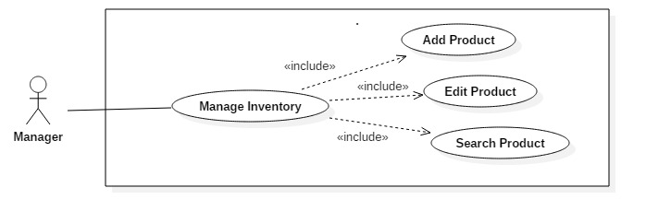

Figure C‑17 < Manager> Manage Inventory Overview Use case

##### **<Manager> Add product**

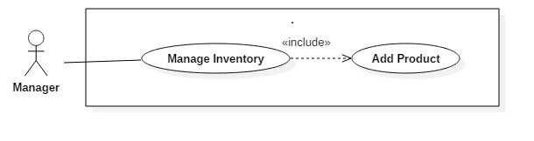

Figure C‑21: <Manager> Add product

Table C‑12: <Manager> Add product

|  |  |  |  |
| --- | --- | --- | --- |
| **USE CASE – UC11** | | | |
| **Use Case No.** | **UC11** | **Use Case Version** | 1.0 |
| **Use Case Name** | Add Product | | |
| **Author** | Le Long Ho | | |
| **Date** | 3/10/2016 | **Priority** | Normal |
| **Actor:**  - Manager  **Summary:**  - This use case allows Manager to add new product to inventory.  **Goal:**  - Add new product.  - In case user can not add product by scanning barcode, user will use on screen keypad or keyboard to input number of barcode to add product.  **Triggers:** - User press “Add Product” button.  **Preconditions:**  - User is manager.  - User goes to “Manage Inventory” screen.  **Post Conditions:**  - Success: Add new product to database.  - Fail: Show error message.  **Main Success Scenario:**   |  |  |  | | --- | --- | --- | | Step | Actor Action | System Response | | 1 | - Scan barcode. |  | | 2 | - Input quantity (default =1) |  | | 3 | - User press “Add Product” button.  [Alternative 1] [Alternative 2] [Alternative 3] [Alternative 4] | - Added product to Database. |   **Alternative:**   |  |  |  | | --- | --- | --- | | No | Actor Action | System Response | | 1 | User press “Add Cart” button. | Add item to Cart.  LCD will display “Search” screen. | | 2 | User press “Menu” button. | LCD will display “Menu” screen. | | 3 | User press “View Cart” button. | LCD will display “View Cart” screen | | 4 | User press “Back” button. | LCD will display “Search” screen. |   **Exceptions:**  -N/A  **Relationships:**  - Have << include>> relationship with “Manage Inventory” use case.  **Business Rules:**  - N/A | | | |

##### **<Manager> Edit product**

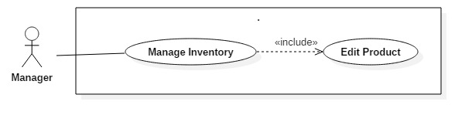

Figure C‑18: <Manager>Edit product

Table C‑13: <Manager>Edit product

|  |  |  |  |
| --- | --- | --- | --- |
| **USE CASE – UC12** | | | |
| **Use Case No.** | **UC12** | **Use Case Version** | 1.0 |
| **Use Case Name** | Edit Product | | |
| **Author** | Le Long Ho | | |
| **Date** | 3/10/2016 | **Priority** | Normal |
| **Actor:**  - Manager  **Summary:**  - This use case allows User to edit product in inventory.  **Goal:** - User can edit product in inventory.  **Triggers:**  - User choose product in “Manage Inventory” screen.  **Preconditions:**  - User is manager.  - User goes to “Manage Inventory” screen.  **Post Conditions:**  - Success: Edit product’s information on “Manage Inventory” screen.  - Fail: Show error message.  **Main Success Scenario:**   |  |  |  | | --- | --- | --- | | Step | Actor Action | System Response | | 1 | - User click item on “Manage Inventory” screen. | - LCD will display “Input by Virtual Keyboard” screen. | | 2 | - Input new information.  - Press “Enter” button.  [Alternative 1] [Alternative 2] [Alternative 3] [Alternative 4] | - LCD will display “Manage Inventory” screen with new information. |   **Alternative:**   |  |  |  | | --- | --- | --- | | No | Actor Action | System Response | | 1 | User press “Add Cart” button. | Add item to Cart.  LCD will display “Search” screen. | | 2 | User press “Menu” button. | LCD will display “Menu” screen. | | 3 | User press “View Cart” button. | LCD will display “View Cart” screen. | | 4 | User press “Back” button. | LCD will display “Search” screen. |   **Exceptions:**   |  |  |  | | --- | --- | --- | | No | Actor Action | System Response | | 1 |  | Display error message: “Cannot change the information” textbox. |   **Relationships:**  - Have << include >> relationship with “Manage Inventory” use case.  **Business Rules:**  - N/A | | | |

##### **<Manager>Search Product**

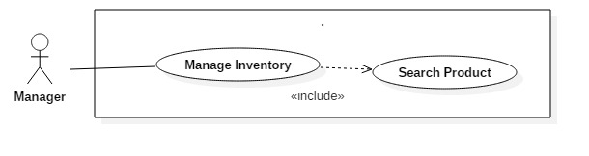

Figure C‑19: <Manager>Search Product

Table C‑14: <Manager>Search Product

|  |  |  |  |
| --- | --- | --- | --- |
| **USE CASE – UC13** | | | |
| **Use Case No.** | **UC13** | **Use Case Version** | 1.0 |
| **Use Case Name** | Search Product | | |
| **Author** | Le Long Ho | | |
| **Date** | 3/10/2016 | **Priority** | Normal |
| **Actor:**  - Manager  **Summary:**  - This use case allows User to search product in inventory.  **Goal:** - User can search product in inventory.  **Triggers:** - User press “Search” button.  **Preconditions:**  - User is manager.  - User goes to “Manage Inventory” screen.  - Have available product.  **Post Conditions:**  - Success: User can search product’s information.  - Fail: Show error message.  **Main Success Scenario:**   |  |  |  | | --- | --- | --- | | Step | Actor Action | System Response | | 1 | - User press “Search” button on “Manage Inventory” screen. | - LCD will display “Search Product” screen. | | 2 | - Input product’s information to search.  [Alternative 1] [Alternative 2] [Alternative 3] [Alternative 4] | - Get information on database.  -Show product’s information on “Search Product” screen. |   **Alternative:**   |  |  |  | | --- | --- | --- | | No | Actor Action | System Response | | 1 | User press “Add Cart” button. | Add item to Cart.  LCD will display “Search” screen. | | 2 | User press “Menu” button. | LCD will display “Menu” screen. | | 3 | User press “View Cart” button. | LCD will display “View Cart” screen. | | 4 | User press “Back” button. | LCD will display “Search” screen. |   **Exceptions:**  -N/A  **Relationships:**  - Have <<include>> relationship with “Manage Inventory” use case.  **Business Rules:**  - N/A | | | |

#### <Manager>Manage Employee Overview Use Case

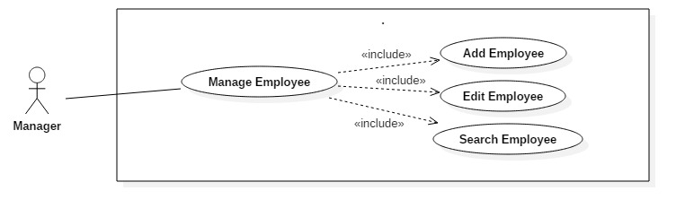

Figure C‑20: < Manager>Manage Employee Overview Use Case

##### **<Manager> Add Employee**

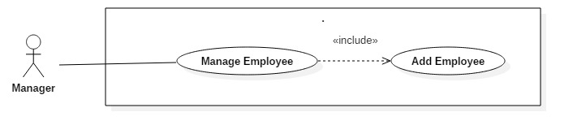

Figure C‑21: <Manager> Add Employee

Table C‑15: <Manager> Add Employee

|  |  |  |  |
| --- | --- | --- | --- |
| **USE CASE – UC14** | | | |
| **Use Case No.** | **UC14** | **Use Case Version** | 1.0 |
| **Use Case Name** | Add Employee | | |
| **Author** | Le Long Ho | | |
| **Date** | 3/10/2016 | **Priority** | Normal |
| **Actor:**  - Manager  **Summary:**  - This use case allows User to add new employee to database.  **Goal:** - Add new employee to database.  **Triggers:**  - User press “Add Employee” button.  **Preconditions:**  - User is manager.  - User goes to “Manage Employee” screen.  **Post Conditions:**  - Success: Add new employee to database. New employee can sign in system.  - Fail: Show error message.  **Main Success Scenario:**   |  |  |  | | --- | --- | --- | | Step | Actor Action | System Response | | 1 | - User press “Manage Employee” button on “Menu” screen. | - LCD will display “Manage Employee” screen. | | 2 | - User press “Add Employee” button. | - LCD will display “Input by Virtual Keyboard” screen. | | 3 | - Input new employee’s information. - User press “Submit” button  [Alternative 1] [Alternative 2] [Alternative 3] | - Added new employee to database.  - LCD will display “Manage Employee” screen. |   **Alternative:**   |  |  |  | | --- | --- | --- | | No | Actor Action | System Response | | 1 | User press “Add Employee” button. | Add employee to database.  LCD will display “Manage Inventory” screen. | | 2 | User press “Menu” button. | LCD will display “Menu” screen. | | 3 | User press “Back” button. | LCD will display “Search” screen. |   **Exceptions:**  -N/A  **Relationships:**  - Have << include>> relationship with “Manage Employee” use case.  **Business Rules:**  - N/A | | | |

##### **<Manager>Edit Employee**

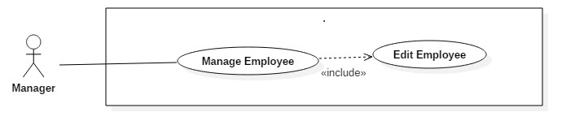

Figure C‑22: <Manager>Edit Employee

Table C‑16: <Manager>Edit Employee

|  |  |  |  |
| --- | --- | --- | --- |
| **USE CASE – UC15** | | | |
| **Use Case No.** | **UC15** | **Use Case Version** | 1.0 |
| **Use Case Name** | Edit Employee | | |
| **Author** | Le Long Ho | | |
| **Date** | 3/10/2016 | **Priority** | Normal |
| **Actor:**  - Manager  **Summary:**  - This use case allows User to edit employee in inventory.  **Goal:** - User can edit product in inventory.  **Triggers:**  - User choose employee in “Manage Employee” screen.  **Preconditions:**  - User is manager.  **Post Conditions:**  - Success: Edit information of employee and save to database.  - Fail: Show error message.  **Main Success Scenario:**   |  |  |  | | --- | --- | --- | | Step | Actor Action | System Response | | 1 | - User click employee on “Manage Employee” screen. | - LCD will display “Input by Virtual Keyboard” screen. | | 2 | - Input new information.  - Press “Enter” button.    [Alternative 1] [Alternative 2] [Alternative 3] [Alternative 4] | - LCD will display “Manage Employee” screen with new information. [Exception 1] |   **Alternative:**   |  |  |  | | --- | --- | --- | | No | Actor Action | System Response | | 1 | User press “Add Cart” button. | Add item to Cart.  LCD will display “Search” screen. | | 2 | User press “Menu” button. | LCD will display “Menu” screen. | | 3 | User press “View Cart” button. | LCD will display “View Cart” screen. | | 4 | User press “Back” button. | LCD will display “Search” screen. |   **Exceptions:**   |  |  |  | | --- | --- | --- | | No | Actor Action | System Response | | 1 |  | Display error message: “Cannot change the information” textbox. |   **Relationships:**  - Have << include >> relationship with “Manage Employee” use case.  **Business Rules:**  - N/A | | | |

##### **<Manager>Search Employee**

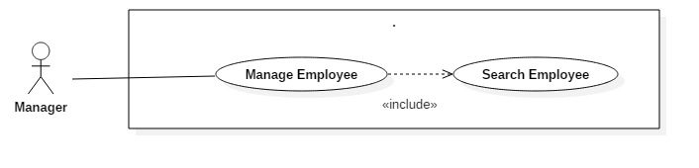

Figure C‑23: < Manager>Search Employee

###### Table C‑17: < Manager>Search Employee

|  |  |  |  |
| --- | --- | --- | --- |
| **USE CASE – UC16** | | | |
| **Use Case No.** | **UC16** | **Use Case Version** | 1.0 |
| **Use Case Name** | Search Employee | | |
| **Author** | Le Long Ho | | |
| **Date** | 3/10/2016 | **Priority** | Normal |
| **Actor:**  - Manager  **Summary:**  - This use case allows User to search item in order list.  **Goal:** - User can search item in order list.  **Triggers:**  - User is manager. - User press “Search” button.  **Preconditions:**  - User have available product in order list.  **Post Conditions:**  - Success: User can view on “View Cart” screen after search item.  - Fail: Show error message.  **Main Success Scenario:**   |  |  |  | | --- | --- | --- | | Step | Actor Action | System Response | | 1 | - User press “Search Item” button on “View Cart” screen.  [Alternative 1] [Alternative 2] [Alternative 3] [Alternative 4] | - LCD will display “View Cart” screen. |   **Alternative:**   |  |  |  | | --- | --- | --- | | No | Actor Action | System Response | | 1 | User press “Add Cart” button. | Add item to Cart.  LCD will display “Search” screen. | | 2 | User press “Menu” button. | LCD will display “Menu” screen. | | 3 | User press “View Cart” button. | LCD will display “View Cart” screen. | | 4 | User press “Back” button. | LCD will display “Search” screen. |   **Exceptions:**  -N/A  **Relationships:**  - Have <<include>> relationship with “Manage Employee” use case.  **Business Rules:**  - N/A | | | |

## Software And Hardware System Attribute

### Reliability

* System is expected to run continuously for years without errors (or in some cases recover by themselves if an error occurs).
* System can safely be shut down for repair, or another way to repair without stopping system.
* The system shall never crash or hang, other than as the result of a network error.
* Mean Time Between Failures (MTBF): The acceptable failure is once a year.
* Mean Time to Repair (MTTR): When the failure occurs, it should take at least time as possible to repair.
* The acceptable mean time for a particular failure must be least than 1 minute.

### Availability

* The system will be use battery which can supply power up to 8 hours.
* When the power comes back, backup batter will be charged into 3 hours.
* When the system goes in under-maintenance, the application will display message “System is maintaining at the moment. Please check again later”.

### Security

* Guarantee the data and application protection from being stolen and modified by encoding and decoding data.

### Maintainability

* When one of component parts is broken, it is easy to fix the problem by changing a new one.
* All code shall be fully documented. All program files shall include comments concerning authorship and date of last change.

### Performance

This is the system's performance characteristics:

* Capacity: end users at the same time.
* Response time for a transaction:
* Average: 3 second
* Maximum: 10 seconds

### Usability

* The system is intuitive and easy to use.
* System provides user friendly GUI with guideline.
* All the texts, label, and message will be written in English.

# **Report No. 4 Software Design Description**

## Design Overview

* This document describes the technical and user interface design of HPOS System. It includes the architectural design, the detailed design of common functions and business functions.
* The architectural design describes the overall architecture of the system and the architecture of each main component and subsystem.
* The detailed design describes static and dynamic structure for each component and functions. It includes class diagrams, class explanations and sequence diagrams for each use cases.
* Document overview:
* Section 2: gives an overall description of the system architecture design.
* Section 3: gives component diagrams that describe the connection and integration of the system.
* Section 4: gives the detail design description which includes class diagram, class explanation, and sequence diagram to details the application functions.
* Section 5: describe screens design.
* Section 6: describe a fully attributed ERD.
* Section 7: describe algorithms.

## System Architecture Design

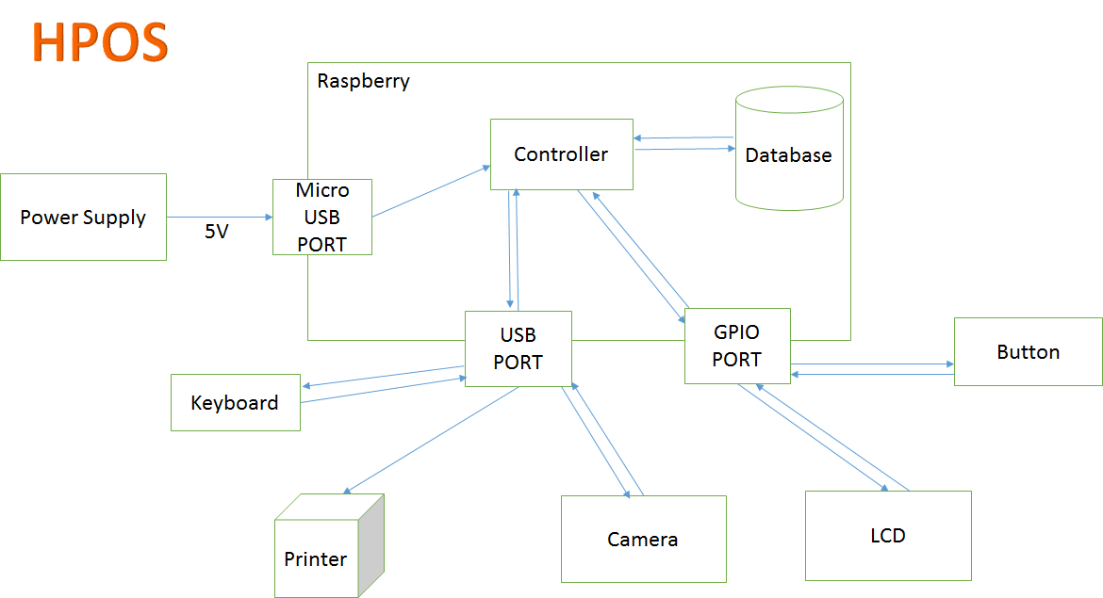

Figure D‑1: System Architecture Design

### 

Figure D‑2: System Architecture Design

### Software Architecture Description

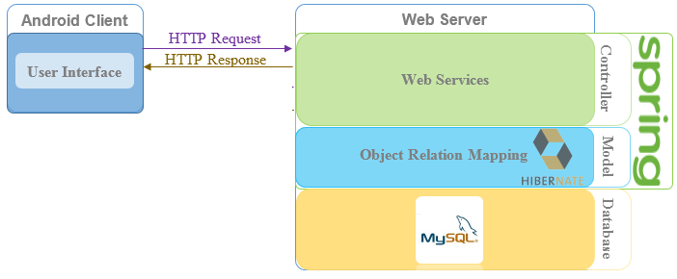

Figure D‑2: Software Architecture Description

There are two parts in software architecture of this system: Android application and Web Server.

+ Android application is developed by JAVA language programing with Android Studio. This application is used to show all user interface, request and response data with web server via Internet.

+ Web server is developed under Spring MVC – Hibernate architecture style. We choose this architecture because of following advantages:

- Web application contains Web services with MVC architecture; we can separate business code with Controller and Model. Therefore, we can use the business code in web service without repeat the code.

- We can organize the code better for maintainability, extensibility, reusability so we can expand the scope to other kind of illnesses such as flu, fever...

- In scope of 3-members team, MVC architecture makes it easier to split the big project into small modules and make it easier to assign each module for members in our team.

This project follows MVC architecture with following components:

Controller is the part of the web server that acts like event handler to handles user interaction. Web Controller is the parts of the controller that acts like event handler for web and server communication via HTTP protocol.

Model is the parts of the web server that acts like a data transfer object between the system and database, handle business of system. Business is the parts of the model that do business processing to solve domain problems.

Business Component is the parts of the business that do business of system.

Business Objects is the parts of the business that define some objects to use in business component.

### Hardware Architecture Description

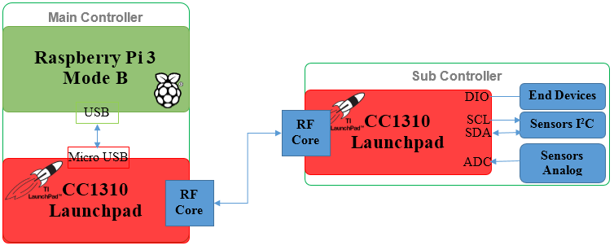

Figure D‑3: Hardware Architecture Description

The hardware architecture contains two parts: Main Controller and Sub Controller. Main Controller connects with Web Server via Wi-Fi and with Sub Controller via RF.

#### Main Controller Detail Design Description

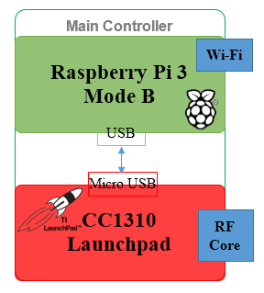

Figure D‑4: Main Controller Detail Design Description

Main Controller includes Raspberry Pi 3 and CC1310 Launchpad. We use UART Serial Port to communicate data between them. Raspberry Pi 3 connects with Web server via HTTP request and HTTP response. CC1310 send and receive data to Sub Controller via RF which created by RF core in each CC1310 at nodes.

CC1310 at Main Controller is used to communicate with Sub Controller at nodes via RF Core.

##### **Raspberry Pi 3**

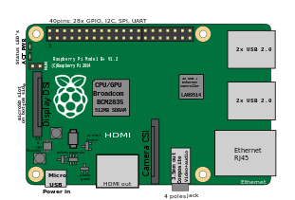

Figure D‑5: Raspberry Pi 3 Overview

**Overview:** Raspberry Pi 3 is a powerful mini computer, which is use Broadcom BCM 43438 chip to provide 2.4 GHz 802.11b/g/n wireless LAN. It is easy to connect hardware system with a Wi-Fi network. Raspberry Pi 3 plays a role as router or gateway to request and response with Webserver. There are four USB serial ports, which allow transfer and receive data with other MCUs more simple because it has a serial port library on Raspberry. MCUs just send and receive packet via UART through serial ports with Raspberry.

**Detail Specifications:** Here are functions that used in system.

Table D‑1: Detail Description of Raspberry Pi 3

|  |  |
| --- | --- |
| Specifications | |
| System on Chip  (SoC) | Broadcom BCM2837  1.2GHz Quad-Core ARM Cortex-A53 |
| CPU | 4x ARM Cortex-A53, 1.2GHz |
| RAM | 1GB LPDDR2 (900 MHz) |
| Networking | Broadcom BCM 43438 chip to provide 2.4 GHz 802.11b/g/n wireless LAN |
| Storage | micro SD |
| Ports | 4 x USB 2.0 |
| Power ratings | 800mA (4.0W) |
| Power source | 5V, 2.5A via Micro USB or GPIO header |
| Size | 85.60 * 56.5 mm (3.370 x 2.224 in) |
| Weight | 45g |

##### **CC1310 Launchpad**

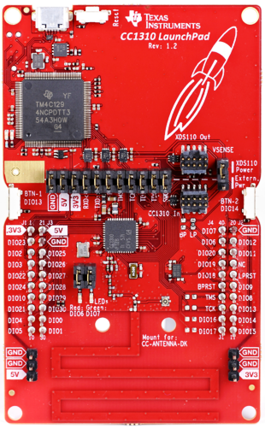

Figure D‑6: CC1310 LaunchPad Overview

**Overview:** This is the first kit Launchpad with a Sub-1 GHz radio, which offers long-range connectivity, combined with a 32-bit ARM Cortex-M3 processor on a single chip. It is a wireless MCU targeting low power, long-range wireless applications. LaunchPad with Sub-1GHz radio for wireless applications with integrated PCB trace antenna Broadband antenna supports both 868 MHz ISM band for Europe and 915 MHz ISM band for US with a single board. The CC1310 device combines a flexible, very low power RF transceiver with a powerful 48-MHz Cortex-M3 microcontroller in a platform supporting multiple physical layers and RF standards. A dedicated Radio Controller (Cortex-M0) handles low-level RF protocol commands that are stored in ROM or RAM, thus ensuring ultralow power and flexibility. The low-power consumption of the CC1310 device does not come at the expense of RF performance; the CC1310 device has excellent sensitivity and robustness (selectivity and blocking) performance.

**Detail Specifications:** Here are functions that used in Main Controller.

Table D‑2: Detail Description of CC1310 LaunchPad in Main Controller

|  |  |
| --- | --- |
| Specifications | |
| Microcontroller | ARM Cortex M3 48 MHz |
| Memory | 128 KB Flash + 128 KB ROM  20 + 2 + 8 KB SRAM |
| Wireless Protocol | IEEE 802.15.4g/e proprietary Sub-1 GHz radio |
| Networking | Broadcom BCM 43438 chip to provide 2.4 GHz 802.11b/g/n wireless LAN |
| Low Power | Wide Supply Voltage Range: 1.8 to 3.8 V  Active-Mode RX: 5.5 mA  Active-Mode TX at +10 dBm: 12.9 mA  Active-Mode MCU 48 MHz Running Coremark:  2.5 mA (51 µA/MHz)  Active-Mode MCU: 48.5 CoreMark/mA  Active-Mode Sensor Controller at 24 MHz:  0.4 mA + 8.2 µA/MHz  Sensor Controller, One Wake Up Every Second  Performing One 12-Bit ADC Sampling: 0.85 µA  Standby: 0.6 µA (RTC Running and RAM and  CPU Retention)  Shutdown: 185 nA (Wakeup on External Events) |
| RF Section | Excellent Receiver Sensitivity –124 dBm Using  Long-Range Mode, –110 dBm at 50 kbps  Excellent Selectivity: 52 dB  Excellent Blocking Performance: 90 dB  Programmable Output Power up to +14 dBm  Single-Ended or Differential RF Interface  Suitable for Systems Targeting Compliance With  Worldwide Radio Frequency Regulations  ETSI EN 300 220, EN 303 131,  EN 303 204 (Europe)  FCC CFR47 Part 15 (US)  ARIB STD-T108 (Japan)  Wireless M-Bus and IEEE 802.15.4g PHY |
| Power source | 5V, 0.5A - 3A via Micro USB or DIO pin |
| Size |  |

#### Sub Controller Detail Design Description

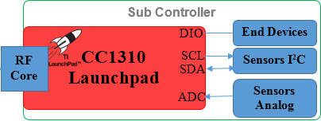

Sub Controller, that at each node in garden, has a CC1310 Launchpad which to send and receive data to Main Controller via RF. In addition, CC1310 connect with end devices such as water pump, pressure pump, light, and traction motor via DIO pins. I2C sensors wired with CC1310 via SCK and SDA pins. Signals from analog sensors will processed with Analog Digital Converter 12-bit inside CC1310.

##### **CC1310 Launchpad**

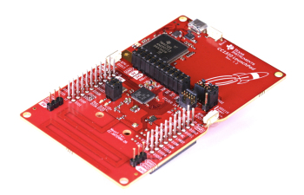

**Overview:** As mentioned above, CC1310 Launchpad is used to communicate RF in the system from Main Controller to Sub Controller. Besides that, the 32-bit ARM Cortex-M3 processor runs at 48 MHz as the main processor and a rich peripheral feature set that includes a unique ultra-low power sensor controller. This sensor controller is ideal for interfacing external sensors and for collecting analog and digital data autonomously while the rest of the system is in sleep mode.

**Detail Specifications:** Here are functions that used in Sub Controller.

|  |  |
| --- | --- |
| Specification | |
| Microcontroller | **ARM Cortex M3 48 MHz** |
| Memory | 128 KB Flash + 128 KB ROM  20 + 2 + 8 KB SRAM |
| Wireless Protocol | IEEE 802.15.4g/e proprietary Sub-1 GHz radio |
| Networking | Broadcom BCM 43438 chip to provide 2.4 GHz 802.11b/g/n wireless LAN |
| Peripherals | All Digital Peripheral Pins Can Be Routed to  Any GPIO  Four General-Purpose Timer Modules  (Eight 16-Bit or Four 32-Bit Timers, PWM Each)  12-Bit ADC, 200 k samples/s, 8-Channel Analog  MUX  Continuous Time Comparator  Ultralow Power Clocked Comparator  Programmable Current Source  UART - 2× SSI (SPI, MICROWIRE, TI)  I2C - I2S  Real-Time Clock (RTC)  AES-128 Security Module  True Random Number Generator (TRNG)  Support for Eight Capacitive Sensing Buttons  Integrated Temperature Sensor |
| Low Power | Wide Supply Voltage Range: 1.8 to 3.8 V  Active-Mode RX: 5.5 mA  Active-Mode TX at +10 dBm: 12.9 mA  Active-Mode MCU 48 MHz Running Coremark:  2.5 mA (51 µA/MHz)  Active-Mode MCU: 48.5 CoreMark/mA  Active-Mode Sensor Controller at 24 MHz:  0.4 mA + 8.2 µA/MHz  Sensor Controller, One Wake Up Every Second  Performing One 12-Bit ADC Sampling: 0.85 µA  Standby: 0.6 µA (RTC Running and RAM and  CPU Retention)  Shutdown: 185 nA (Wakeup on External Events) |
| RF Section | Excellent Receiver Sensitivity –124 dBm Using  Long-Range Mode, –110 dBm at 50 kbps  Excellent Selectivity: 52 dB  Excellent Blocking Performance: 90 dB  Programmable Output Power up to +14 dBm  Single-Ended or Differential RF Interface  Suitable for Systems Targeting Compliance With  Worldwide Radio Frequency Regulations  ETSI EN 300 220, EN 303 131,  EN 303 204 (Europe)  FCC CFR47 Part 15 (US)  ARIB STD-T108 (Japan)  Wireless M-Bus and IEEE 802.15.4g PHY |
| Power source | 5V, 0.5A - 3A via Micro USB or DIO pin |
| Size |  |

##### **Ambient Light Sensor**

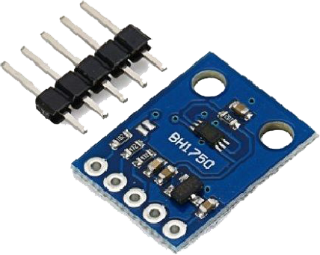

Figure D‑7: Module BH1750-FVI

**Overview:** Reason for using ambient light sensor BH1750 FVI:

- Cheap sensor, easy to buy via market.

- Detect light and convert to ambient light unit (lux) quickly.

- I2C interface, less pin more peripheral devices.

**Specification:**

+ Block diagram

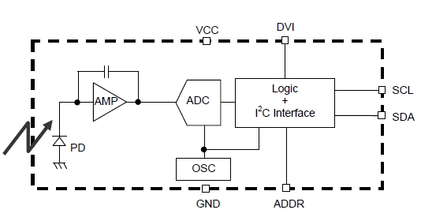

Figure D‑8: BH1750-FVI Block Diagram

・ PD: Photo diode with approximately human eye response.

・AMP: Integration-OPAMP for converting from PD current to Voltage.

・ ADC: AD converter for obtainment Digital 16bit data.

・Logic + I2C Interface: Ambient Light Calculation and I2C BUS Interface. It is including below register.

Data Register → this is for registration of Ambient Light Data. Initial Value is "0000_0000_0000_0000".

Measurement Time Register → this is for registration of measurement time. Initial Value is "0100_0101".

・ OSC: Internal Oscillator (typ. 320 kHz) is CLK for internal logic.

+ Input and Output Pins:

Table D‑3: BH1750 Ouput Pins

|  |  |  |  |
| --- | --- | --- | --- |
| **No.** | **Name** | **I/O** | **Description** |
| 1 | VCC |  | Power Supply 3.3V |
| 2 | GND |  | Ground |
| 3 | SCL | I | Serial Clock Line |
| 4 | SDA | I-O | Serial Data Line |

Table D‑4: BH1750 Measurement Flow Chart

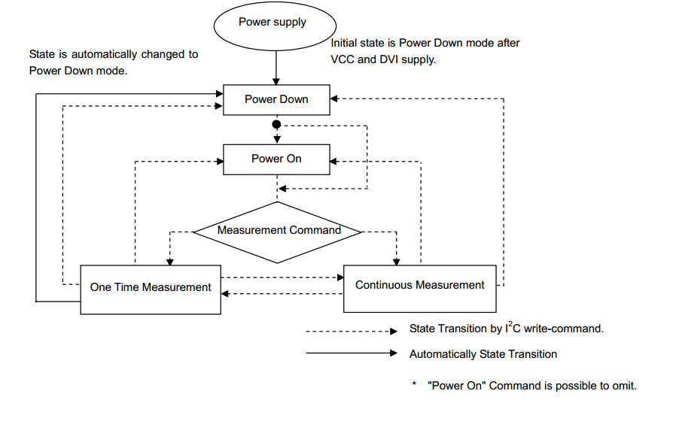

The BH1750-FVI can measure ambient light in many modes. There are six modes resolution mode and two ways to change measurement time. It also has two different slave address of I2C when ADDR Pin is changed. As we discussed, 0x23 is chosen slave address and 0x10 (Continuously H-Resolution Mode) is used as definite mode to measure ambient light.

##### **Temperature and Humidity Sensor – HDC 1008**

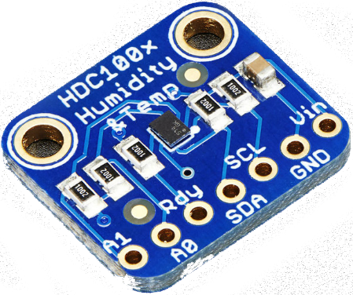

Figure D‑9: Module HDC1008

**Overview:** This sensor using I2C interface. It has 2 address select pins. It also 3-5V power and logic safe so the system do not need any level shifters or regulators to use with a 5V or 3V microcontroller.

**Note:** TI has indicated that there is a 'settling' effect for the humidity and that you will need to re-hydrate the sensor once you receive it. To rehydrate it, place it in a location with 85% humidity for 24 hours or 60% humidity for 10 days.

**Specification:**

+ Block diagram

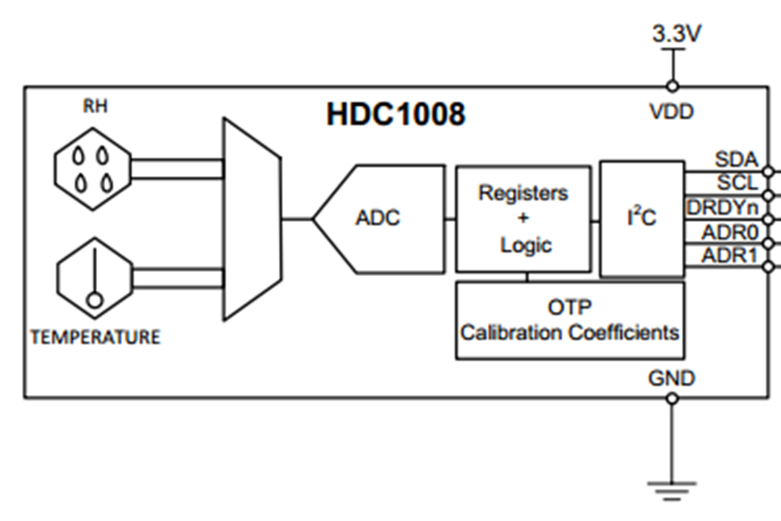

Figure D‑10: HDC1008 Block Diagram

Table D‑5: HDC1008 Output Pins

|  |  |  |  |
| --- | --- | --- | --- |
| **No.** | **Name** | **I/O** | **Description** |
| 1 | VCC |  | 3-5V |
| 2 | GND |  | Ground |
| 3 | SCL | I | Serial Clock Line. 3-5V logic |
| 4 | SDA | I-O | Serial Data Line. 3-5V logic |
| 5 | RDY | I | Interrupt/’ready’. Open collector |
| 6 | A0 |  | Address pin A0 = Address + 1 |
| 7 | A1 |  | Address pin A0 = Address + 2 |

RDY - This is the interrupt/'ready' pin from the HDC100x. The chip has some capability to 'alert' you when data is ready to be read from the sensor. We do not use this pin in our library but it is available if you need it! It is open collector so you need to use a pull-up resistor if you want to read signal from this pin.

A0 A1 - These are the address select pins. Since you can only have one device with a given address on an i2c bus, there must be a way to adjust the address if you want to put more than one HDC100X on a shared i2c bus. The A0/A1 pins set the bottom 2 bits of the i2c address. There are pull-down resistors on the board so connect them to VIN to set the bits to '1'. They are read on power up, so de-power and re-power to reset the address.

##### **Soil Moisture Sensor using LM393**

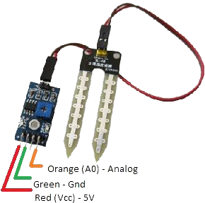

Figure D‑11: Module Soil Moisture Sensor using LM393

**Overview:** This is a simple water sensor can be used to detect soil moisture when the soil moisture deficit module outputs a high level, and vice versa output low. Use this sensor produced an automatic plant-watering device, so that the plants in your garden without people to manage. Small board analog output AO and AD module connected through the AD converter, to get more precise values of soil moisture.

**Specification:**

+ Schematic

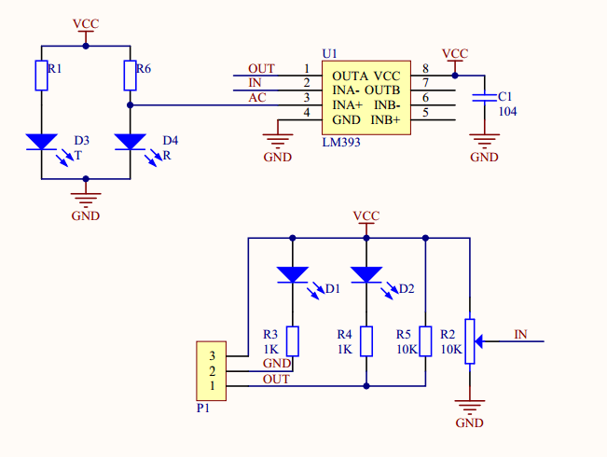

Figure D‑12: Module Soil Moisture Sensor Schematic

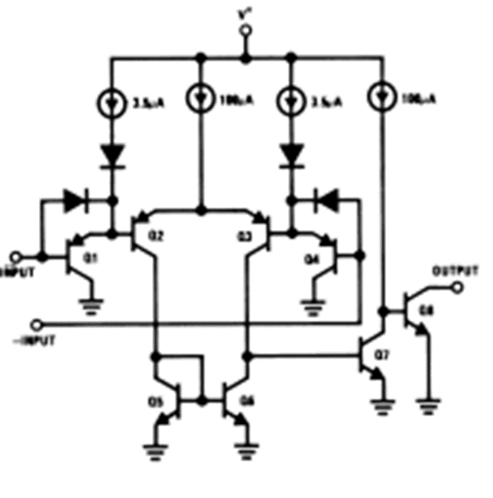

aaa

Table D‑6: Soil Moisture Sensor Output Pins

|  |  |  |  |
| --- | --- | --- | --- |
| **No.** | **Name** | **I/O** | **Description** |
| 1 | VCC |  | 3.3-5V |
| 2 | GND |  | Ground |
| 3 | DO | O | Digital value output connector (0 or 1) |
| 4 | AO | O | Analog value output connector |

##### **PH Meter – DFRobot PH Meter Kit**

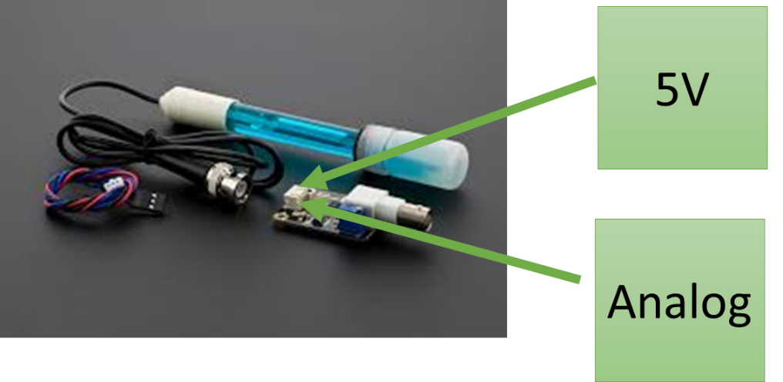

Figure D‑13: Module DFRobot pH Meter

**Overview:**  It has an LED, which works as the Power Indicator, a BNC connector and PH2.0 sensor interface. You can just connect the pH sensor with BNC connector, and plug the PH2.0 interface into any analog input on MCU to read pH value easily.

**Specification:**

- Module Power: 5.00V

- Module Size: 43mmx32mm

- Measuring Range: 0-14PH

- Measuring Temperature: 0-60 ℃

- Accuracy: ± 0.1pH (25 ℃)

- Response Time: ≤ 1min

- PH Sensor with BNC Connector

- PH2.0 Interface (3-foot patch)

- Gain Adjustment Potentiometer

- Power Indicator LED

|  |  |  |  |
| --- | --- | --- | --- |
| **No.** | **Name** | **I/O** | **Description** |
| 1 | VCC |  | 5V |
| 2 | GND |  | Ground |
| 4 | AO | O | Analog value output connector |

Figure D‑14: Module pH Meter Output Pins

### Software – Hardware Connection Architecture Description

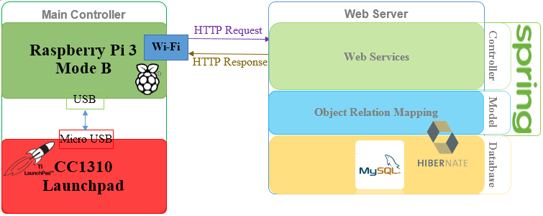

Figure D‑15: Hardware - Software Connection Architecture Description

The model use wireless protocol to communicate between hardware and software. There is Internet Connected for almost people, who live in the city, the model use Wi-Fi to connect hardware to Webserver via HTTP protocol. This solution not only helps keep stable of data in transceiver but also helps user control their system from anywhere in anytime.

## Component Diagram

### Physical Component Diagram

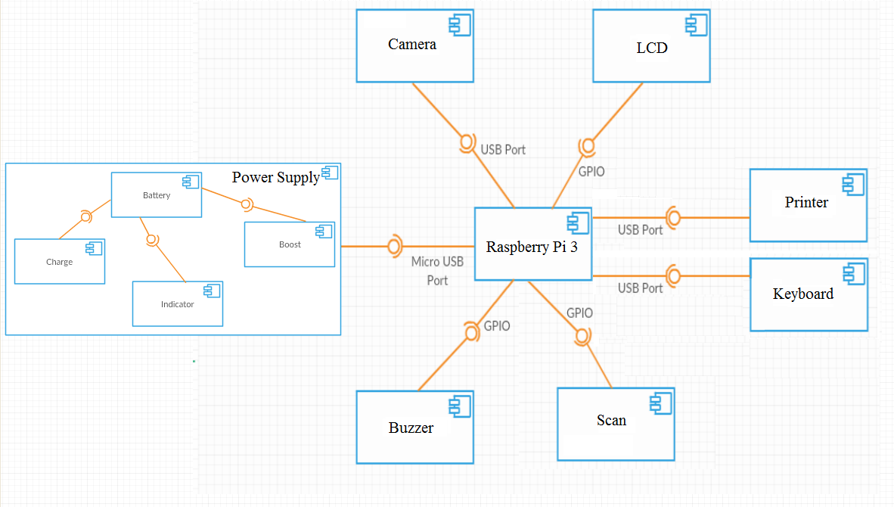

*Figure D‑16: Physical Component Diagram*

* + 1. **Component Dictionary**

*Table D‑7: Component Dictionary*

|  |  |
| --- | --- |
| Component Dictionary: Describes components | |
| Power Supply |  |
| Charge circuit |  |
| Battery |  |
| Indicator circuit |  |
| Boost circuit |  |
| Raspberry Pi 3 |  |
| Buzzer circuit |  |
| Scan |  |
| LCD |  |
| Camera |  |
| Keyboard |  |
| Printer |  |

## Detailed Description

### Class Diagram

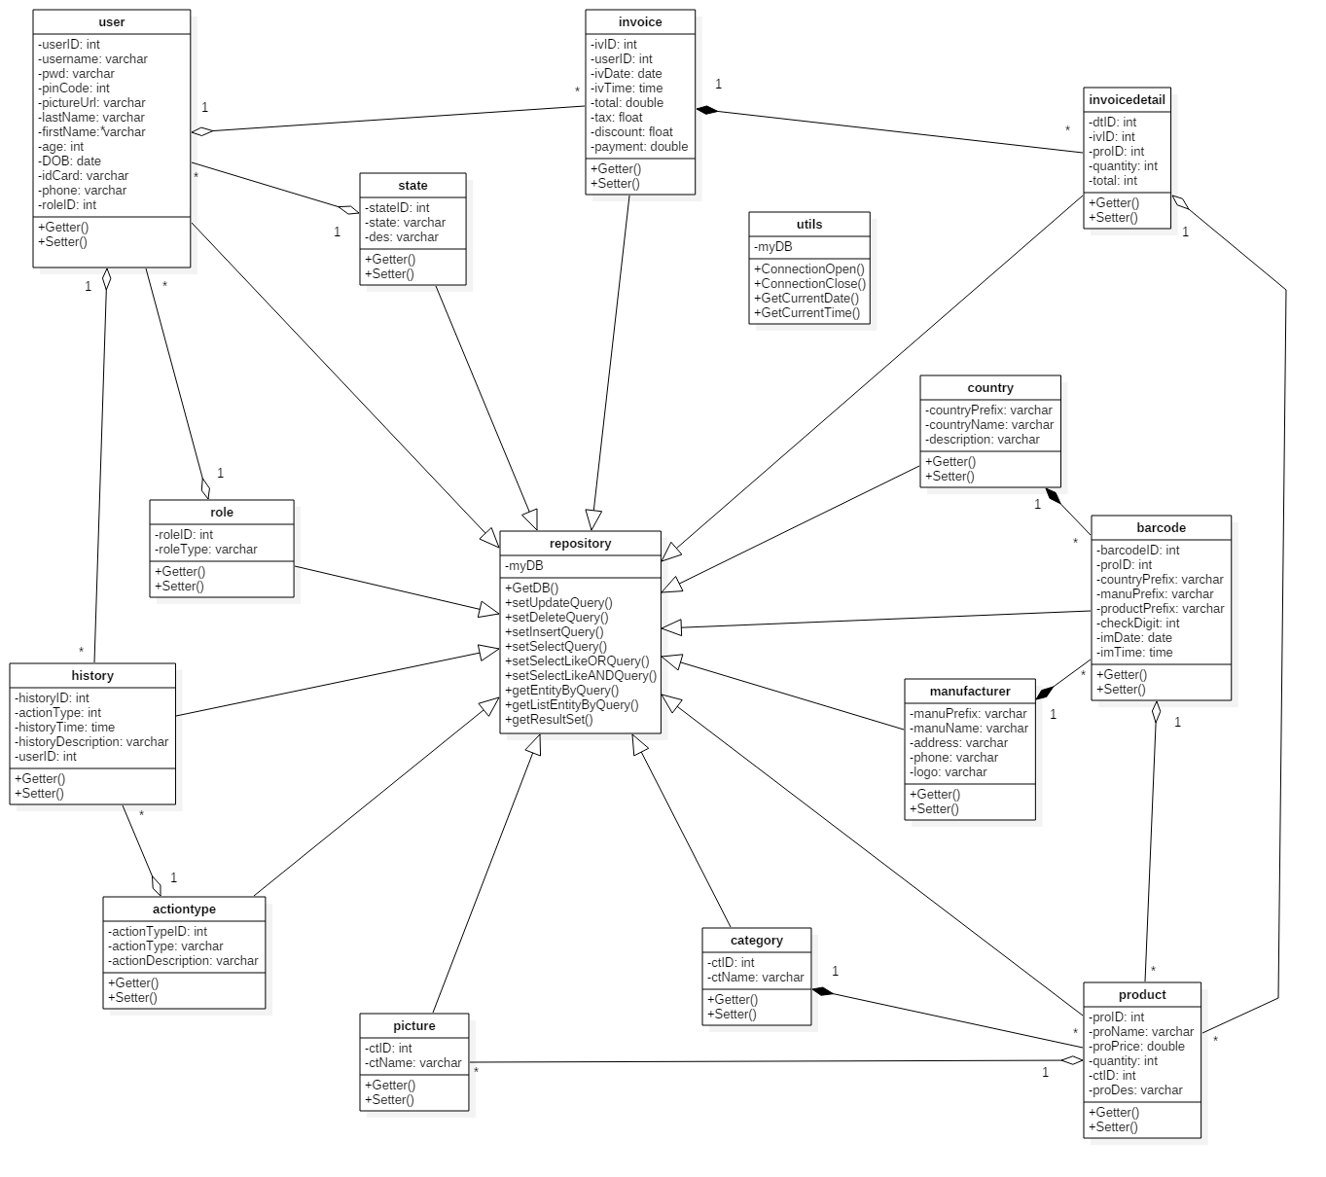

Figure D‑18: Class Diagram

### Class Diagram Explanation

#### Role

Table D‑: Role Explanation

|  |  |  |  |
| --- | --- | --- | --- |
| Attribute | Type | Visibility | Description |
| roleID | Integer | Private | Unique identifier of a role |
| roleType | String | Private | Type of role |
| Method | **Type** | **Visibility** | **Description** |
| Getter | Attribute | Public | Get attribute value |
| Setter | Void | Public | Set value of attribute |

#### User

Table D‑: User Explanation

|  |  |  |  |
| --- | --- | --- | --- |
| Attribute | Type | Visibility | Description |
| userID | Integer | Private | Unique identifier for each user |
| username | String | Private | Username for each user |
| pinCode | Integer | Private | PIN code of user |
| pictureUrl | String | Private | URL of Picture |
| lastName | String | Private | Last Name of user |
| firstName | String | Private | First Name of user |
| age | Integer | Private | Age of user |
| DOB | Date | Private | Date of birth |
| idCard | String | Private | Identifier |
| phone | String | Private | Phone number |
| roleID | Integer | Private | Unique identifier of a role |
| Method | **Type** | **Visibility** | **Description** |
| Getter | Attribute | Public | Get attribute value |
| Setter | Void | Public | Set value of attribute |

#### History

Table D‑: History Explanation

|  |  |  |  |
| --- | --- | --- | --- |
| Attribute | Type | Visibility | Description |
| historyID | Integer | Private | Identifier of history |
| actionTypeID | Integer | Private | Identifier of action type |
| historyTime | Time | Private | Time of history |
| historyDescription | String | Private | Description of history |
| userID | Integer | Private | Unique identifier for each user |
| Method | **Type** | **Visibility** | **Description** |
| Getter | Attribute | Public | Get attribute value |
| Setter | Void | Public | Set value of attribute |

#### Action type

Table D‑: Action type Explanation

|  |  |  |  |
| --- | --- | --- | --- |
| Attribute | Type | Visibility | Description |
| actionTypeID | Integer | Private | Unique identifier of action type |
| actionType | String | Private | Type of action |
| actionDescription | String | Private | Description of action |
| Method | **Type** | **Visibility** | **Description** |
| Getter | Attribute | Public | Get attribute value |
| Setter | Void | Public | Set value of attribute |

#### Invoice

Table D‑: Invoice Explanation

|  |  |  |  |
| --- | --- | --- | --- |
| Attribute | Type | Visibility | Description |
| ivID | Integer | Private | Unique identifier of invoice |
| userID | Integer | Private | Unique identifier for each user |
| ivDate | Date | Private | Date of invoice |
| ivTime | Time | Private | Time of invoice |
| subtotal | Double | Private | Total of price |
| Tax | Float | Private | Tax of invoice |
| discount | Float | Private | Discount |
| total | Double | Private | Invoice total |
| Method | **Type** | **Visibility** | **Description** |
| Getter | Attribute | Public | Get attribute value |
| Setter | Void | Public | Set value of attribute |

#### Invoice Detail

Table D‑: Invoice Detail Explanation

|  |  |  |  |
| --- | --- | --- | --- |
| Attribute | Type | Visibility | Description |
| dtID | Integer | Private | Unique identifier of invoice detail |
| ivID | Integer | Private | Unique identifier of invoice |
| proID | Integer | Private | Unique identifier of product |
| quantity | Integer | Private | Quantity of product |
| subtotal | Integer | Private | Total of detail invoice |
| Method | **Type** | **Visibility** | **Description** |
| Getter | Attribute | Public | Get attribute value |
| Setter | Void | Public | Set value of attribute |

#### Product

Table D‑: Product Explanation

|  |  |  |  |
| --- | --- | --- | --- |
| Attribute | Type | Visibility | Description |
| proID | Integer | Private | Unique identifier of product |
| proName | String | Private | Name of product |
| proPrice | Double | Private | Price of product |
| quantity | Integer | Private | Quantity of product |
| ctID | Integer | Private | Unique identifier of category |
| proDes | String | Private | Description of product |
| Method | **Type** | **Visibility** | **Description** |
| Getter | Attribute | Public | Get attribute value |
| Setter | Void | Public | Set value of attribute |

#### Category

Table D‑: Category Explanation

|  |  |  |  |
| --- | --- | --- | --- |
| Attribute | Type | Visibility | Description |
| ctID | Integer | Private | Unique identifier of category |
| ctName | String | Private | Name of category |
| Method | **Type** | **Visibility** | **Description** |
| Getter | Attribute | Public | Get attribute value |
| Setter | Void | Public | Set value of attribute |

#### Barcode

Table D‑: Barcode Explanation

|  |  |  |  |
| --- | --- | --- | --- |
| Attribute | Type | Visibility | Description |
| barcodeID | Integer | Private | Unique identifier of barcode |
| proID | Integer | Private | Unique identifier of product |
| countryPrefix | String | Private | Prefix number of country |
| manuPrefix | String | Private | Prefix number of manufacture |
| productPrefix | String | Private | Prefix number of product |
| checkDigit | Integer | Private | Checking number of barcode |
| imDate | Date | Private | Import date |
| imTime | Time | Private | Import time |
| Method | **Type** | **Visibility** | **Description** |
| Getter | Attribute | Public | Get attribute value |
| Setter | Void | Public | Set value of attribute |

#### Manufacturer

Table D‑: Manufacturer Explanation

|  |  |  |  |
| --- | --- | --- | --- |
| Attribute | Type | Visibility | Description |
| manuPrefix | String | Private | Prefix number of manufacturer |
| manuName | String | Private | Name of manufacturer |
| address | String | Private | Address of manufacturer |
| phone | String | Private | Phone number of manufacturer |
| logoUrl | String | Private | URL address of logo |
| Method | **Type** | **Visibility** | **Description** |
| Getter | Attribute | Public | Get attribute value |
| Setter | Void | Public | Set value of attribute |

#### Country

Table D‑: Country Explanation

|  |  |  |  |
| --- | --- | --- | --- |
| Attribute | Type | Visibility | Description |
| countryPrefix | String | Private | Prefix number of country |
| countryName | String | Private | Name of country |
| description | String | Private | Description of country |
| Method | **Type** | **Visibility** | **Description** |
| Getter | Attribute | Public | Get attribute value |
| Setter | Void | Public | Set value of attribute |

#### Picture

Table D‑: Picture Explanation

|  |  |  |  |
| --- | --- | --- | --- |
| Attribute | Type | Visibility | Description |
| picID | Integer | Private | Unique identifier of picture |
| picUrl | String | Private | URL address of picture |
| proID | Integer | Private | Unique identifier of product |
| Method | **Type** | **Visibility** | **Description** |
| Getter | Attribute | Public | Get attribute value |
| Setter | Void | Public | Set value of attribute |

#### Repository

|  |  |  |  |
| --- | --- | --- | --- |
| Attribute | Type | Visibility | Description |
| myDB | Integer | Private | Unique identifier of picture |
| Method | **Type** | **Visibility** | **Description** |
| GetDB() | Void | Public | Connect database |
| setUpdateQuery() | Void | Public | Set Update Query |
| setDeleteQuery() | Void | Public | Set Delete Query |
| setInsertQuery() | Void | Public | Set Insert Query |
| setSelectQuery() | Void | Public | Set Select Query |
| setSelectLikeORQuery() | Void | Public | Set Select Like OR Query |
| setSelectLikeANDQuery() | Void | Public | Set Select Like AND Query |
| getEntityByQuery() | Void | Public | Get Entity By Query |
| getListEntityByQuery() | Void | Public | Get List Entity By Query |
| getResultSet() | Void | Public | Get Result Set |

#### State

|  |  |  |  |
| --- | --- | --- | --- |
| Attribute | Type | Visibility | Description |
| stateID | Integer | Private | Unique identifier of picture |
| state | String | Private | URL address of picture |
| description | Integer | Private | Unique identifier of product |
| Method | **Type** | **Visibility** | **Description** |
| Getter | Attribute | Public | Get attribute value |
| Setter | Void | Public | Set value of attribute |

### Interaction Diagram

#### Login Sequence Diagram

Figure D‑19: Login Sequence Diagram

#### Log out Sequence Diagram

Figure D‑20: Show Zone Sequence Diagram

#### Search Sequence Diagram

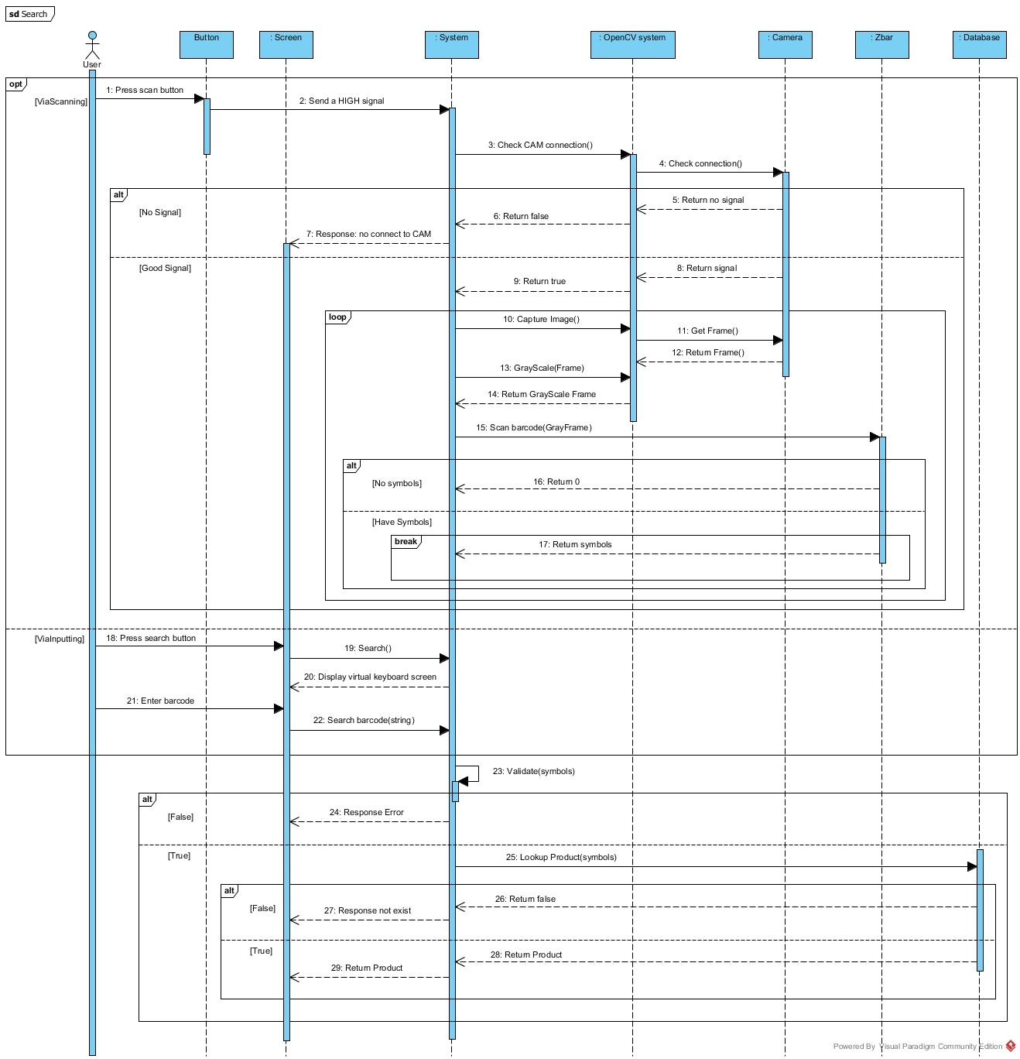

Figure D‑21: Search Sequence Diagram

#### Manage Order Items Sequence Diagram

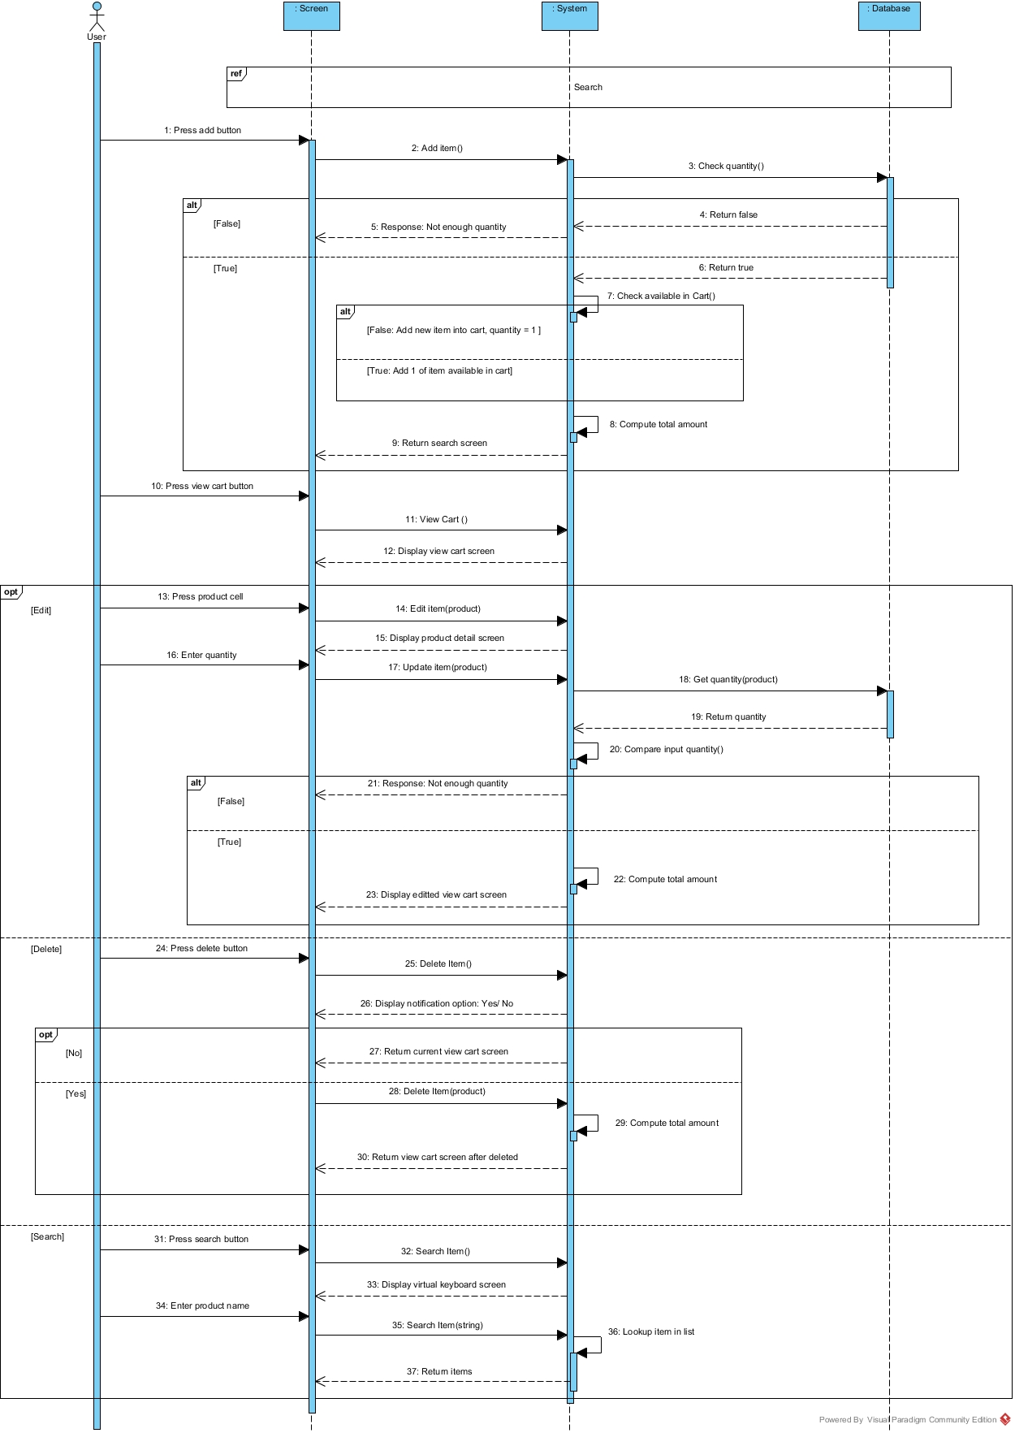

Figure D‑22: Manage Order Items Sequence Diagram

#### Add Product Sequence Diagram

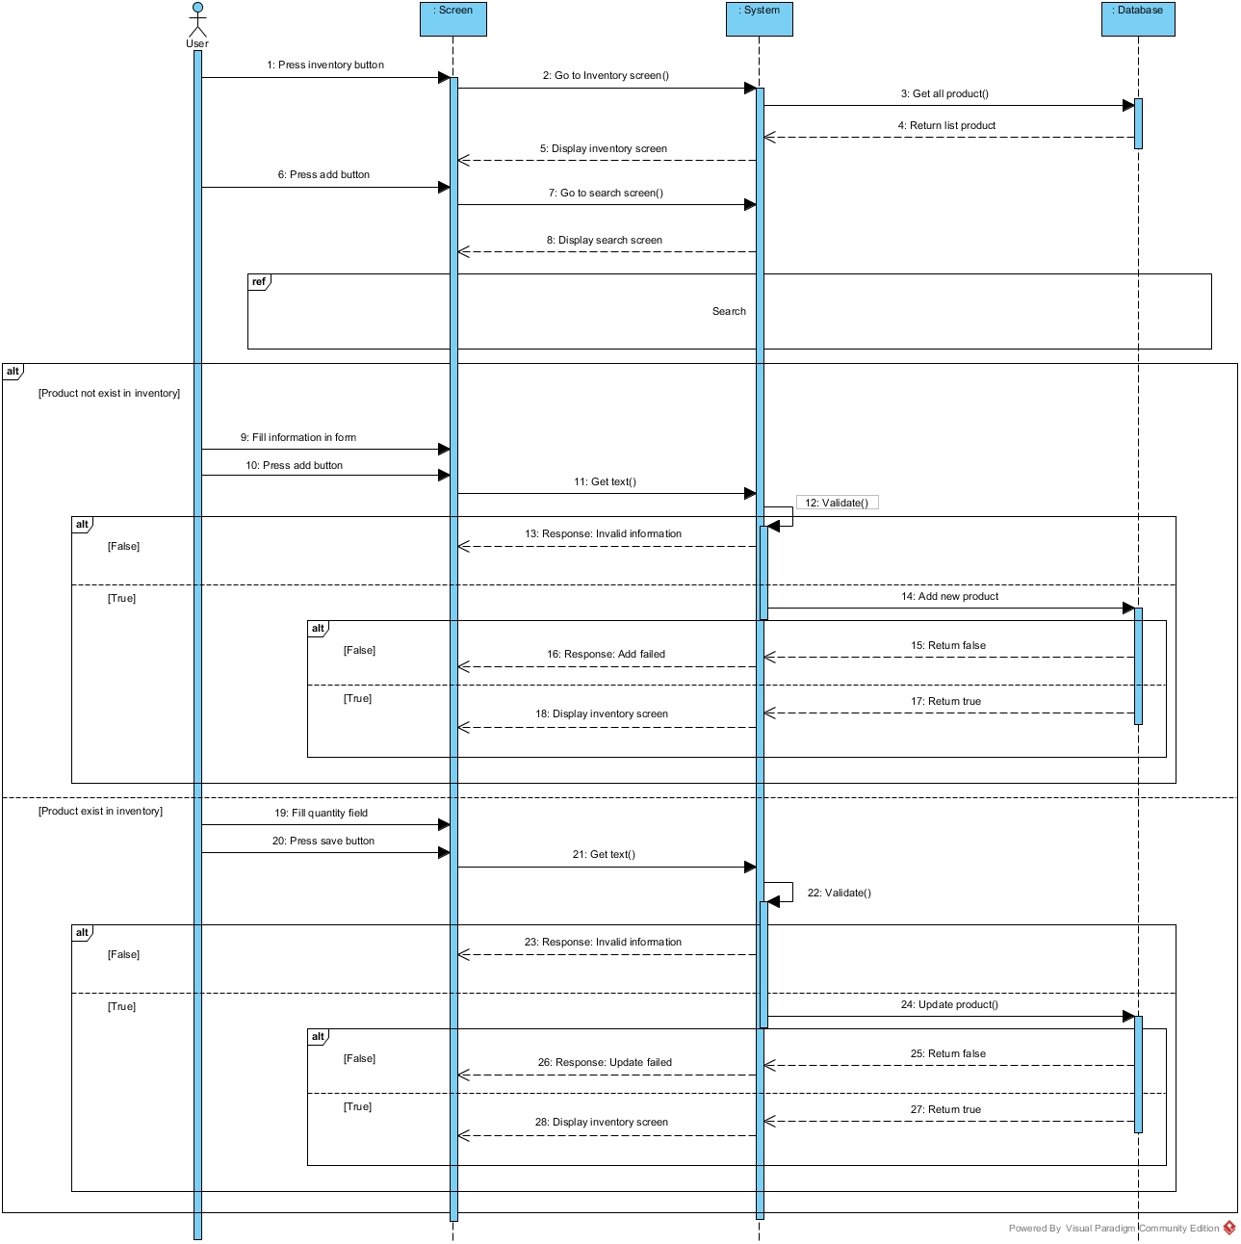

Figure D‑23: Delete Zone Sequence Diagram

#### Edit Product Sequence Diagram

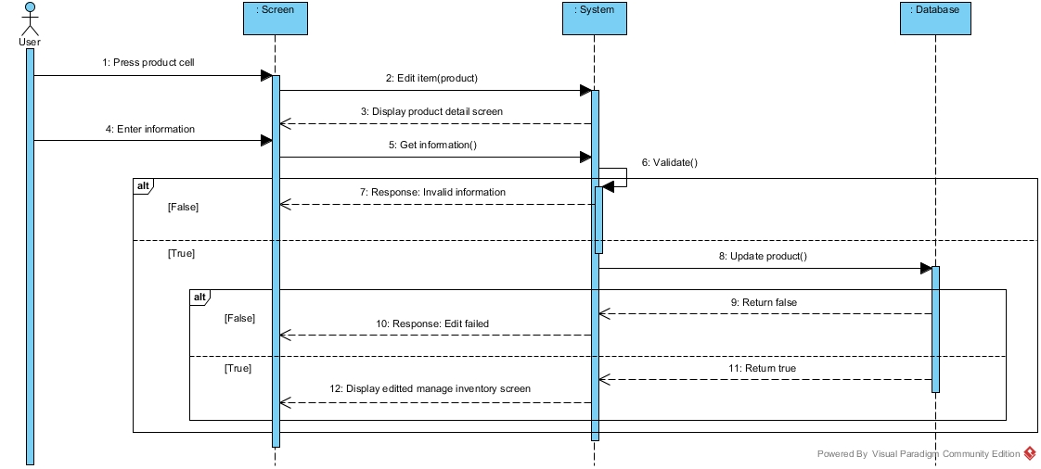

Figure D‑24: Edit Product Sequence Diagram

#### Search Product Sequence Diagram

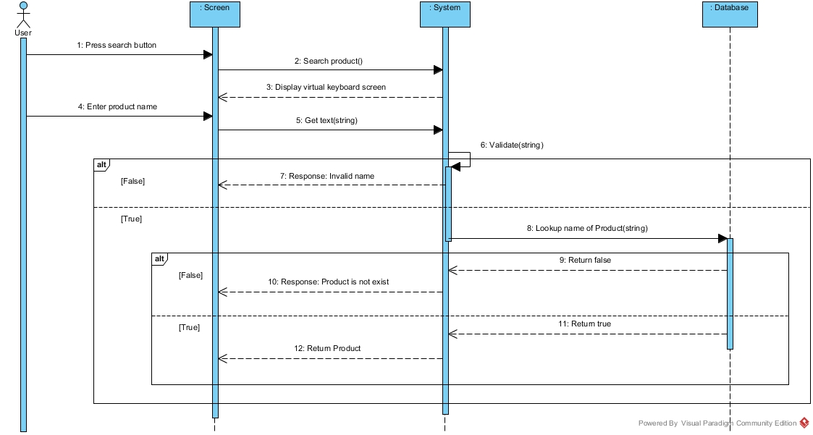

Figure D‑25: Search product Sequence Diagram

#### Add Employee Sequence Diagram

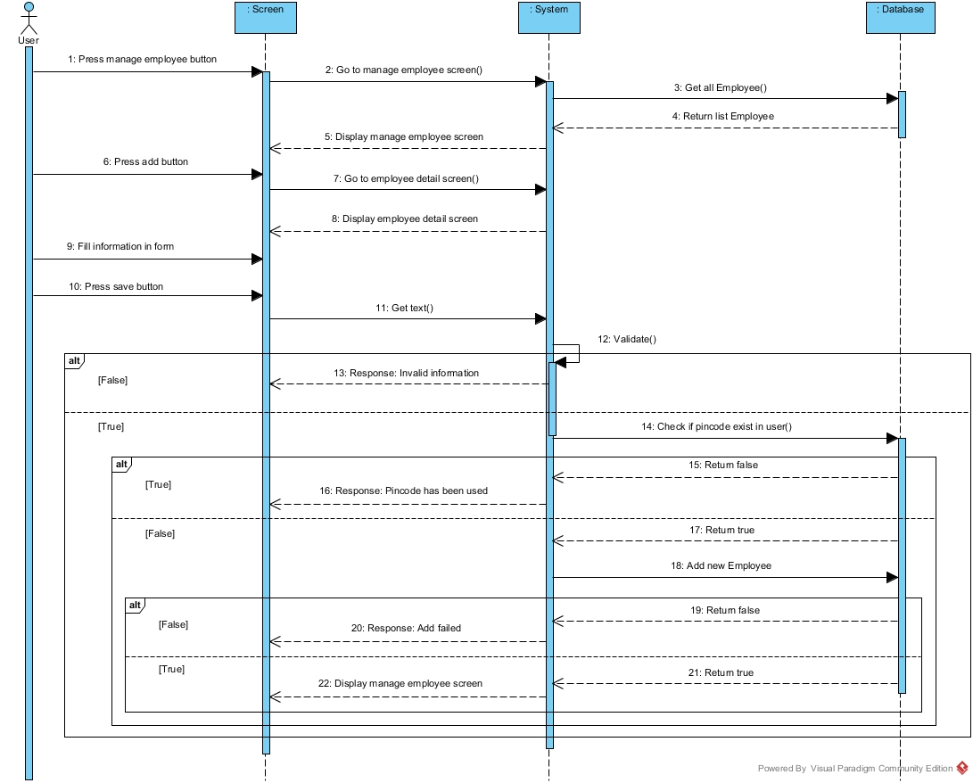

Figure D‑26: Add Employee Sequence Diagram

#### Edit Employee Sequence Diagram

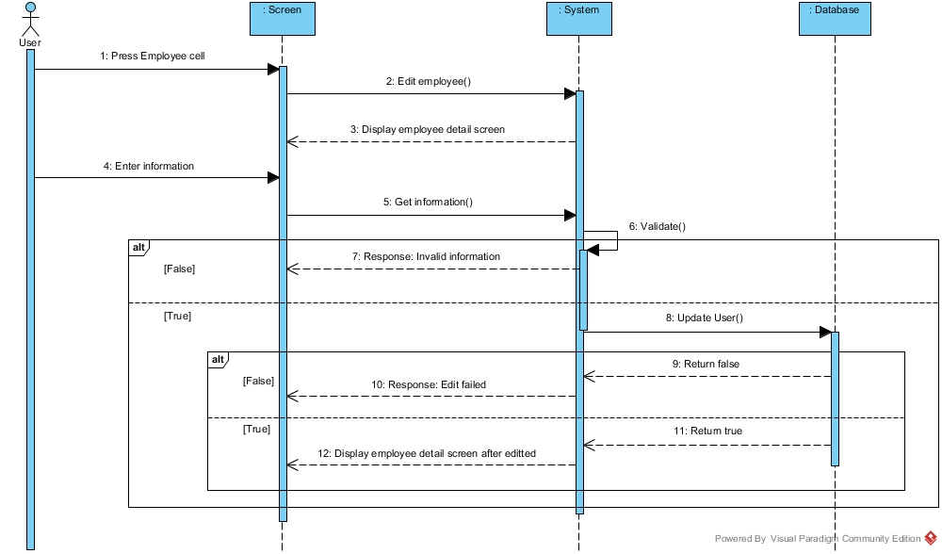

Figure D‑27: Edit Employee Sequence Diagram

#### Search Employee Sequence Diagram

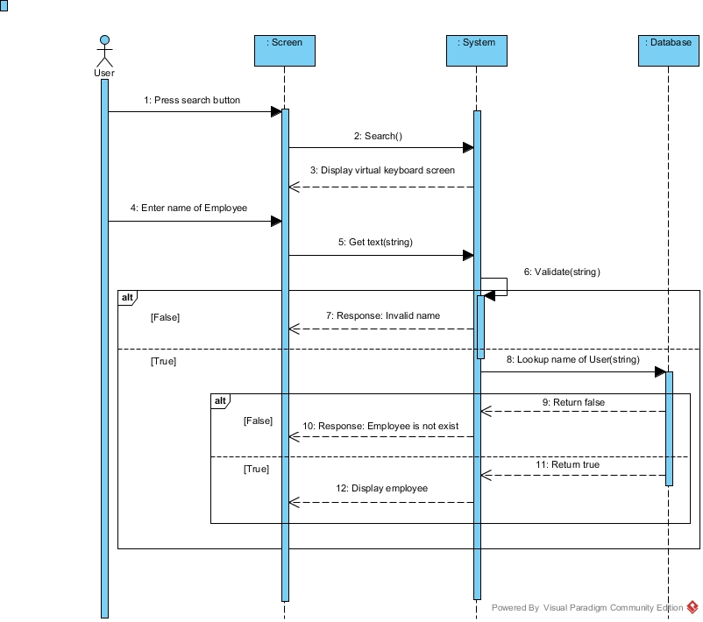

Figure D‑29: Control End Device Sequence Diagram

## Interface

### Component Interface

Table D‑14: Component Interface

|  |  |  |  |  |  |
| --- | --- | --- | --- | --- | --- |
| **Signature** | **Description** | **Input** | **Output** | **Output Format** | **Exception** |
| **public** **boolean** checkLogin  (String username, String password) | Check login user | Request(username, password) | Json  Boolean | Boolean | Rollback |
| **public** List<Zone> getZoneInfo  (Integer userLibID) | Show list zone of user | Request  (userLibID) | Object  Json | Object | Rollback |
| **public** **void**  addZone(Zone zone) | Add new one zone in system | Request  (zone) | Message | Show  object | Rollback |
| **public** List<Userlibrary> getUserlibraryList (String username) | Show list userlib of user | Request  (user) | List  object | List  object | Rollback |
| **public** **void** addUserlibrary  (Userlibrary userlibrary) | Add new one plant in library | Request  (userlibrary) | Object  Json | Object | Rollback |
| Userlibrary getUserlibrary  (Integer userLibID) | Show information of plant in zone | Request  (userLibID) | Object  Json | Object | Rollback |
| **public** String updatezone  (UserlibraryDTO userlibraryDTO) | Update information of zone and plant | Request(userlibraryDTO) | Object  Json | Object | Rollback |
| **public** SensorinfoDTO  findSensorInfo( Integer zoneID) | Show sensorinfo of zone | Request  (zoneID) | Object  Json | Object | Rollback |
| **public** List<SensorinfoDTO>  listsensor(Integer zoneID) | Show list sensor have insert in sever | Request  (zoneID) | List json | List  object | Rollback |
| **public** Enddevice  updateEnddeviceByUser  (Enddevice enddevice) | Update actuator in zone | Request  (enddevice) | Object  Json | Object | Rollback |

### User Interface Design

#### Loading



**“Loading” screen**

#### Login

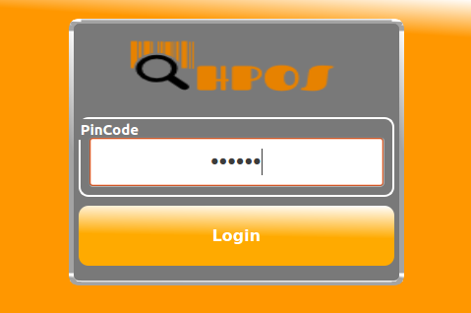

**“Login” screen**

#### Manager’ Menu

**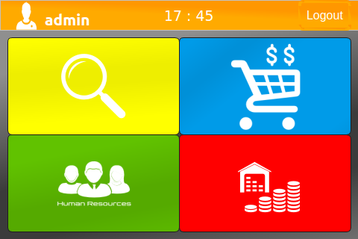  
“Manage’s Menu” screen**

#### Shop Assistant’s Menu

**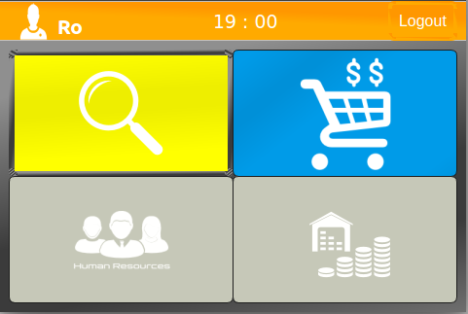  
 “Shop Assistant’s Menu” screen**

#### Search

**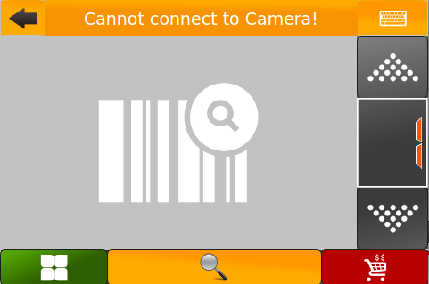  
“Search” screen.**

#### View Cart

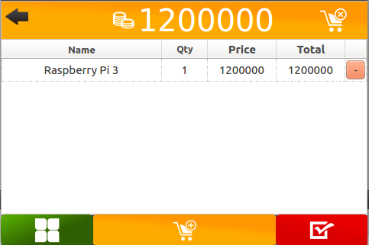

**“View Cart” screen.**

#### Manage Employee

**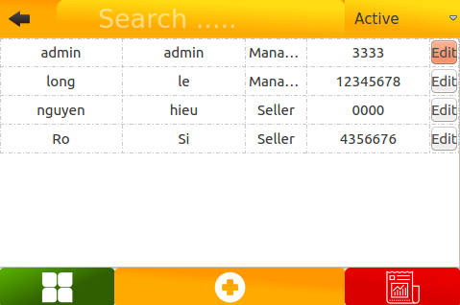  
 “Manage Employee” screen.**

#### Manage Inventory

**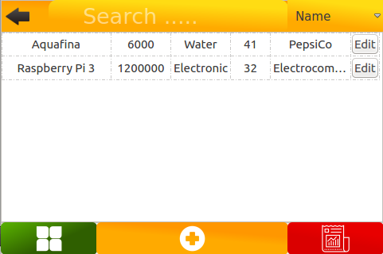  
“Manage Inventory” screen.**

#### Virtual Keyboard

**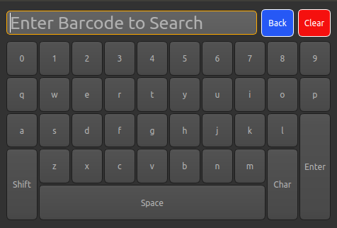  
“Virtual Keyboard” screen.**

#### Result Search

**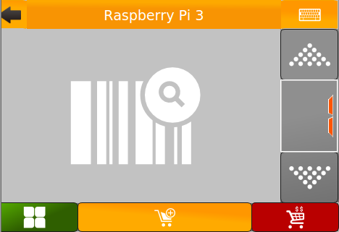  
“Result Search” screen.**

#### 5.2.10 Employee Detail

**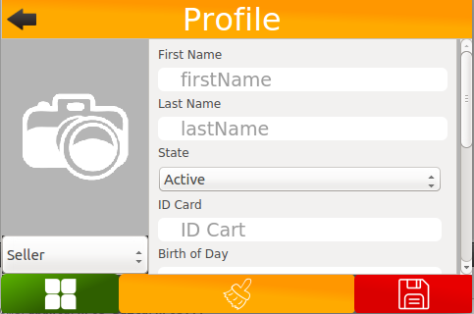  
“Employee Detail” screen.**

#### Product Detail

**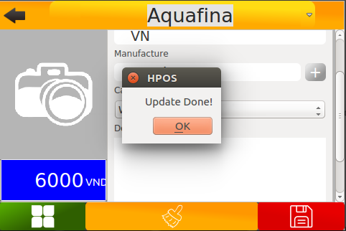  
“Product Detail” screen.**

#### Payment

**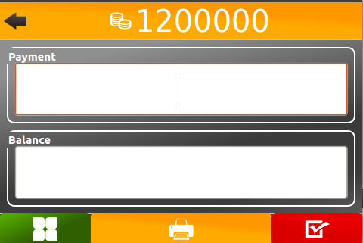  
“Payment” screen.**

## Database Design

### Entity Relationship Diagram (ERD)

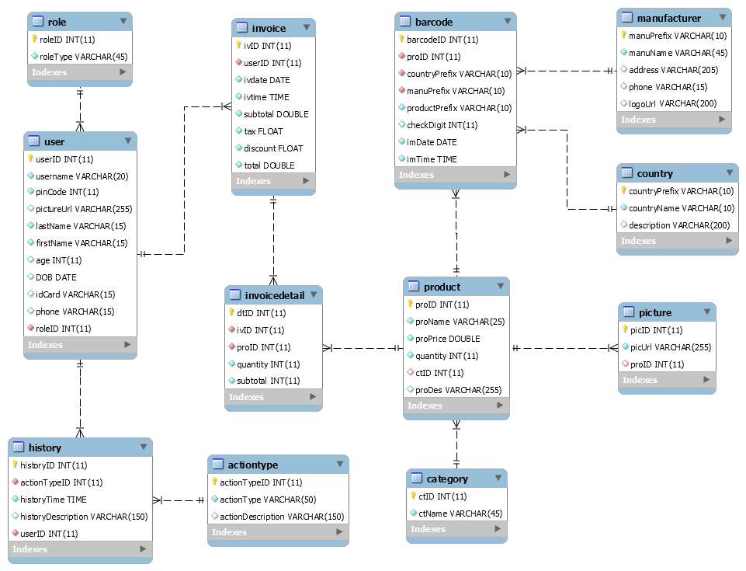

### Data Dictionary

|  |  |  |
| --- | --- | --- |
| **Data dictionary: descript be content of all tables** | | |
| **Table Name** | **Description** |
| Role | Describe user’s role in the system (Manager and Shop Assistant). One user has one role. |
| User | Describe account of user of system. |
| History | Describe all history in the system. |
| ActionType | Describe all action type of user in the system. |
| Picture | Describe all pictures in the system. |
| Invoice | Describe all invoice in the system. |
| InvoiceDetail | Describe all detail of invoice in the system. |
| Barcode | Describe all product barcode in the system. |
| Product | Describe all product in the system. |
| Category | Describe all category in the system. |
| Manufacturer | Describe all manufacturer in the system. |
| Country | Describe all country in the system. |

|  |  |  |  |  |
| --- | --- | --- | --- | --- |
| **Entity name** | **Attributes** | **Description** | **Domain** | **Null** |
| **Role** | roleID {PK} | ID of role. Unique identifier of role, auto increment. | Integer | No |
| roleType | Type of Role. | Nvarchar(45) | No |
| **User** | userID {PK} | ID of user. Unique identifier of user, auto increment. | Integer | No |
| username | Unique identifier, username of user. | Nvarchar(20) | No |
| pwd | Password of user. | Nvarchar(20) | No |
| pinCode | Unique identifier, information user | Integer | No |
| lastName | Information user | Text | No |
| firstName | Information user | Text | No |
| age | Information user | Integer | No |
| DOB | Information user | Date | No |
| idCard | Information user | Text | Yes |
| phone | Information user | Text | Yes |
| roleID | Information user | Integer | No |
| **History** | historyID {PK} | ID of history. Unique identifier of history, auto increment. | Integer | No |
| actionTypeID | ID of actionType. | Integer | No |
| historyTime | Time of history. | Time | No |
| historyDescription | Description of history. | Nvarchar(150) | Yes |
| userID | ID of user. | Integer | No |
| **ActionType** | actionTypeID | ID of actionType. Unique identifier of actionType, auto increment. | Integer | No |
| actionType | Type of action. | Nvarchar(50) | No |
| actionDescription | Description of action. | Nvarchar(150) | Yes |
| **Picture** | picID {PK} | ID of picture. Unique identifier of picture, auto increment. | Integer | No |
| picUrl | Url of picture. | Integer | No |
| proID | ID of product. | Integer | Yes |
| userID | ID of user. | Integer | Yes |
| **Invoice** | ivID {PK} | ID of invoice. Unique identifier of invoice, auto increment. | Integer | No |
| userID | ID of user. | Integer | No |
| ivdate | Date of invoice. | Date | No |
| ivtime | Time of invoice. | Time | No |
| total | Total of invoice. | Double | No |
| tax | Tax of invoice. | Float | No |
| discount | Discount of invoice. | Float | No |
| payment | Payment | Double | No |
| **InvoiceDetail** | dtID {PK} | ID of Invoice Detail.  Unique identifier of role, auto increment. | Integer | No |
| ivID | ID of invoice. | Integer | No |
| proID | ID of product. | Integer | No |
| quantity | Quantity of product. | Integer | No |
| total | Total of Invoice Detail. | Integer | No |
| **Barcode** | barcodeID {PK} | ID of barcode. Unique identifier of role, auto increment. | Integer | No |
| proID | ID of product. | Integer | No |
| countryPrefix | Prefix of country. | Nvarchar(10) | No |
| manuPrefix | Prefix of manufacturer. | Nvarchar(10) | No |
| productPrefix | Prefix of product. | Nvarchar(10) | No |
| checkDigit | Check digit of barcode. | Integer | Yes |
| imDate | Date of import. | Date | No |
| imTime | Time of import. | Time | No |
| **Manufacturer** | manuPrefix {PK} | Prefix of manufacturer. | Nvarchar(10) | No |
| manuName | Name of manufacturer. | Nvarchar(45) | No |
| address | Address of manufacturer. | Nvarchar(205) | Yes |
| phone | Phone of manufacturer. | Nvarchar(15) | Yes |
| logo | Logo of manufacturer. | Nvarchar(200) | Yes |
| **Country** | countryPrefix {PK} | Prefix of country. | Nvarchar(10) | No |
| countryName | Name of country. | Nvarchar(10) | No |
| description | Country’s information | Nvarchar(200) | Yes |
| **Category** | ctID | ID of category. Unique identifier of category, auto increment. | Interger | No |
| ctName | Name of category. | Nvarchar(45) | No |
| **Product** | proID | ID of product. Unique identifier of category, auto increment. | Interger | No |
| proName | Name of product. | Nvarchar(25) | No |
| proPrice | Price of product. | Double | No |
| quantity | Quantity of product. | Interger | No |
| ctID | ID of category. | Interger | Yes |
| proDes | Description of product. | Nvarchar(255) | Yes |

## Flowchart

### Add index of sensors to database



Figure D‑32: Add index of sensors to database Flow Chart

### Control Water Pump through Algorithm



Figure D‑33: 7.2. Control Water Pump through Algorithm Flow Chart

### Control Light through Algorithm



Figure D‑34: Control Light through Algorithm Flow Chart

# **System Implementation & Test**

## Introduction

### Overview

In this section, contains information about the test plan, test approach, test process, test environment, test pass/fail criteria, checklist to check test this system.

### Test Approach

White box testing: Developers self-test code that they wrote and fix themselves

Black box testing: Test on each function of each module in system to ensure each module execute the right function. Then integration testing to test the function in system when integrate. Finally, system test to test the whole system.

Goal: Discover bug in system 🡪 fix bug 🡪 regression test 🡪 completed system.

## Database Relationship Diagram

### Physiscal Diagram



Figure E‑1: Physical Diagram

### Data Dictionary

|  |  |  |
| --- | --- | --- |
| **Data dictionary: descript be content of all tables** | | |
| **Table Name** | **Description** |
| Role | Describe user’s role in the system (Manager and Shop Assistant). One user has one role. |
| User | Describe account of user of system. |
| History | Describe all history in the system. |
| ActionType | Describe all action type of user in the system. |
| Picture | Describe all pictures in the system. |
| Invoice | Describe all invoice in the system. |
| InvoiceDetail | Describe all detail of invoice in the system. |
| Barcode | Describe all product barcode in the system. |
| Product | Describe all product in the system. |
| Category | Describe all category in the system. |
| Manufacturer | Describe all manufacturer in the system. |
| Country | Describe all country in the system. |

|  |  |  |  |  |
| --- | --- | --- | --- | --- |
| **Entity name** | **Attributes** | **Description** | **Domain** | **Null** |
| **Role** | roleID {PK} | ID of role. Unique identifier of role, auto increment. | Integer | No |
| roleType | Type of Role. | Nvarchar(45) | No |
| **User** | userID {PK} | ID of user. Unique identifier of user, auto increment. | Integer | No |
| username | Unique identifier, username of user. | Nvarchar(20) | No |
| pwd | Password of user. | Nvarchar(20) | No |
| pinCode | Unique identifier, information user | Integer | No |
| lastName | Information user | Text | No |
| firstName | Information user | Text | No |
| age | Information user | Integer | No |
| DOB | Information user | Date | No |
| idCard | Information user | Text | Yes |
| phone | Information user | Text | Yes |
| roleID | Information user | Integer | No |
| **History** | historyID {PK} | ID of history. Unique identifier of history, auto increment. | Integer | No |
| actionTypeID | ID of actionType. | Integer | No |
| historyTime | Time of history. | Time | No |
| historyDescription | Description of history. | Nvarchar(150) | Yes |
| userID | ID of user. | Integer | No |
| **ActionType** | actionTypeID | ID of actionType. Unique identifier of actionType, auto increment. | Integer | No |
| actionType | Type of action. | Nvarchar(50) | No |
| actionDescription | Description of action. | Nvarchar(150) | Yes |
| **Picture** | picID {PK} | ID of picture. Unique identifier of picture, auto increment. | Integer | No |
| picUrl | Url of picture. | Integer | No |
| proID | ID of product. | Integer | Yes |
| userID | ID of user. | Integer | Yes |
| **Invoice** | ivID {PK} | ID of invoice. Unique identifier of invoice, auto increment. | Integer | No |
| userID | ID of user. | Integer | No |
| ivdate | Date of invoice. | Date | No |
| ivtime | Time of invoice. | Time | No |
| total | Total of invoice. | Double | No |
| tax | Tax of invoice. | Float | No |
| discount | Discount of invoice. | Float | No |
| payment | Payment | Double | No |
| **InvoiceDetail** | dtID {PK} | ID of Invoice Detail.  Unique identifier of role, auto increment. | Integer | No |
| ivID | ID of invoice. | Integer | No |
| proID | ID of product. | Integer | No |
| quantity | Quantity of product. | Integer | No |
| total | Total of Invoice Detail. | Integer | No |
| **Barcode** | barcodeID {PK} | ID of barcode. Unique identifier of role, auto increment. | Integer | No |
| proID | ID of product. | Integer | No |
| countryPrefix | Prefix of country. | Nvarchar(10) | No |
| manuPrefix | Prefix of manufacturer. | Nvarchar(10) | No |
| productPrefix | Prefix of product. | Nvarchar(10) | No |
| checkDigit | Check digit of barcode. | Integer | Yes |
| imDate | Date of import. | Date | No |
| imTime | Time of import. | Time | No |
| **Manufacturer** | manuPrefix {PK} | Prefix of manufacturer. | Nvarchar(10) | No |
| manuName | Name of manufacturer. | Nvarchar(45) | No |
| address | Address of manufacturer. | Nvarchar(205) | Yes |
| phone | Phone of manufacturer. | Nvarchar(15) | Yes |
| logo | Logo of manufacturer. | Nvarchar(200) | Yes |
| **Country** | countryPrefix {PK} | Prefix of country. | Nvarchar(10) | No |
| countryName | Name of country. | Nvarchar(10) | No |
| description | Country’s information | Nvarchar(200) | Yes |
| **Category** | ctID | ID of category. Unique identifier of category, auto increment. | Interger | No |
| ctName | Name of category. | Nvarchar(45) | No |
| **Product** | proID | ID of product. Unique identifier of category, auto increment. | Interger | No |
| proName | Name of product. | Nvarchar(25) | No |
| proPrice | Price of product. | Double | No |
| quantity | Quantity of product. | Interger | No |
| ctID | ID of category. | Interger | Yes |
| proDes | Description of product. | Nvarchar(255) | Yes |

## Performance Measures

Clustering is performed by running K Mean Algorithm which has complexity of: O(n * k * I * d)

* n : number of points
* k : number of cluster
* I : number of iteration
* d : number of attributes (3)

Clustering take almost the time of process that we can ignore the time needed to load data from database, digitalize data.

The speed of clustering will vary and increase dramatically when n increase. The purpose of this project is not about optimizing K-Mean Algorithm so it is accepted to let the process run till it completes. Moreover, the clustering is designed to run by staff, wait time is acceptable.

## Test plan

The purpose of the test is to verify the functionality of the system. Functions need to be tested. Functions to ensure technical requirements and system requirements of the user. Error (error) will not happen after the trial.

The next content will describe which function will be tested and which will not and plan for them

### Features to be tested

We separate two part for testing: hardware and software.

#### Hardware

After assembling hardware devices to system, we test all of them to ensure that all hardware devices working well.

Here is list of hardware devices that we tested:

|  |  |
| --- | --- |
| **Functions** | **Description** |
| Ambient Light Sensor  BH1750 | We tested light indoor, outdoor and with other light sources such as flashlight, lamp at some points of time in day.  The max of ambient light is 65535 lx and there are 0 lx at night or dark light.  Each light of sun indoor and outdoor, we tested around 100 times. If the sensor can get index of light between 0 to 65535 and they have similar indexes which measure in same environment and same time; the result of test case is “Passed”, otherwise the result is “Failed” |
| Temperature  Humidity  Sensor  HDC1008  AM2320  LM35-HR202 | Standard of temperature and humidity is on weather forecast.  We tested temperature and humidity at the same time in some points of time in a day.  We tested the sensor in differents environment such as: morning, afternoon, night, sunny or wetty.  Each measurement, we tested around 100 times, if the result is also similar with which get in same environment and time, the test case is “Passed”, otherwise test case is “Failed”.  At the beginning of project, we choose AM2320 for reading temperature and humidity. We spent 2 weeks with hundred times to implemet and test this sensor, but there are “Fail” result when the sensor could not connect with MCU and reading right output. Data  We decide to change to LM35 for reading temperature and HR202 for humidity. LM35 working right but HR202 make noise with other sensor and did not output right index. We spent more two days. |
| Soil Moisture  Sensor | This sensor is tested in different kinds of soil such as sand, silt and clay plus humus, loam, and scoria.  In each kind of soil, we put sensor in variety of water level.  The sensor just can dectect when the soil is dry (0% - 15%) or wet (80% - 100%). When we fill water more, the sensor could not dectect clearly changes of volume water. Arround 300 tested times, we assigned “Passed” for test cases which could sensitivy dry or wet, and “Failed” for otherwise. |
| pH Sensor | The sensor is put in an environment which has 7 pH degees (neutral). The sensor has a quite high cost with our balance so we tested it in some environment which is a little different with standard environment such as putting in drink water, water well or salt water. If the sensor give index still pH is 7 which is not reality in real environment, the result of test case is “Failed”, otherwise the result is “Passed” |
| DIO Controll  End Devices | Before setup real devices for model, we chose led light to test control DIO on MCU. Define status of a pin is high level, the led is off, when assign a low level to make the led on and otherwise. Follow above scenario, the resul is “Passed” and “Failed” is otherwise. |
| CC1310  LaunchPad | At Sub Controller:  + CC130 Launchpad is tested with sensors to read indexes and control devices. After tested separate sensors, we tested CC1310 with all sensors in different environment at the same time. We did the test hundred times to read all sensors. The test case was “Passed” if the CC1310 could get all indexes, otherwise if there are missing one or more indexes of five sensors, the result is “Failed”.  RF Communicate:  + We also tested the distance of RF in different topographic in many regions such as obstructions of buildings, walls or metal. Besides that, we also tested distance on the straight line, how far they could work. The test case is “Passed” if sub and main still send and receive signals, otherwise is “Failed”.  + We also tested process of transceiver with 3 nodes at the same time. If the main controller can control and receive all indexes from 3 nodes, the test case is “Passed”, otherwise is “Failed”. |
| Raspberry  Pi 3 | We tested ability of serial port connection between Raspberry and CC1310 Launchpad. We defined some packets to transfer and receive sequentially, continously or parallel. If one of them could not transfer or receive, the test case is “Failed”, otherwise is “Passed”. We need to find the best way to communicate between them without error or delay too long. |

#### Software

The features of user and web services will be focused and list below:

|  |  |
| --- | --- |
| **Functions** | **Description** |
| Web Services | Automatic Services  + Update status of end devices to database after system do algorithms.  + Counting how much time algorithm work and update to database.  Services are provided for Raspberry Pi 3.  + Insert sensor’ indexes from hardware to database.  + Stress test with request and response services continuously in a long time.  Services are provided for Android Application  + Login  + View sensor indexes  + View zone  + Add new zone  + View library  + Add new library  + Update zone  + Delete zone  + Change mode of control  + Control End Devices in Manual  + Update status of devices in Automatic |
| Android Application | Black box testing on user interface. |

### Features not to be tested:

- N/A.

### Test environment

Web server: Firefox (newest version), Chrome (newest version).

OS: Windows 10, Windows 7.

Android application: test on Android OS 4.0

Hardware: test on CC1310

## System Testing Test Case

### Component Testing

#### Ambient Light Sensor – BH1750

|  |  |  |  |  |  |  |  |
| --- | --- | --- | --- | --- | --- | --- | --- |
| **ID** | **Test Case**  **Description** | **Test Case**  **Procedure** | **Expected**  **Output** | **Inter-test Case**  **Dependence** | **Result** | **Test**  **Date** | **Note** |
| TC001 | BH1750 Sensor with light indoor at morning, afternoon, night | After integrating sensor to Arduino, MCU send command to get value from sensor and print it to Console screen or UART | Result is a value which in 0 - 65535 | N/A | Pass | Week 2 | 25-50 lux |
| TC002 | BH1750 Sensor with light outdoor at morning, afternoon, night | Pass | Week 2 | 25-50 lux |
| TC003 | BH1750 Sensor with distance of flashlight source | Pass | Week 2 | From 10000  To 65535  lux |
| TC004 | BH1750 Sensor with lamp | Pass | Week 2 | From 10000  To 30000  lux |
| TC005 | BH1750 Sensor with dark light | Similar with above test case, sensor put in box without light | 0 | N/A | Pass | Week 2 | 0 lux |

#### Temperature an Humidity Sensor

|  |  |  |  |  |  |  |  |
| --- | --- | --- | --- | --- | --- | --- | --- |
| **ID** | **Test Case**  **Description** | **Test Case**  **Procedure** | **Expected**  **Output** | **Inter-test Case**  **Dependence** | **Result** | **Test**  **Date** | **Note** |
| TC006 | AM2320 Sensor | After integrating sensor to Arduino, MCU send command to get value from sensor and print it to Console screen or UART | Read value from sensor: temperature and humidity | N/A | Fail | Week 4 | Maybe that is not compatible with MCU |
| TC007 | LM35 Temperature Sensor | Read analog from sensor and convert to temperature | Pass | Week 5 | Get around environment temperature |
| TC008 | Module Humidity HR202 using chip LM393 comparator | Read analog from sensor and convert to humidity | Fail | Week 5 | Can not get right value from sensor, make noise other modules |
| TC009 | HDC1008 in test environment | Integrated sensor to CC1310.MCU send command to get data.  Read value temperature and humidity at the same time in the same environment | Converted value is the same with weather forecast | Pass | Week 8 | Temperature: 30. Humidity: 50-80% |
| TC010 | HDC1008 in real environment | Pass | Week 8 | The module have to put in reset standard environment to get right value |

#### Soil Moisture Sensor using LM393

|  |  |  |  |  |  |  |  |
| --- | --- | --- | --- | --- | --- | --- | --- |
| **ID** | **Test Case**  **Description** | **Test Case**  **Procedure** | **Expected**  **Output** | **Inter-test Case**  **Dependence** | **Result** | **Test**  **Date** | **Note** |
| TC011 | Soil Moisture Sensor in dry sand.  Soil Moisture Sensor in wet sand. | After integrating sensor to Arduino, MCU send command to get value from sensor and print it to Console screen or UART | Value output is analog 16 bit: 0 – 4096. Convert to percent value | N/A | Pass | Week 3 | Dry sand: 0-20%  Wet sand: 70-99% |
| TC012 | Soil Moisture Sensor in dry silt.  Soil Moisture Sensor in wet silt. | Pass | Week 3 | Dry silt: 0%  Wet silt: 50-99% |
| TC013 | Soil Moisture Sensor in dry clay and humus  Soil Moisture Sensor in wet clay and humus. | Pass | Week 3 | Dry sand: 0-20%  Wet sand: 70-99% |
| TC014 | Soil Moisture Sensor in dry loam.  Soil Moisture Sensor in wet loam. | Pass | Week 8 | Dry: 0-20%  Wet: 70-99% |
| TC015 | Soil Moisture Sensor in dry scoria  Soil Moisture Sensor in wet scoria. | Pass | Week 8 | Dry: 0-20%  Wet: 70-99% |

#### PH Meter – DFRobot Kit

|  |  |  |  |  |  |  |  |
| --- | --- | --- | --- | --- | --- | --- | --- |
| **ID** | **Test Case**  **Description** | **Test Case**  **Procedure** | **Expected**  **Output** | **Inter-test Case**  **Dependence** | **Result** | **Test**  **Date** | **Note** |
| TC016 | Measure pH in test environment | After integrating sensor to Arduino, MCU send command to get value from sensor and print it to Console screen or UART.  Read value temperature and humidity at the same time in the same environment. | Read analog value from sensor: and convert to pH degree. | N/A | Pass | Week 4 | pH degree: 7 |
| TC017 | Measure pH in acid environment | Pass | Week 5 | pH degree < 7 |
| TC018 | Measure pH in basicity environment | Pass | Week 5 | pH degree > 7 |
| TC019 | Measure pH in neutrality environment | Pass | Week 5 | pH degree around 7 |

#### DIO Control End Devices

|  |  |  |  |  |  |  |  |
| --- | --- | --- | --- | --- | --- | --- | --- |
| **ID** | **Test Case**  **Description** | **Test Case**  **Procedure** | **Expected**  **Output** | **Inter-test Case**  **Dependence** | **Result** | **Test**  **Date** | **Note** |
| TC020 | Test how MCU output signal to control actuators | Assume an actuator or an end device is a led. Numbers of led is numbers of actuators in system. MCU output low level or high level to control actuators | MCU output low level, led is on.  MCU output high level, led is off. | N/A | Pass | Week 3 |  |

#### CC1310 LaunchPad

|  |  |  |  |  |  |  |  |
| --- | --- | --- | --- | --- | --- | --- | --- |
| **ID** | **Test Case**  **Description** | **Test Case**  **Procedure** | **Expected**  **Output** | **Inter-test Case**  **Dependence** | **Result** | **Test**  **Date** | **Note** |
| TC021 | Read all indexes of sensors at the same time | After integrating all sensors to CC1310, MCU send command to get value from sensor and print it to Console screen or UART serial by USB ports via puTTy application. | Light: 0-65535  Temperature: 0-1000  Humidity: 0 – 100 %  pH: 0-14  Soil moisture: 0-100% | All test case of separate sensors is passed. | Pass | Week 9 |  |
| TC022 | Packet transmit RF between two CC1310 | Set up a sample packet and transmit to other. The received side is connect with IDE and print packet to Console screen or UART serial by USB ports via puTTy application. | Packet is received. | N/A | Pass | Week 9 |  |
| TC023 | Distance transmit RF straight line between two CC1310 | Set up a sample packet to transmit. Put two CC1310 in a straight line distance which far than 2 meters. The received side is connect with IDE and print packet to Console screen or UART serial by USB ports via puTTy application. | Packet is received at distance of 100 m straight line without obstructions | N/A | Pass | Week 10 |  |
| TC023 | Transmit RF through obstructions such as wall, building. | Set up a sample packet to transmit.  + Put two CC1310 in two different room.  + Put a CC1310 on 5th floor, other put on 1st floor.  The received side is connect with IDE and print packet to Console screen or UART serial by USB ports via puTTy application. | Packet is received when there are less four wall than between two CC1310s.  Packet is received when put two CC1310 in different room in different floor | N/A | Pass | Week 10 |  |
| TC024 | Transmit RF closer distance and overlap signal waves between two CC1310. | Set up a sample packet to transmit.  Put two CC1310 closer together, their antenna is opposite or diagonal.  The received side is connect with IDE and print packet to Console screen or UART serial by USB ports via puTTy application. | Packet is received. | N/A | Pass | Week 9 |  |
| TC025 | Transceiver RF between two CC1310 | Set up a sample packet on CC1310 named A to transmit. Set up a condition when the received side – CC1310 named B has a packet, it resend another packet B | Pack A is received in CC1310 B and packet B is received in CC1310 A | N/A | Pass | Week 11 |  |
| TC026 | Transceiver RF between more than two CC1310 | Set up a CC1310 as a master, and two others as slaves. In each slave CC1310, set up a named packet. Transmit packets to master.  Master set up status 1 or 0 to transmit to slave for controlling turn on/off light | Master received two named packet and resend status to named slave, turn on/off Led on slaves | DIO Control End Devices | Pass | Week 11 |  |
| TC027 | Size of packet which is transmit via UART CC1310 | Set up a packet that has size of small to big. 0-60 byte. Transmit it to UART, CC1310 connect with computer, UART received and print on Console or UART serial by USB ports via puTTy application. | UART received packet | N/A | Pass | Week 10 | Enough size of data for transmitting indexes of sensors |
| TC028 | Baud rate of UART transmit from CC1310 to Raspberry | Set up 8 byte of packet.  + Set up baud rate is 115200  + Set up baud rate is 9600  Transmit to Raspberry | Raspberry received packet | N/A | Pass | Week 10 | Compatible baud rate is 9600 |
| TC029 | UART transmit from CC1310 and Raspberry via UART serial ports | Set up 8 byte of packet. Transmit to Raspberry. | Raspberry received packet | N/A | Pass | Week 10 |  |
| TC030 | UART transmit from CC1310 to Raspberry via UART TX RX with USB TTL | N/A | Pass | Week 10 |  |

#### Raspberry Pi 3

|  |  |  |  |  |  |  |  |
| --- | --- | --- | --- | --- | --- | --- | --- |
| **ID** | **Test Case**  **Description** | **Test Case**  **Procedure** | **Expected**  **Output** | **Inter-test Case**  **Dependence** | **Result** | **Test**  **Date** | **Note** |
| TC031 | Raspberry request object of data from Webserver | Raspberry request a link, which Webserver provides.  Webserver set up data to return if request successful. | Successful | Webserver | Pass | Week 6 |  |
| TC032 | Raspberry request a link to insert to database. | Webserver provide a link, which allow inserting to database.  Webserver return to raspberry value of inserted data. | Data inserted to database | Webserver | Pass | Week 6 |  |
| TC033 | Time to response after Raspberry request | Raspberry request a link, which provided for inserting to database and run algorithm on server.  Counting time when raspberry received a response data | Data inserted into database  Time is less than 1 second if internet connection is stable. | Webserver  Internet connection is stable | Pass | Week 6 |  |

#### Mobile

|  |  |  |  |  |  |  |  |
| --- | --- | --- | --- | --- | --- | --- | --- |
| **ID** | **Test Case**  **Description** | **Test Case**  **Procedure** | **Expected**  **Output** | **Inter-test Case**  **Dependence** | **Result** | **Test**  **Date** | **Note** |
| TC034 | Test user login app. | User open app on mobile. User to enter username and password. Click “Login” button | Mobile application show zone selection screen. |  | Pass | From 20/06/16 To 13/07/16 | (over 40 times) |
| TC035 | Test user add new zone | User click “ADD” on screen “zone”. User to “choose from library”, user choose “plant”, enter “Device code”, enter location after click “Done” button. | Mobile application show list zone of user. |  | Pass | From 20/06/16 To 13/07/16 | (over 40 times) |
| TC036 | Test user add new plant | User clicks “ADD NEW” on screen “Library”.  User enter: “plant”, “High PH”, “Low PH”, “High Light”, “Low Light”, “High Humidity”, “Low Humidity”, “High soil moisture”, “Low soil moisture”, “High Temperature”, “Low Temperature”, choose “Date Fertilize”, “Weight of Fertilize ”.  Click “DONE” button | Mobile application show notification “Add success” |  | Pass | From 20/06/16 To 13/07/16  (over 40 times) |  |
| TC037 | Test update zone | User click “Update” button on screen “Indexes”. User fix: “plant”, “High PH”, “Low PH”, “High Light”, “Low Light”, “High Humidity”, “Low Humidity”, “High soil moisture”, “Low soil moisture”, “High Temperature”, “Low Temperature”, choose “Date Fertilize”, “Weight of Fertilize ”, “Device code ”, “location”.  Click “DONE” button | Mobile application show notification “Update success” |  | Pass | From 20/06/16 To 13/07/16  (over 40 times) |  |
| TC038 | Test checking index sensors | User click “sensor” tab  User click “list day of sensor”  User choose one day | Mobile application shows sensor information of day. |  | Pass | From 20/06/16 To 13/07/16  (over 40 times) |  |
| TC039 | Test control device | User click “Actuator” tab. User unselect “Automatically”  User on/off the device | Mobile application  On/off the device of user |  | Pass | From 20/06/16 To 13/07/16  (over 40 times) |  |

#### Webserver

|  |  |  |  |  |  |  |  |
| --- | --- | --- | --- | --- | --- | --- | --- |
| **ID** | **Test Case**  **Description** | **Test Case**  **Procedure** | **Expected**  **Output** | **Inter-test Case**  **Dependence** | **Result** | **Test**  **Date** | **Note** |
| TC040 | Test login | URL of input page:  <http://smartgarden-thanhsang.rhcloud.com/SmartGarden/rest/account/chinh/123456/loginjson> Check information of user show web browser with information in database | Web browser show information of user |  | Pass | From 25/02/16 To 13/04/16  (over 40 times) | (over 40 times) |
| TC041 | Test list zone of user | URL of input page:  <http://smartgarden-thanhsang.rhcloud.com/SmartGarden/rest/zone/sang/findzonebyuserlidid> Check information zone follow username, show web browser with information in database. | Web browser show zone info follow username |  | Pass | From 25/02/16 To 13/04/16  (over 40 times) | (over 40 times) |
| TC042 | Test Add zone | URL of input page:  <http://smartgarden-thanhsang.rhcloud.com/SmartGarden/rest/zone/insertzone> Use http Requester: content Type: application/json Data: "devideCode":"", location":"","userLibId":""zone name":""}  Check information in database | Web browser show information zone |  | Pass | From 25/02/16 To 13/04/16  (over 40 times) |  |
| TC043 | Test list library of user | URL of input page:  <http://smartgarden-thanhsang.rhcloud.com/SmartGarden/rest/userlibrary/sang/findalluserlibrary>Check information show on bowser with index of database | Web browser show information follow username |  | Pass | From 25/02/16 To 13/04/16  (over 40 times) |  |
| TC044 | Test add new one plant | URL of input page:  <http://smartgarden-thanhsang.rhcloud.com/SmartGarden/rest/userlibrary/insertuserlib>  Use Http Requester:  Content type: application/json data {"userFertilizeDate":"","userHighHumidity":"","userHighLight":"","userHighPh":"","userHighSoilMoisture":"","userHighTemperature":"" ,"userLibId":"","userLowHumidity":"","userLowLight":"","userLowPh":"","userLowSoilMoisture":"","userLowTemperature":"","userPlanName":"","userTypePlan":"","userWeightFertilize":"","username":""}  Check information in database | Web browser show library information |  | Pass | From 25/02/16 To 13/04/16  (over 40 times) |  |
| TC045 | Test show information one plant | URL of input page:  <http://smartgarden-thanhsang.rhcloud.com/SmartGarde/rest/userlibrary/2/infoplan>  Check information show on bowser with index of database | Web browser show information follow zone |  | Pass | From 25/02/16 To 13/04/16  (over 40 times) |  |
| TC046 | Test Update zone | URL of input page:  <http://smartgarden-thanhsang.rhcloud.com/SmartGarden/rest/userlibrary/updatezone>  Use Http Request:  Content type: application/json  Data: "dateOfGrow":"", "devideCode":"","location":"","userFertilizeDate":"","userHighHumidity":"","userHighLight":"","userHighPh":"","userHighSoilMoisture":"","userHighTemperature":"","userLibId":"","userLowHumidity":"","userLowLight":"","userLowPh":"","userLowSoilMoisture":"","userLowTemperature":"","userPlanName":"","userTypePlan":"","userWeightFertilize":"","username":"","zonename":""} | Web browser show information plant follow zone |  | Pass | From 25/02/16 To 13/04/16  (over 40 times) |  |
| TC047 | Test show sensor information | URL of input page:  <http://smartgarden-thanhsang.rhcloud.com/SmartGarden/rest/sensorinfo/2/sensorinfolistjson> Check information show on bowser with index of database | Web browser show information of sensor follow zone |  | Pass | From 25/02/16 To 13/04/16 (over 40 times) |  |
| TC048 | Test show history sensor information | URL of input page:  <http://smartgarden-thanhsang.rhcloud.com/SmartGarden/rest/sensorinfo/1/listsensor>  Check information show on bowser with index of database | Web browser show history information of sensor follow zone |  | Pass | From 25/02/16 To 13/04/16  (over 40 times) |  |
| TC049 | Test show status actuator | URL of input page:  <http://smartgarden-thanhsang.rhcloud.com/SmartGarden/rest/enddevice/1/enddevicelistjson>  Check information show on browser with index of database | Web browser show status |  | Pass | From 25/02/16 To 13/04/16  (over 40 times) |  |
| TC50 | Test control actuator | URL of input page:  <http://smartgarden-thanhsang.rhcloud.com/SmartGarden/rest/enddevice/postupdateenddevice> Use Http Request: Content type: application/json:  {"enddeviceId":"","zoneId":"", "statusFertilize":"", "statuscovered":"", "statusmisting":"", "statuspump":"", "automatically":""} | Web browser show status have update |  | Pass | From 25/02/16 To 13/04/16  (over 40 times) |  |

### Integration Test

|  |  |  |  |  |  |  |  |
| --- | --- | --- | --- | --- | --- | --- | --- |
| **ID** | **Test Case**  **Description** | **Test Case**  **Procedure** | **Expected**  **Output** | **Inter-test Case**  **Dependence** | **Result** | **Test**  **Date** | **Note** |
| TC051 | Control Light/ Covered Manual | + User change status of light or covered on mobile app.  + Update status of control to database.  + Raspberry request Webserver to get status of control.  + Transmit status to CC1310 in Main Controller via UART  + CC1310 in Main Controller detects status of control which CC1310 sub is belong to. Send it to CC1310 Sub via RF.  + CC1310 Sub Controller receives status of control, output DIO to control light or covered. | The light or covered will turn on/off after user change status of them on mobile app. Average time process: 3 second | + Change status on mobile  + Update data on Webserver  + HTTP request on Raspberry  +Transmit UART, Pi 3 and CC1310  + Transmit and receive data via RF  + DIO Control End devices | Pass | Week 13 |  |
| TC052 | Control Water Pump/Misting Machine Manual | + User change status of water pump or misting machine  + Update status of control to database.  + Raspberry request Webserver to get status of control.  + Transmit status to CC1310 in Main Controller via UART  + CC1310 in Main Controller detects status of control which CC1310 sub is belong to. Send it to CC1310 Sub via RF. CC1310 analyze status to output DIO control main pump of water or misting machine.  + CC1310 Sub Controller receives status of control, output DIO to control light or covered. | The water pump or misting machine will turn on/off after user change status of them on mobile app. Average time process: 3 second | + Change status on mobile  + Update data on Webserver  + HTTP request on Raspberry  +Transmit UART, Pi 3 and CC1310  + Transmit and receive data via RF.  +DIO Control End Devices | Pass | Week 13 |  |
| TC053 | Control Covered Automatic | + CC1310 Sub get index of ambient light  + CC1310 send index with named code via RF to Main  + CC1310 Main transmit data via UART to Raspberry Pi 3  + Raspberry Pi 3 request link to insert light index to database.  + Webserver insert into database.  + Webserver run algorithm with current index. Update status of Covered to database.  + After request, Webserver response a status of covered to Raspberry  +Raspberry transmit UART to CC1310 Main  + CC1310 Main transmits command to control covered to CC1310 Sub.  + CC1310 Sub output command to control covered | The covered will turn on/off after index of sensors put in an algorithm.  Average time: 3 second. | Get index of ambient light  Transceiver RF between Main and Sub.  Transceiver UART between Main and Raspberry  Insert sensor to database  Update end devices status  DIO control end devices | Pass | Week 13 |  |
| TC054 | Control Water Pump/Misting Machine Automatic | + CC1310 Sub get index of soil moisture, temperature and humidity  + CC1310 send index with named code via RF to Main  + CC1310 Main transmit data via UART to Raspberry Pi 3  + Raspberry Pi 3 request link to insert light index to database.  + Webserver insert into database.  + Webserver run algorithm with current index. Update status of Covered to database.  + After request, Webserver response a status of covered to Raspberry  +Raspberry transmit UART to CC1310 Main  + CC1310 Main control main pump or main misting machine and transmits command to control covered to CC1310 Sub.  + CC1310 Sub output command to control covered | The water pump or misting machine will turn on/off after index of sensors put in an algorithm.  Average time: 3 second. | Get index of soil moisture, temperature, humidity.  Transceiver RF between Main and Sub.  Transceiver UART between Main and Raspberry  Insert sensor to database  Update end devices status  DIO control end devices | Pass | Week 13 |  |
| TC055 | Get & Insert sensor to database. | + CC1310 Sub gets all indexes of sensor: light, temperature, humidity, soil moisture and pH.  + CC1310 Sub transmit all indexes to CC1310 Main via RF  + CC1310 Main transmit data to Raspberry via UART  + Raspberry request Webserver to insert received data into database. | The data of all sensors indexes are inserted into table sensor in database. | + Get all indexes of sensors  + Transceiver RF between Main and Sub.  + Transceiver UART between Main and Raspberry  Insert sensor to database | Pass | Week 13 |  |

# **Report No.6 Software User’s Manual**

## Installation Guide

### Setting up environment

#### Hardware requirement

* Raspberry Pi 3 with Micro SD class 10 16GB.
* LCD 3.5 inch with solution 320x480 pixel.
* Mini Wireless Keypad.
* Camera 5.0 megapixels.
* Printer.
* Power supply board.

#### Software requirement

* Raspbian environment for Raspberry Pi (25/7/2016release date or newer)
* Opencv library version 2.4.10
* Qt Development tool, Qt Creator, Qt Designer.

### Deployment

#### Prepare deployment package Project zip package which will be deployed.

#### Configure Raspberry Pi 3 before deploy

Step 1: Install Raspbian environment for Raspberry Pi 3.

Step 2: We choose Raspbian because it is based on Debian, because we choose Ubuntu is programming environment on PC, and Ubuntu and Debian are closely related. It is favorable to build our project on Raspberry Pi 3. Download Raspbian from this link:

<http://downloads.raspberrypi.org/raspbian_latest>.

Step 3: After download unzip file, obtained *.img file.

Step 4: Use Win32 Disk Imager to write a raw disk image to Micro SD device,can be downloaded here: <http://sourceforge.net/projects/win32diskimager/>

Step 5: Put Micro SD to PC, target to *.img file and click “write”.

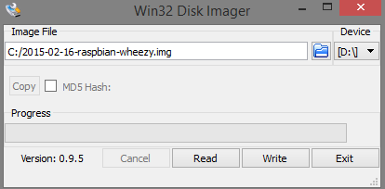

Figure 60. Write raw disk image to MicroSD

Step 6: Put Micro SD into Raspbery Pi 3, then turn on power. We must have 1 keyboard, screen connected to Raspberry VIA HDMI cable, and internet cable to install some requirement package.

Step 7: Configure raspbian on the first running

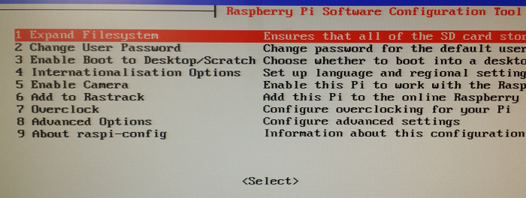

Figure 61. Configure raspbian

Step 8: Config options 1, 2, 5, then restart

#### Configure IP for Raspberry

Step 1: Open command line

Step 2: At command line, enter: sudo nano /etc/network/interfaces

Step 3: And replace text on file by this:

auto lo

iface lo inet loopback //default of Kit

iface eth0 inet static //config LAN network

address 192.168.1.230 //set static IP for raspbery

// if your moderm have defferent gateway, you must set other IP //following gateway

netmask 255.255.255.0

gateway 192.168.1.1 //set gateway

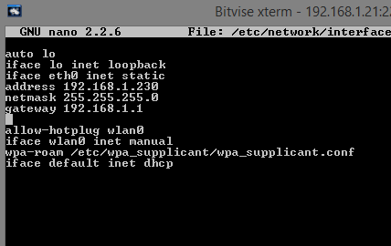

Figure 62. Configure IP network

Step 4: Press ctrl+X to save, then restart again. Now your raspberry pi have IP 192.168.1.230. You can set to other IP VIA modem IP and visible to remote Raspberry from your PC VIA Terminal. Install xrdp if you want to remote desktop. Xrdp uses the remote desktop protocol to present a GUI to the user: Sudo apt-get install xrdp

#### Install OpenCV library

**Step #1: Expand filesystem**

* The first thing you should do is expand your filesystem to include all available space on your micro-SD card: $ sudo raspi-config

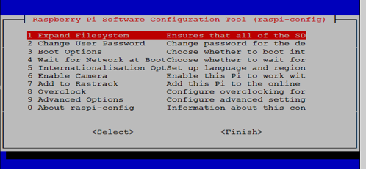

* Select the first option, “1. Expand File System”, hit Enter on your keyboard, arrow down to the “<Finish>” button, and then reboot your Pi: $ sudo reboot
* Delete the Wolfram engine to free up some space on your Pi: $ sudo apt-get purge wolfram-engine

**Step #2: Install dependencies**

* The first step is to update and upgrade any existing packages: $ sudo apt-get update

$ sudo apt-get upgrade

* We then need to install some developer tools, including CMake, which helps us configure the OpenCV build process: $ sudo apt-get install build-essential cmake pkg-config
* Next, we need to install some image I/O packages that allow us to load various image file formats from disk $ sudo apt-get install libjpeg-dev libtiff5-dev libjasper-dev libpng12-dev
* We also need video I/O packages. These libraries allow us to read various video file formats from disk as well as work directly with video streams: $ sudo apt-get install libavcodec-dev libavformat-dev libswscale-dev libv4l-dev

$ sudo apt-get install libxvidcore-dev libx264-dev

* The OpenCV library comes with a sub-module named highgui which is used to display images to our screen and build basic GUIs. In order to compile the highgui module, we need to install the GTK development library: $ sudo apt-get install libgtk2.0-dev
* Many operations inside of OpenCV (namely matrix operations) can be optimized further by installing a few extra dependencies: $ sudo apt-get install libatlas-base-dev gfortran
* Let’s install both the Python 2.7 and Python 3 header files so we can compile OpenCV with Python bindings: $ sudo apt-get install python2.7-dev python3-dev

### Step #3: Download the OpenCV source code

* Now that we have our dependencies installed, let’s grab the 2.4.13 archive of OpenCV from the official OpenCV repository.

$ cd ~

$ wget -O opencv.zip https://github.com/Itseez/opencv/archive/2.4.13.zip

$ unzip opencv.zip

**Step #4 Setup our build using Cmake with prefix: /opt/opencv2.4.13**

$ cd opencv-2.4.13  
$ cmake -DCMAKE_INSTALL_PREFIX:PATH=/opt/opencv2.4.13

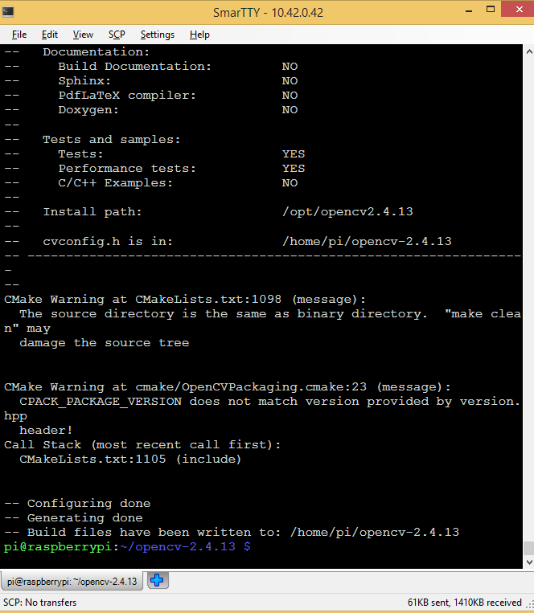

* When this done, go to compilation step:   
   $ sudo make -j5

$ sudo make install

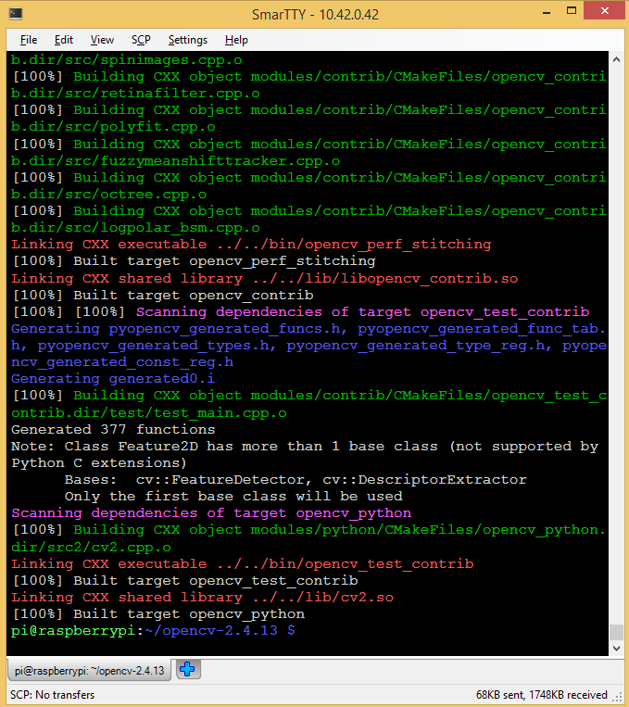

#### Install QT

Step 1: Open command line.

Step 2: Install cross-platform C++ application framework can use to build Qt project: sudo apt_get install qt5-default

Step 3: Install Qt programming: sudo apt-get install qtcreator

#### Install ZBar

Step 1: Open command line.

Step 2: In command line, enter:

Wget <https://sourceforge.net/projects/zbar/files/zbar/0.10/zbar-0.10.tar.bz2>

tar *xvjf zbar-0.10.tar.bz2*

./configure --without-qt --without-gtk --without-python --without-imagemagick --prefix=/opt/zbar.arm --with-x=no

sudo make –j5

sudo make install

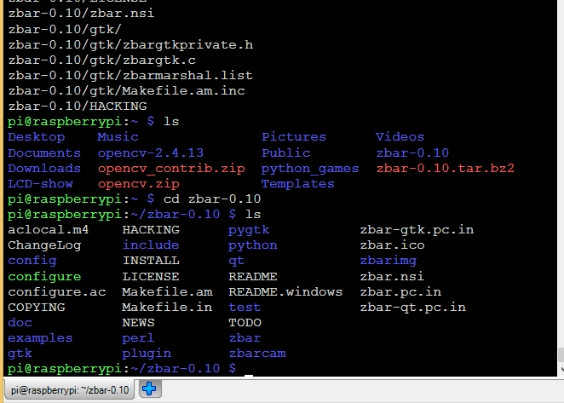

#### Deploy application on Raspberry Pi 3

Step 1: Copy .zip file of application to raspberry VIA scp command, bitvise ssh, or any program at directory “/home/pi”

Step 2: At raspberry, unzip file zip, open command line, enter:

unzip DemoCapstone.zip

cd DemoCapstone

Step 3: Build qt application.

Create makefile by qt development tool: qmake DemoCapstone.pro;

Build application: make

#### Step 4: Finally, reboot raspberry and that auto run application (with path to execution file (DemoCapstone file on DemoCapstone directory) you entered on .xinitrc file

#### Connection map between components

Figure 67. Connection map between all components

#### 

## User’s Guide

### Login



|  |  |  |
| --- | --- | --- |
| No. | Item | Description |
| 1 | PinCode | Fill PinCode to log in |

You must enter a valid PinCode provided by the publisher. After the test, correctly you click "login". If you enter an invalid your PinCode, the

### Show zone

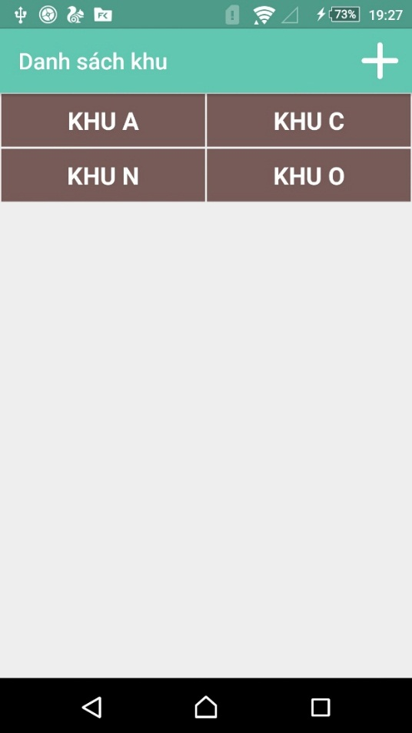

|  |  |  |
| --- | --- | --- |
| No. | Item | Description |
| 1 | + | You can add a new zone. |
| 2 | Zone | Contains information on the zone |
| 3 | DELETE | You can delete the zone. |

Display the user's zone, with a new user will not have any zone displayed. When user click on "+" to add a new zone. You need only enter the number required by the system.

When user click on "DELETE". They must be sure you want to delete the zone. They will choose the zone you want to delete. The display will appear the message "Are you sure you want to delete" user click "Ok" to clear the zone.

### Add zone

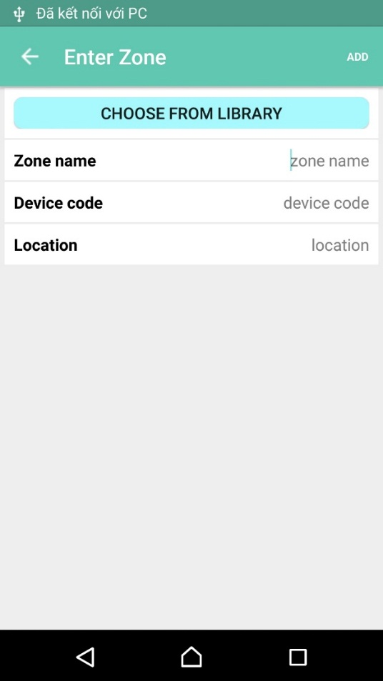

|  |  |  |
| --- | --- | --- |
| No | Item | Description |
| 1 | Back | Back screen shows zone |
| 2 | Choose from library | The user will select plants at the library |
| 3 | Device code | Enter the correct product code |
| 4 | Location | Users enter the area you want to name |
| 5 | Create date | The system will automatically retrieve the date and time |

Users who want to add a zone. They must make sure that there is a real part here we called "node". On the node will have the code, this is the device that the user must enter the code in the "Device code".

"Choose from the library": users will choose plants that they want to grow in the zone. If the plant does not exist, a user can add new ones.

“Location”: users can enter the location you want.

“Create date”: users do not need this option. Auto save system date and time to add new users. Users can view the creation date, when necessary.

### Library info

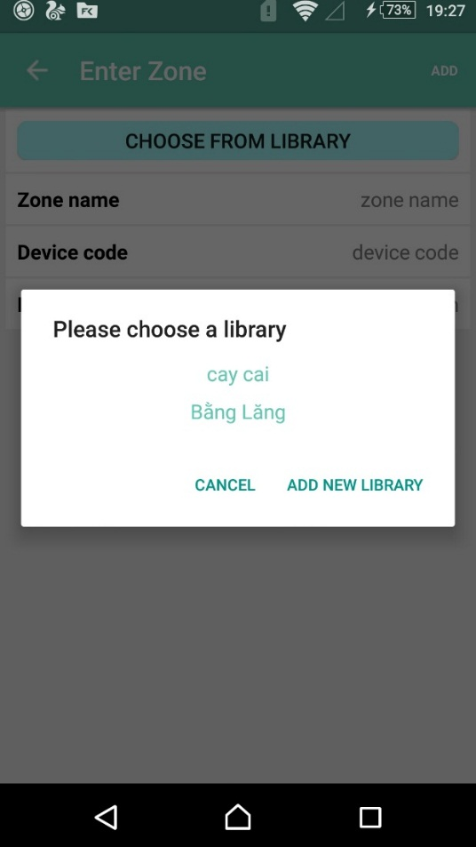

|  |  |  |
| --- | --- | --- |
| No | Item | Description |
| 1 | Back | Back screen shows zone |
| 2 | Plant name | Plant where the user can choose |
| 3 | ADD NEW LIBRARY | Finish choose plant |

The user chooses to plant they want on zone.

### Add new plant

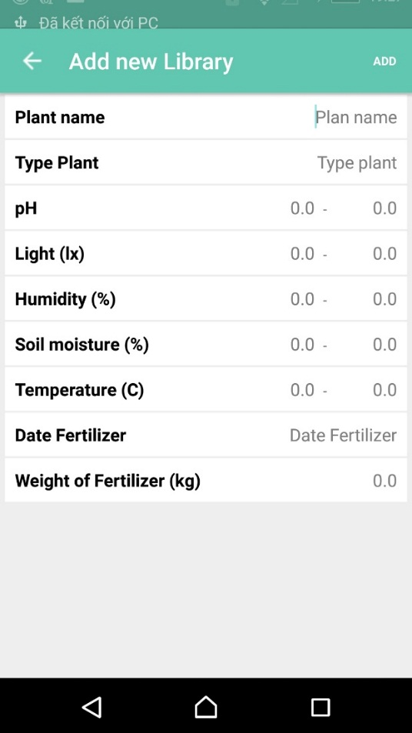

|  |  |  |
| --- | --- | --- |
| No. | Item | Description |
| 1 | Back | Back screen add zone |
| 2 | Plant | Enter plant name |
| 3 | PH | PH input indicators include 2 upper and lower |
| 4 | Light | Light input indicators include 2 upper and lower |
| 5 | Humidity | Humidity input indicators include 2 upper and lower |
| 6 | Soil moisture | Soil moisture input indicators include 2 upper and lower |
| 7 | Temperature | Temperature input indicators include 2 upper and lower |
| 8 | Date Fertilizer | Select dates for fertilizing plants |
| 9 | Weight of Fertilizer | Fertilizer for plants |
| 10 | DONE | Finish add new plan. |

Add a new user to the library tree. They must be fully and accurately enter the parameters of the tree. They can consult online or based on actual experience itself.

Date Fertilizer: The next day fertilizing (Unfinished function).

Weight of Fertilizer: Unfinished function.

### Show plant info

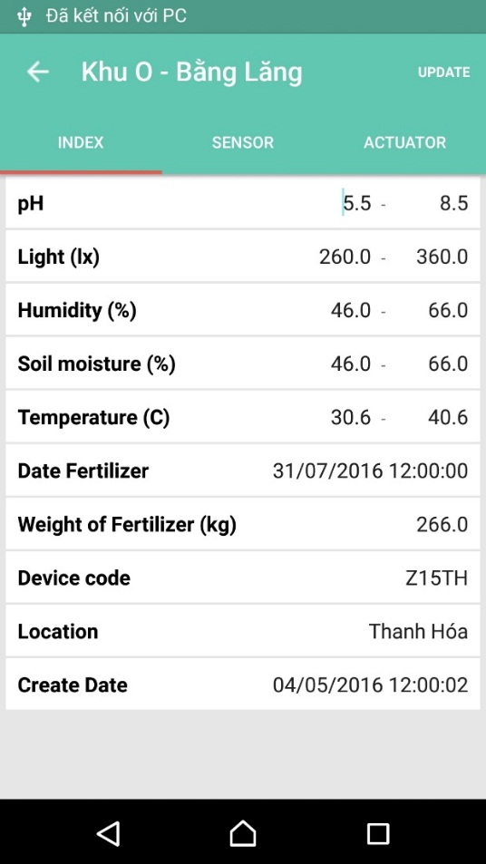

|  |  |  |
| --- | --- | --- |
| No. | Item | Description |
| 1 | “<=” | Back screen choose zone |
| 2 | “Khu O” | Show zone name |
| 3 | “bằng lăng” | Plant were planted in the zone name |
| 4 | PH | PH input indicators include 2 upper and lower |
| 5 | Light | Light input indicators include 2 upper and lower |
| 6 | Humidity | Humidity input indicators include 2 upper and lower |
| 7 | Soil moisture | Soil moisture input indicators include 2 upper and lower |
| 8 | Temperature | Temperature input indicators include 2 upper and lower |
| 9 | Date Fertilizer | Select dates for fertilizing plants |
| 10 | Weight of Fertilizer | Fertilizer for plants |
| 11 | Device code | Manufacturer's code |
| 12 | Location | Location name |
| 13 | Create day | The system will automatically retrieve the date and time |
| 14 | Update | will speak at the following guidelines |

Showing all the information of the plant.

### Update Zone



|  |  |  |
| --- | --- | --- |
| No. | Item | Description |
| 1 | “<=” | Back screen choose zone |
| 2 | “Khu O” | Show zone name |
|  | “Bằng Lăng” | Plant were planted in the zone name |
| 3 | PH | PH input indicators include 2 upper and lower |
| 4 | Light | Light input indicators include 2 upper and lower |
| 5 | Humidity | Humidity input indicators include 2 upper and lower |
| 6 | Soil moisture | Soil moisture input indicators include 2 upper and lower |
| 7 | Temperature | Temperature input indicators include 2 upper and lower |
| 8 | Date Fertilizer | Select dates for fertilizing plants |
| 9 | Weight of Fertilizer | Fertilizer for plants |
| 10 | Device code | Manufacturer's code |
| 11 | Location | Location name |
| 12 | Create day | The system will automatically retrieve the date and time |
| 13 | Update | Button for user send command to update zone |

When user want to change index of plant in zone. They will change index by click line on screen.

Must ensure that the parameters are correct. Click the button “update” to finish.

### Show sensor info

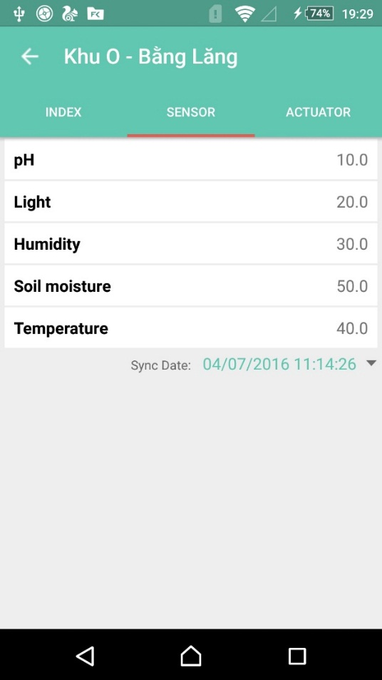

|  |  |  |
| --- | --- | --- |
| No. | Item | Description |
| 1 | “<=” | Back screen choose zone |
| 2 | “Khu O” | Show zone name |
| 3 | “Bằng lăng” | Plant were planted in the zone name |
| 4 | PH | PH sensor that measured |
| 5 | Light | Light sensor that measured |
| 6 | Humidity | Humidity sensor that measured |
| 7 | Soil moisture | Soil moisture sensor that measured |
| 8 | Temperature | Temperature sensor that measured |
| 9 | Last check | The latest update now |
| 10 | Weight of Fertilizer | Fertilizer for plants |

Display which sensor parameters measured. Users cannot edit the information it. The parameters are updated approximately every 30 minutes trying. Users can review the history of the sensor.

### History sensor

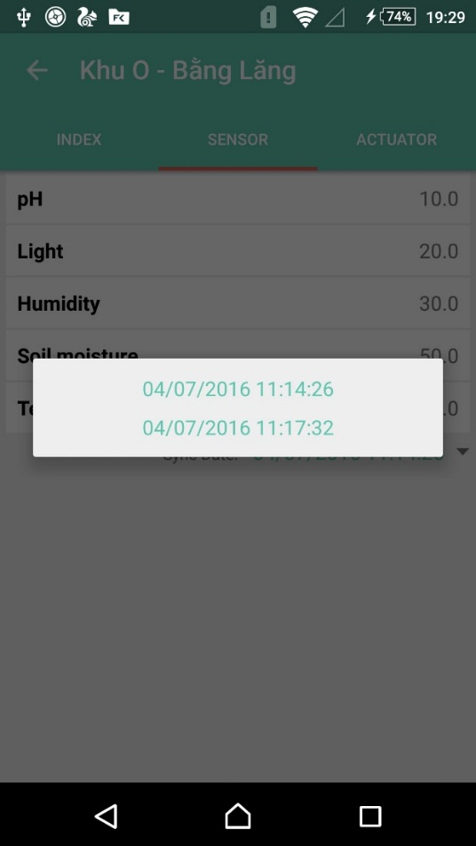

User clicks date to show on screen.

Select the date and time you want to see

### Show actuator

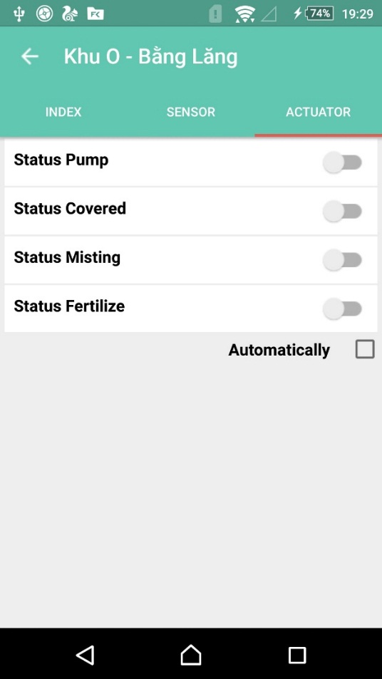

|  |  |  |
| --- | --- | --- |
| No. | Item | Description |
| 1 | Back | Back screen choose zone |
| 2 | “Khu O” | Show zone name |
| 3 | “Bằng lăng” | Plant were planted in the zone name |
| 4 | Status Pump | Show the status of pump |
| 5 | Status Covered | Show the status of covered |
| 6 | Status Misting | Show the status of Misting |
| 7 | Automatically | On/off control |

Users can view the status of the actuator.

There are two modes for users to choose:

+ Automatic control mode. Users can only view. Users cannot control the actuator.

+ Manual control mode. Users can control any device that appears on the screen. Automatic mode turns off.